Simplified dual kinetics model for the extraction of high value-added components from coffee bean’s silverskin.
Andrea Galeazzi¹, Giulia Bozzano¹, Flavio Manenti¹, Luisella Verotta², Rita Nasti², Stefania Marzorati²
1 Politecnico di Milano, DCMIC, p.zza L. Da Vinci, 32, Milano, Italy; 2 Università degli Studi di Milano, DESP, Via Celoria 2, Milano, Italy
*Corresponding author: f.manenti@polimi.it
Highlights
- Supercritical carbon dioxide extraction from micronized silverskin matrices
- Extraction simplified model
- Experimental data

1. Introduction
Extraction of oils and other valuable components from wasted biomass, such as roasted coffee silverskin, offers the possibility to recover and create value in a sustainable way. Supercritical CO₂ is one of the most environmentally friendly extraction methods available, especially compared to traditional solvent techniques which are toxic and dangerous. By applying a proper mathematical approach to describe the extraction of natural products from silverskin, it is possible to predict the system behavior in different operative conditions. This enables to develop a reasonable design of experiment and to envisage a possible scale-up in industrial plants by also maximizing the output and minimizing wastes.
For doing so, a simplified mathematical model is proposed describing the supercritical carbon dioxide extraction of high value-added components from roasted coffee bean’s silverskin. It is based on that first introduced by Sovová [1] in 1994 and later used in a myriad of cases [2]. Having an empirical approach in defining the mass transfer coefficient between the two phases, these models offer a simple solution, which is analytical, as well as good fitting of data. Through experimental data derived from silverskin extraction, the characteristic parameters of the model have been deduced. Such parameters allow to predict the behavior of the system in different operative conditions and optimize the system.
2. Methods
Experiments are carried out in a 100ml stainless steel vessel which can house approximately 40g of non-compressed micronized silverskin powder. Supercritical CO₂ is pumped at desired pressure by a compressor and flows inside the column from the bottom to the top. The solute extracted is collected in pre-weighted glass vials positioned after a small collection chamber at the exit of the vessel. At desired times the vial is substituted, the solute extracted is measured with a laboratory scale and data are collected. In the adopted model, the desorption of solutes is modeled with two different steps. At first, solute present on the outside of the solid matrix is extracted and later, when that solute is depleted, the extraction proceeds towards the solute present inside the solid. Solubility is the driving force that describes the mass transfer when solute is readily available and in direct contact with the fluid, on the other hand diffusivity is responsible for the extraction of solute stranded inside the solid matrix.
Original Sovová’s model considers also a third transient step. To further simplify the model, Patel [3] proposed to remove this transition period and consider the two principal stages only. It is assumed that an axial solvent flows, at a constant superficial velocity, through a fixed bed of cylindrical shape. The solvent is pure at the entrance. The temperature and pressure are kept constant throughout the fixed bed and the total time of extraction. Additionally, the bed is considered homogeneous in terms of solute distribution as well as particle size. The model also assumes pseudo-steady state with plug flow and neglects the accumulation of the solute in the fluid phase. It considers the solute solubility in the solvent and mass transfer coefficient both in solvent and in solid phases.
To verify the experimental data a non-linear regression is applied, the dimensionless parameters are calculated having the foresight of separating all the operative changing parameters like interstitial velocity or initial mass of solid from the constant ones.
3. Results and discussion
Preliminary results show a good fitting of the experimental data, although at the actual state the model suffers severely from the changing in CO₂ flowrate. In facts, the model right now describes quite good different operative conditions like changes in temperature as well as void factor (by reducing the initial solid in the vessel) but only if the fluid flowrate remains constant.
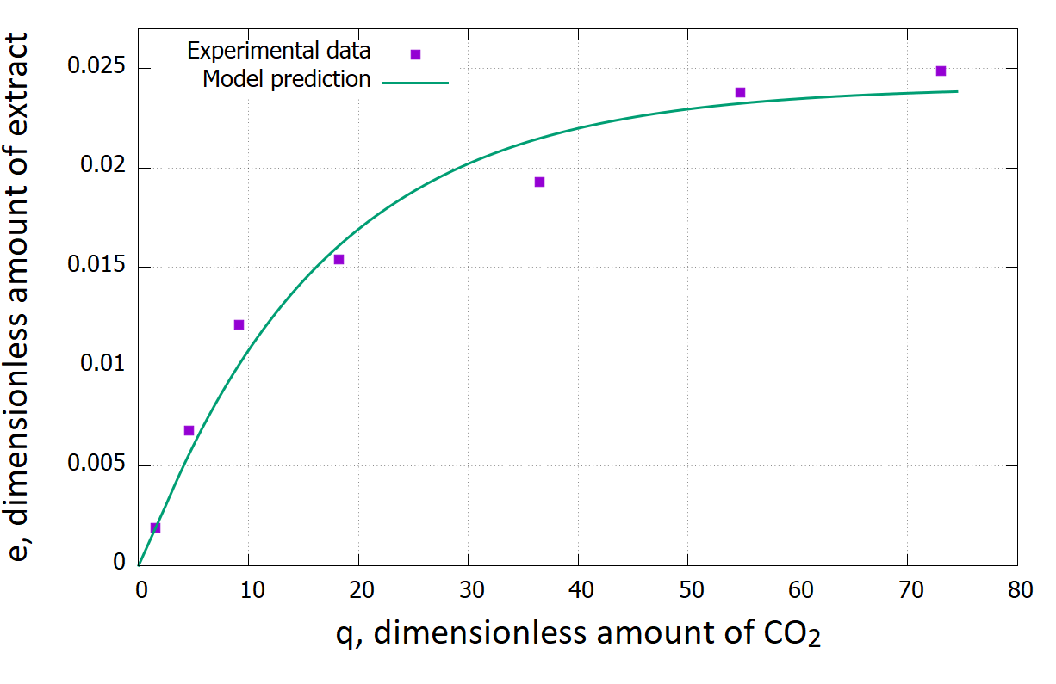
Figure 1. Example of model comparison for 300bar,330K and 4 hours extraction.
4. Conclusions
This model has a good potential but only if it would be possible to apply it to different ranges of flowrates. This problem might be caused by the changing in the mass transfer rates due to the changing in mass flow rate. It is evident that it is necessary to apply some more constraints and a mass transfer theory to further separate the variable parameters from the constant ones. Doing so might enhance the regression of the adjustable parameters making this model suitable to proceed to a possible design of experiment as well as optimization of operative conditions and possibly a scale-up.
References
- H. Sovová, Chemical Engineering Science, pp. 409-414, 1994.
- R.N. Patel, S. Bandyopadhyay, A. Ganesh, Energy Conversion and Management, pp. 652-657, 2011.
- J.M. Del Valle & J.C. De La Fuente, Critical Reviews in Food Science and Nutrition, pp. 131-160, 2006.

