Mathematical and Computational Modelling of Anodic Oxidation of Oxygen in Copper Refining with Arc Electrolysis.
Jorge Manríquez¹, Gerardo Cifuentes¹, Cristian Vargas¹, Alejandro Gutierrez²
1 Full Professor, Metallurgical Engineering Department, University of Santiago of Chile, Avda. L. B. O’Higgins 3363, Estación Central, Santiago, Chile; 2 Full Professor, Mechanical Engineering Department, University of Santiago of Chile, Avda.L.B. O’Higgins 3363, Estación Central, Santiago, Chile.
*Corresponding author: jorge.manriquez@usach.cl
1. Introduction
The common route of refining the impurities of copper and other non-ferrous metals is pyrometallurgical. The penalties in the price of copper for the level of impurities vary from 0.9 to 4.1 US/lb. The classic equipment of operation is the rotatory furnace of pyrorefining. The operation involves two sequential process steps: (a) oxidation - complexing; according to reaction of Eq(1):S+O₂ = SO₂ , and (b) reduction, according to reaction of Eq(2): C + O =CO. Refining with arc electrolysis is considered an alternative means of removing impurities from the molten copper without introducing deoxidizing agents. The use of this electrochemical method replaces the chemical reactions involved in the oxidation and reduction processes by electrochemical reactions. In this work, we will be studied the dynamic behavior of the anodic oxidation of the oxyanion as the supply of oxidizing agent of impurities in the blister copper through modeling and simulation using program Comsol.
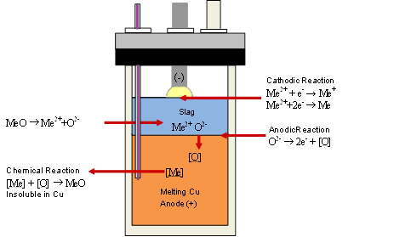
2. Methods
The arc electrolysis furnace consists of a cylindrical crucible (see Figure 1). The crucible is contained in a furnace of silica refractory bricks heated with silicon carbide electrodes. A single graphite electrode enters through the top seal of the crucible. Copper blister and slag are fed from the top prior to heating and sealing the crucible.
Figure 1. Scheme Arc Electrolysis Furnace
The mesh was refined at the walls and slag – metal and arc -slag interfaces. Complete mesh consists of 6,274 elements, minimum quality of 0.1208 and average quality of 0.8981. The system consists of 5 domains, 19 edges and 15 points. The physical properties of the subdomains of the system are given in the following Table 1. Where k, is the thermal conductivity, h is the heat transfer coefficient by convection. Q, u, and v are values that are obtained by simultaneously solving the equation of the conductive medium DC and Navier-Stokes, respectively. To solve the energy equation the temperature at which the furnace is initially located is 1500 K and to evaluate
the heat transfer by radiation ε = 0.5 and σ = 5.67 x 10⁻⁸ [W/m²K⁴].
Table 1. Physical properties of the subdomains.
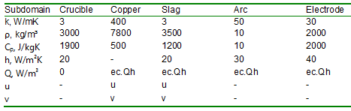
To solve the mass equation the oxygen concentration at which the slag is initially is 2,446 mol/m³, Value obtained by the stoichiometric oxygen contained in the Cu₂O in the slag and the volume of the slag. In Eq(3):
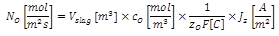The oxygen diffusivities (Fukunaka et al, 1991) in the slag and oxygen in the blister copper are 10⁻⁷ m²/s and 10⁻⁶ m²/s, respectively. The metal-slag interface is modeled as a boundary condition of flow discontinuity where it is entered Faraday’s Law, the mass transfer of oxygen to this interface is by natural convection and is modeled by its coupling with momentum transfer and is generated by temperature gradients modeled by its coupling with transfer heat. Where C₀ is the concentration of oxygen in the slag obtained from the mass transport equation and Jz is the total current density obtained from the coupling with the conductive medium DC equation for the z component of the current density.
3. Conclusions
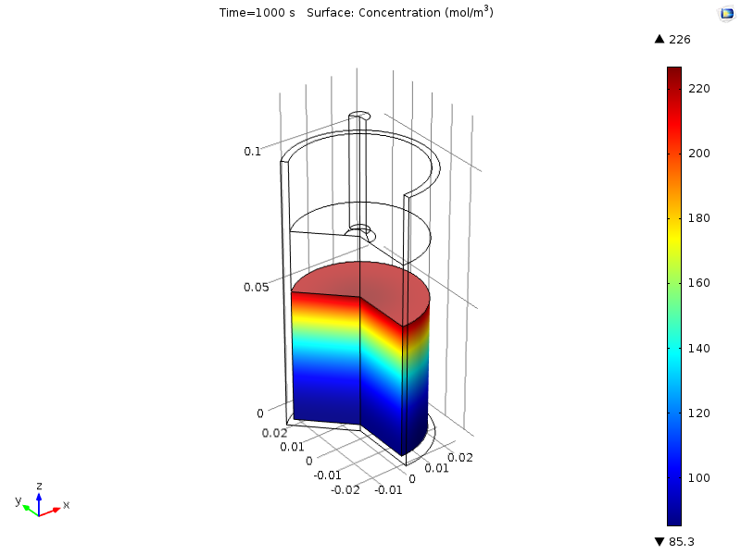
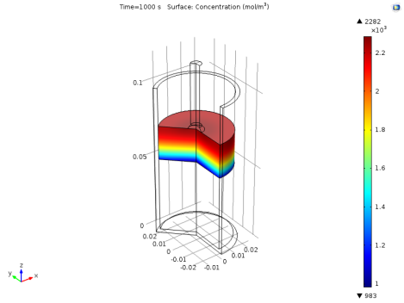
The simulation results in an arc temperature of 2,067 K that forms a movement created by natural convection generated by temperature gradients that in turn generate concentration gradients.
Figure 2. Profile Concentration of oxygen in Slag, mol/m³ (left) and in Blister Copper, mol/m³ (right).
In the slag speed reaches a maximum of 6.79 x 10⁻⁷ m/s, and in the molten copper 10⁻¹⁰ m/s. In Figure 2, the simulation of the oxygen mass transport in the slag shows that the initial oxygen with a concentration of 2,446 mol/m³ develops after 1,000 s of simulation a profile with a maximum of 2,282 mol/m³ in the slag - gas interface that goes down to 983 mol/m³ in the metal slag interface where the electrochemical oxidation reaction occurs. The simulation of mass oxygen transport in copper shows that the oxygen not present initially, as a result of the electrochemical oxidative oxidation reaction, develops a profile with a maximum of 226 mol/m³ in the metal slag interface in that descends to reach 85.3 mol/m³ at the bottom of the crucible.
Acknowledgments. The authors thank to the DICYT 051714MF(2017) and Project 155LD of the USACH.
References
- D.R. Gaskell, 1997, Structural Aspects of Slags, Molten slags, fluxes and salts '97 conference, 11-26.
- T. R. Shelley and J. A. Charles, Transactions of the Institute of Mining & Metallurgy, (1974), C18-C24.
- COMSOL Multiphysics 4.3b, License Number: 2079130, (2013) Version: 4.3b, Stockholm, Sweden.
- Y. Fukunaka, K. Nishikawa, H.S. Sohn, And Z. Asaki, Metallurgical Transactions B, 22B (1991), 5–11.
- Q.G. Reynolds, R.T. Jones, and B.D. Reddy, 2010, The Journal of The Southern African Institute of Mining and Metallurgy, 110 (2010), 733–742.
- A. Powell and D.Dussault, Scandinavian Journal of Metallurgy 32(2003), 33–36.

