Model-Assisted Design of Experiments.
Johannes Möller¹, Kim B. Kuchemüller¹, André Moser², Volker C. Hass² , Tanja Hernández Rodríguez³, Sahar Deppe³, Björn Frahm³, Ralf Pörtner^{1,*}

¹Institute of Bioprocess and Biosystems Engineering, Hamburg University of Technology,
Hamburg, D-21073, Germany, ²Hochschule Furtwangen University, Faculty of Medical and Life Sciences, Villingen-Schwenningen, D-78054, Germany, ³Biotechnology and Bioprocess Engineering, Ostwestfalen-Lippe University of Applied Sciences, Lemgo, D-32657, Germany,
*Corresponding author: poertner@tuhh.de
Highlights
- Workflow for knowledge-based bioprocess development.
- Combination of mathematical modeling and statistical Design of Experiments.
- Reducing the number of experiments for process design.

1. Introduction
The development of biotechnological processes is still mainly based on one-factor-at-a-time approaches. This increases the time for process development and simultaneously limits the obtained knowledge. As an alternative, Design of Experiments (DoE) tools can be used for the evaluation of multiple variable impacts simultaneously. However, conventional DoE frequently leads to a high number of time-consuming and costly experiments.
In this study, a model-assisted DoE (mDoE) concept is introduced for a knowledge-based process design with a reduced number of experiments. The main part of mDoE is a mathematical process model, which incorporates the prior knowledge and known mechanistic relationships [1]. The combination of the process model with conventional DoE methods enables the knowledge-based reduction of the experimental space. This method is exemplarily shown for the optimization of the initial glucose and glutamine concentration (batch) and the development of a bolus fed-batch strategy (4 parameters) for the cultivation of antibody-producing CHO cells.
2. Methods
For mDoE, data of first cultivations based on literature or prior knowledge (e.g. former studies) is generated. It is used to model biomass growth, metabolic activity and product formation during the process. Models of different complexity may be utilized, describing e.g. phenomenological relationships and effects [2], structured biomass compartments [3], or segregated population dynamics [4]. After process modeling, conventional DoEs are planned and the factor combinations are exported. The planned processes are simulated instead experimentally performed and the DoEs are evaluated using statistical methods. A response-surface model is estimated and a constraint-based optimization of the experimental space is conducted. This loop (see Figure 1) can be repeated several times to reduce the number of experiments further. Finally, a reduced number of cultivations is performed in the optimized experimental space.
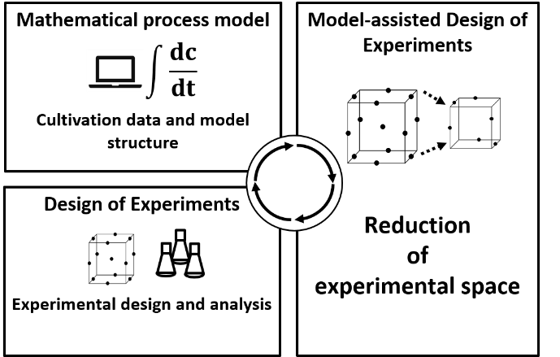
Figure 1. Scheme of the method for mDoE.
3. Results and discussion
The parameters of a mathematical process model [2] were estimated based on data of four first experiments for each application (batch and fed-batch). Conventional DoEs with broadly distributed factor boundary values were planned and the responses were simulated. The experimental spaces were evaluated and the factor boundary values were adapted. Experiments were conducted within the reduced experimental spaces and the results compared to the simulated DoEs. The same optimal conditions were found for both, simulated and experimentally performed cultivations. For the optimization of the initial glucose and glutamine concentration (see Figure 2), the number of experiments could be reduced by 50 % (8 for modeling/validation vs. 16). The number of experiments could be reduced by 72 % (8 for modeling/validation vs. 29) for the development of a bolus fed-batch strategy.
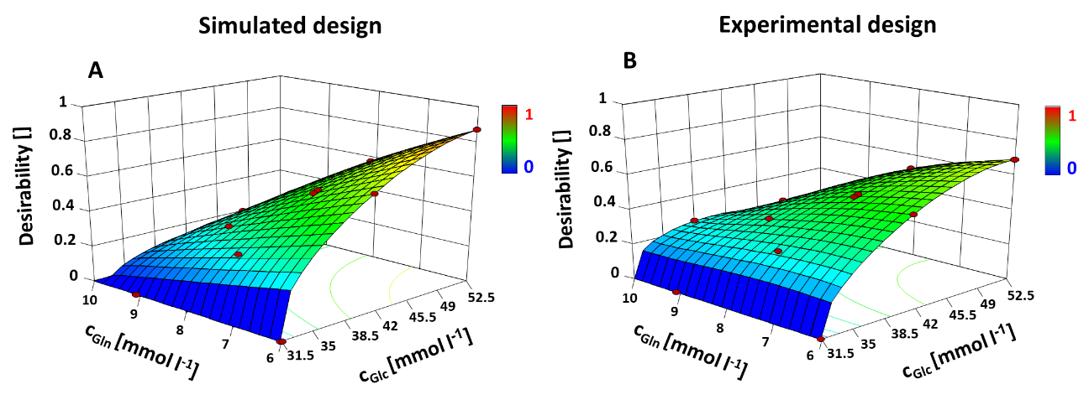
Figure 2. Desirability function for medium optimization, constraints: maximal antibody titer and minimal ammonium concentration. A: simulated responses, B: experimentally determined responses, cultivations as described in [4]
4. Conclusions
mDoE utilizes the currently available process understanding in form of a mathematical process model and significantly reduces the number of experiments.
References
- V Abt et al. (2018) Curr Opin Chem Eng, https://doi.org/10.1016/j.coche.2018.11.007
- S Kern et al. (2016) Cytotechnology, https://doi.org/10.1007/s10616-015-9858-9
- S Brüning et al. (2017) Chem Eng Technol, https://doi.org/ 10.1002/ceat.201600639
- J Möller et al. (2018) Biotechnol Bioeng, https://doi.org/10.1002/bit.26828

