Mastering Digitized Chemical Engineering
Dr. Hermann J. Feise¹, Eric Schaer²
1 European Federation of Chemical Engineering, Rugby, United Kingdom and BASF SE, Ludwigshafen, Germany
2 Université de Lorraine, Nancy, France
*Corresponding author: Hermann.Feise@basf.com
Highlights
- Digitization transforms the Chemical Industry rapidly across its entire chain
- New competencies will be required from chemical engineers to interact with new colleagues. The specific Engineering competencies needed for digitized Chemical Engineering are necessarily unknown, because of the fast-changing digital environment
- Data analytics tools will become standard engineering tools like CAD, FEM. The fundamentals will keep their importance, nevertheless.
- More and better lifelong learning will be required. Universities can and possibly must develop new offerings for the new learners.

1. Introduction
The chemical industry with its large world scale production units and its multi-purpose facilities is one of the energy-, raw materials- and capital-intensive industries, which currently face the challenges of the digital transformation. In these conditions, the chemical engineer’s activities also have to evolve.
2. Digital Transformation
The digital transformation or Industry 4.0 is expected to change business models, allowing new efficiency gains and improving European competitiveness. In the chemical industry much of the key aspects of the digital transformation are not foreign: Internet of Things, Industrial Internet or automated ordering, have a strong history in process optimization and -automation. However, logistics and maintenance are the only two fields which have developed truly digital workflows. The way to a truly digitally transformed plant is still very long.
3. Skills and Competences
A digitally transformed chemical plant will lead to new challenges and new opportunities for chemical engineers. New tasks will be developed and colleagues with new competencies and different skills will work together with chemical engineers. This will require additive knowledge from the chemical engineer which are not part of today’s engineering skill set, although some of them have been for previews generations of chemical engineers.

Drivers for the digital transformation can be found in various areas, e.g. data management systems, digital data, improved sensors for control, connectivity, simulation, spatial data. While the use of smart sensors for control has always been part of chemical engineering, neither their design or their use for simulation and optimization tools are mainstream chemical engineering tasks. Digital transformation will logically lead to the use and application of artificial intelligence systems in the industry, and should require, for example, strong knowledge and skills in (transient) simulation and optimization. This should also require an ability to critically evaluate the results provided by such systems.
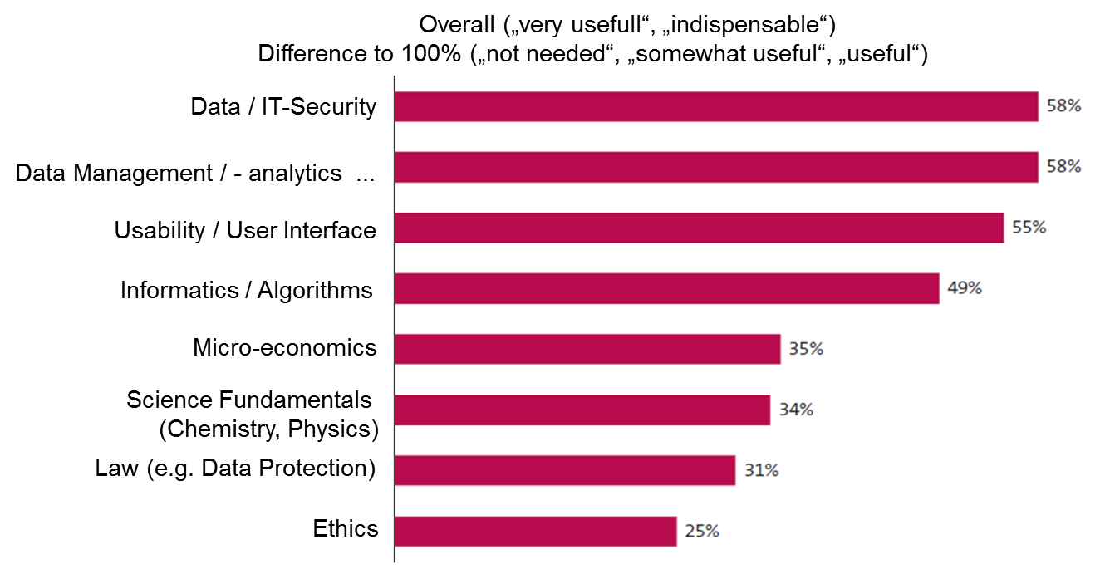
Figure 1. Industry 4.0 engineering knowledge outside the core [1]
4. Conclusions
The future chemical engineers will still have to demonstrate technical and management skills, taking into account ethics (global warming, resources depletion, well-being…) and economic aspects. The digital transformation should be seen as an opportunity, both for teaching and learning (use of virtual, augmented reality, contributions of artificial intelligence on acquisition of skills and knowledge…), as for the engineering practices, allowing to focus on innovation, interdisciplinarity and optimization.
The way to a truly digitally transformed plant is still very long, so far only logistics and maintenance have digitalized. Engineering competencies needed for digitized Chemical Engineering are necessarily unknown, because of the fast-changing digital environment. However, it will at least require: statistics, data models, data combination (vocabulary). Data analytics tools will become standard engineering tools like CAD, FEM. For the next decade we will still rely on data engineering experts, however.
Some new teaching topics should so be added in the curriculum, but as the first law of thermodynamics imposes, if the teaching duration remains unchanged, some other topics should then be removed. It is our responsibility, and interest to remain competitive and innovative, but also to meet social expectations, to think and anticipate these deep changes in the training of future chemical engineers.
References
- E Heidling et al.: Ingenieurinnen und Ingenieure für Industrie 4.0, Institut für Sozialwissenschaftliche Forschung e.V., München, 2019.
- VDI - Statusreport: „Bedeutung der digitalen Transformation für die chemische Industrie“, 2017.
- Wolfram Keller: Berufe 4.0 – Wie Chemiker und Ingenieure, in der digitalen Chemie arbeiten, Whitepaper, GDCh, 2018.

