PC-SAFT Prediction of Amino-Acid Solubility with New Experimental Melting Properties.
Hoang Tam Do ¹, Yeong Zen Chua², Christoph Schick², Dzmitry Zaitsau², Christoph Held^{1*}
¹Laboratory of Thermodynamics, Department of Biochemical and Chemical Engineering, TU Dortmund University,
Emil-Figge Str. 70, 44227 Dortmund, Germany

² Institute of Physics, University of Rostock, Competence Centre CALOR, Faculty of Interdisciplinary Research, University of Rostock, Albert-Einstein-Str. 25, 18051 Rostock, Germany

*Christoph Held: christoph.held@tu-dortmund.de
Highlights
- New experimental melting properties of amino acids
- Prediction of aqueous solubility of amino acids with PC-SAFT
- Transfer of the method to peptides

1. Introduction
The solubility of amino acids plays an essential role for the production and purification of amino acids, especially for crystallization processes. The solubility affects product yield and purity as well as the choice of solvent for the process. Further, several (bio)chemical operations are processed at homogenous conditions, i.e. amino-acid precipitation has to be avoided; this also requires solubility data. The experimental measurement of solubility is time-consuming and expensive considering the nearly uncountable different conditions in biological solutions (pH-value, temperature, type and concentration of co-solutes and co-solvents). Therefore, the prediction of solubility using thermodynamic models is desired, which however requires activity coefficients and the melting properties of the considered solute. However, measuring the enthalpy of fusion and the melting temperature of biomolecules such as amino acids is usually not possible using conventional differential scanning calorimetry due to decomposition of the solid during the measurement.
2. Methods
Application of fast scanning calorimetry (FSC) overcomes the problem of decomposition, and FSC was used in this work to measure the melting properties. The measurements were performed under an inert atmosphere of nitrogen with a sample mass less than 100 ng. Figure 1 shows the temperature-time profile used in this study.
The profile is divided into three measurements stages. (i) Sample mass determination (#1-#4), (ii) sample melting and quenching (#5-#7) and (iii) reheating of supercooled sample (#8-#11). In this work the enthalpy of fusion and melting temperature were measured for a series of amino acids.
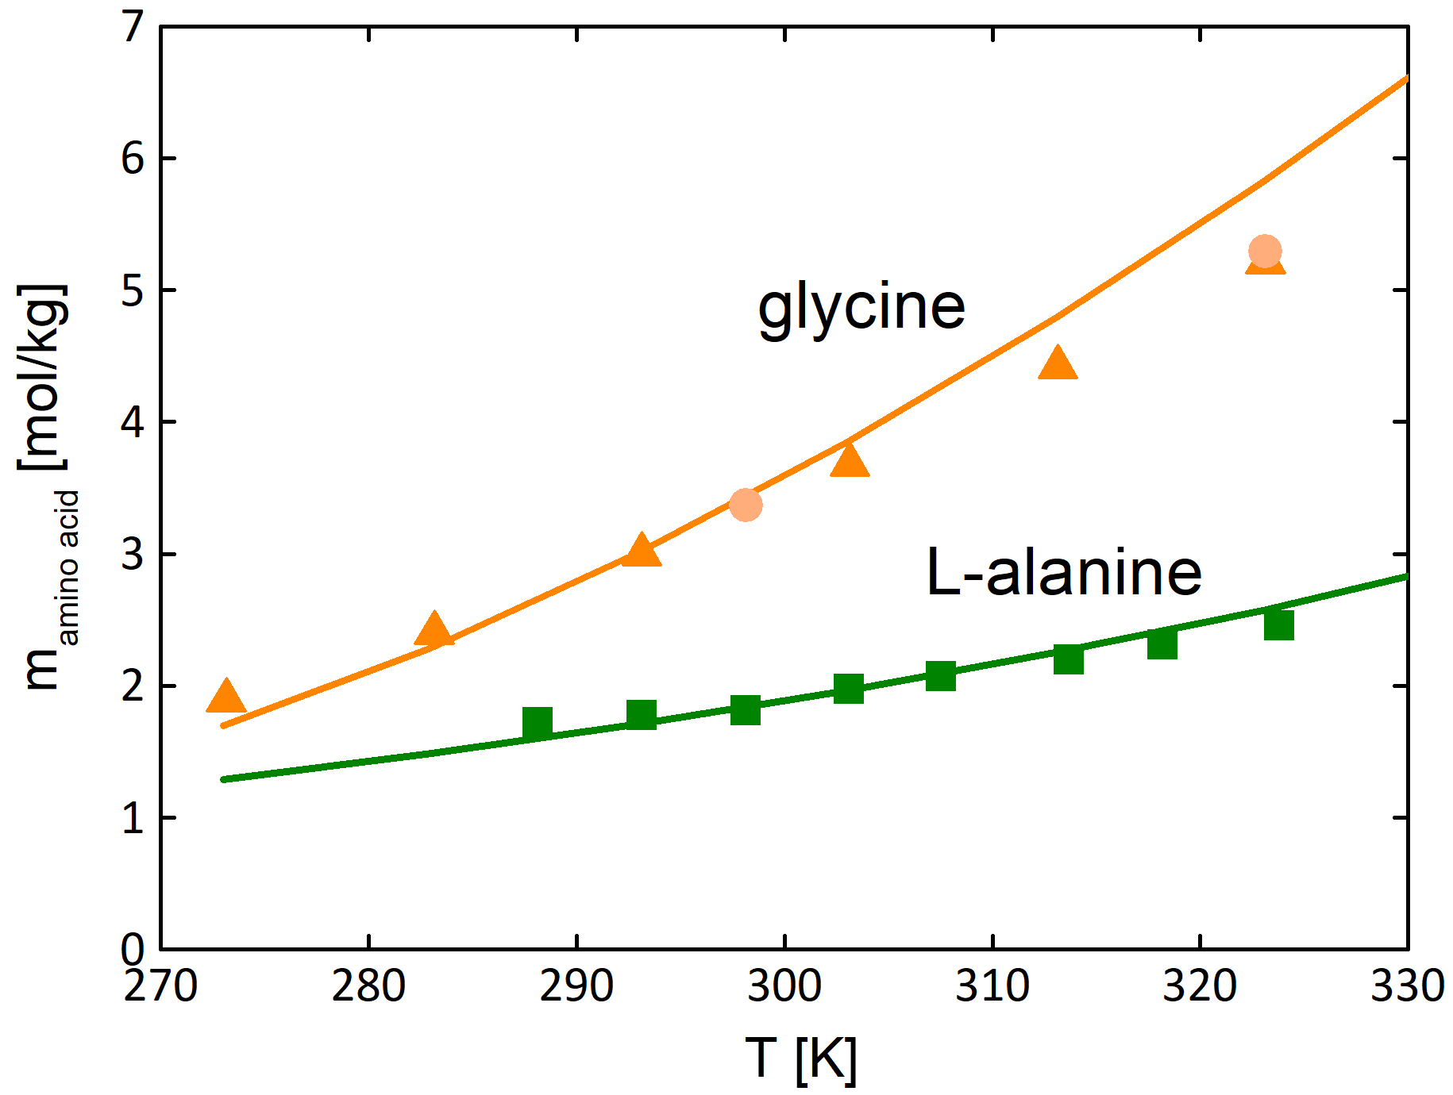
Figure 2 Glycine and L-alanine solubility in water as molality vs. temperature. Symbols represent experimental data (circles^{[3]}, triangle^{[4]}, squares^{[5]}). Lines represent PC-SAFT predictions.
2. Results and discussions
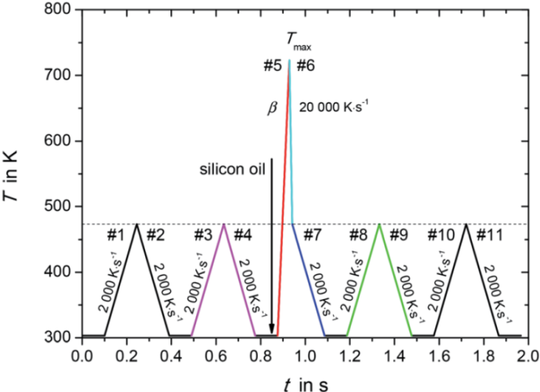
The solubility measurements of amino acids were performed in aqueous solution. The PC-SAFT pure-component parameters for the amino acids as well as the water parameters were taken from literature [2]. Additionally, one binary interaction parameter k_{ij} was used between amino acid and water. The values for k_{ij} were fitted to experimental osmotic-coefficient data of aqueous amino-acid solutions at 298.15 K and atmospheric pressure. As shown in Figure 2 the temperature-dependent solubility of glycine and L-alanine in water were predicted with PC-SAFT using the melting properties measured from FSC in very good agreement to the experimental data. The method could be successfully transferred to peptide solutions as well as to solubility of amino acids in water-alcohol mixtures.
Fiure. 1: Temperature-time profile for determination of melting properties with fast scanning calorimetry.
4. Conclusions
In this work it was the goal to predict solubility of components that decompose before melting, e.g. amino acids or peptides. The predictions require PC-SAFT parameters and melting data. All PC-SAFT parameters were taken from literature or fitted to new solubility-independent thermodynamic properties such as osmotic coefficients. Melting properties were measured using FSC. The results revealed that amino-acid solubilities can be accurately predicted over a broad temperature range. The combination between PC-SAFT and FSC generally allows the predicting solubility of molecules that decompose before melting.

References
- Y.Z. Chua, H.T. Do, C. Schick, D. Zaitsau, C. Held, RSC Advances, 8, 6365-6372; (2018)
- C. Held, L.F. Cameretti, G. Sadowski, Ind- Eng- Chem. Res., 50, 131-141; (2011)
- J. P. Amend, H. C. Helgeson, Pure Appl. Chem, 69, 935-942, (1997)
- H. Sober, Handbook of Biochemistry, Selected Data for Molecular Biology, CRC Press, (1973)
- T. H. Lilley, Physical Properties of Amino Acids, ed. G.C. Barret, 591-624, (1985)

