Enzymatic activity of commercial enzymes in hydroalcoholic solvents and its effect on bioactive molecules recovery.
Carmen Soto-Maldonado^{1*}, Paola Poirrier-González; María Elvira Zúñiga-Hansen²
1 Centro Regional de Estudios en Alimentos Saludables, Av. Universidad 330, Curauma-Placilla, Valparaíso, Chile; 2 Escuela de Ingeniería Bioquímica, Pontificia Universidad Católica de Valparaíso, Av. Brasil 2085, Valparaíso, Chile.
*Corresponding author: carmensoto@creas.cl
Highlights
- Antioxidant recovery can be improved by enzymatic treatment
- Enzymes can be inhibited by solvent presence during the extraction process.
- Ethanol 10% allow to maintain enzyme activity almost in a 50%
1. Introduction
Antioxidants are substances that limit the oxidation of several molecules. They are present in fruit and vegetables (pulp, seeds, and skins) (Laroze et al. 2010). Extraction of antioxidant compounds depends of several factors. Also, different treatments are used to improve the bioactive compounds extraction, such as the use of plant cell wall degrading enzymes. Few works report enzymatic treatment of vegetable material to improve the antioxidant recovery (Kim et al., 2005; Li et al., 2006; Pinelo et al., 2008; Kapasakalidis et al., 2009; Maier et al., 2008; Laroze et al., 2010). In most of them, enzyme incorporation increases the presence of phenolic compounds and its antioxidant activity; however, results depend of several variables, including enzyme inhibition (Kim et al., 2011; Ximenes et al., 2011). Also, authors as Bezerra and Dias (2005) reports that organic solvent as ethanol produce enzyme denaturation. Due to this fact enzyme application during antioxidant compounds extraction with solvents must be not efficient. The aim of this work was to evaluate the effect of organic solvent in the enzymatic activity of commercial formulations which are used in the treatment of agro-industrial solid waste to improve the antioxidant compounds extraction.
2. Methods
Enzymes: Commercial enzymes (Grindamyl CA 150 from Danisco; Macer 8 FJ from Biocatalyst; Celluclast 1.5L and Cellubrix L from Novozymes) were characterized about their enzymatic activity.
Enzymatic activity determination: Two types of enzyme activities assays were done. A) Cellulolytic activity was established using carboxymethylcellulose (CMC) as substrate according to Ghose (1987). B) Polygalacturonase activity (pectinase activity), was determined by Ros et al (1992) method. The enzymes were dissolved in buffer and then, different amount of solvent was added.
Extraction of phenolic compounds with antioxidant activity: A solid/solvent ratio of 1/10 w/v was used in the extraction of phenolic compounds from Maqui berry pomace, which was used as model raw material because its high antioxidant compound content. Enzymes were dissolved in water, added to the solid, blended, and the solvent was incorporate then. Solid and extracting solvent were put at 50°C during 6 hours under magnetically stirring. Extract was recovery by filtration.
Antioxidant presence: Total polyphenolic compounds (TPC) were determined by Folin-Ciocalteu method, according to Conde et al. (2009). Antioxidant activity (AA) was determined by two methods (1) The 2,2-diphenyl-1-picrylhydrazyl = 2,2-diphenyl-1-(2,4,6-trinitrophenyl) hydrazyl) (DPPH) radical scavenging capacity was measured according to Laroze et al. (2000), and (2) the 2,2'-azino-bis(3-ethylbenzthiazoline-6-sulphonic acid) (ABTS) assay according to Conde et al. (2009).
3. Results and discussion
Figure 1 shows the effect of several proportion of ethanol on the enzymatic activity of 4 commercial catalysts. As it is possible to observed in all the cases the presence of ethanol decreases drastically the enzyme activity. Only when 10% of ethanol was used the cellulolytic activity was maintained over 50% of the original value. Then, this solvent (ethanol 10%) was used to probe the enzymatic extraction of phenolic compounds from maqui berry pomace. The Figure 2 shows an increment on the extraction of phenolic compounds from maqui berry pomace and its antioxidant activity when enzymes as Macer 8FJ and Celluclast were used, in comparison to control.
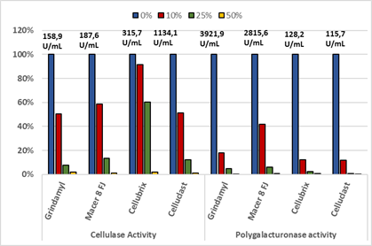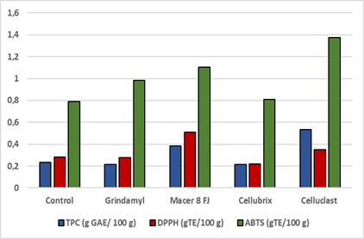
Figure 2: Recovery of phenolic compounds with antioxidant activity using an enzymatic treatment.
Figure 1. Enzymatic activity of commercial catalyst in ethanol presence.

4. Conclusions
The extraction of antioxidant compounds is improved when mixtures of organic solvents with water are used, in comparison to only water extraction. In addition, the use of enzymes is an attractive alternative to improve the extraction, but its activity is deeply affected by the presence of organic solvent. Despite that, it is possible to find an amount of solvent that allows the enzymes to act and at the same time improve extraction. Then, catalysts as Celluclast 1.5L and Macer 8FJ allows to increase the efficiency of extraction of phenolic compounds with antioxidant activity from Maqui pomace up to 100%, considering as extraction solvent a 10% of aqueous ethanol.
References
- RM.F.Bezerra, A.A.Dias Appl Biochem Biotech, 126 (2005) 49-59.
- E. Conde, C. Cara, A. Moure, E. Ruiz, E Castro, H.Domínguez, Food Chem, 114(2009) 806-812.
- T.K. Ghose. Pure & Appl Chem 59(1987) 257-268.
- P.G. Kapasakalidis, R.A. Rastall, M.H. Gordon. J Agr Food Chem, 57 (2009) 4342-4351.
- Y. Kim, E. Ximenes, N. Mosier, M. Ladisch. Enzyme Microb Tech, 48 (2011) 408–415
- L. Laroze, C. Soto, M.E. Zúñiga, Electron J Biotechn,13 (2010) 6
- B.B Li, B. Smith, M.D.M. Hossain. Sep Purif Technol, 48 (2006)189-196.
- T. Maier, A. Göppert, D.R. Kammerer, A. Schieber, R. Carle. Eur Food Res Technol, 227 (2008) 267-275.
- M. Pinelo, B. Zornoza, A.S. Meyer. Sep Purif Technol, 63 (2008) 620-627.
- J.M. Ros, D. Saura, L. Coll, J. Laencina. Alimentación, Equipos y Tecnología 8(1992)127 –134.
- Ximenes, E., Kim, Y., Mosier, N., Dien, B., and Ladisch, M. Enzyme Microb Tech 48 (2011) 54–60.

