Carotenoids production in Antarctic Chryseobacterium marinum
Florencia Risso¹, Eugenia Vila¹, Verónica Saravia¹*
1 Departamento de Bioingeniería, Instituto de Ingeniería Química, Facultad de Ingeniería, Universidad de la República, Julio Herrera y Reissig 565, Montevideo, Uruguay.
* Corresponding author: vsaravia@fing.edu.uy
Highlights
- Psychrotolerant strains from King George Island, Antarctica
- Identification of carotenoids by chromatographic analysis
- Chryseobacterium marinum potential source for carotenoids production

1. Introduction
Carotenoids are among the most diverse natural products. They are synthesized de novo by many organisms, mainly plants and microorganisms. They absorb light between 400 to 550 nm, which gives them their yellow-orange color [1]. In fact, as antioxidant compounds, carotenoids have relevant biological functions in quenching of singlet oxygen, light capture and photosynthesis protection. There is currently much interest in biological active compounds derived from natural resources due to the high costs and waste materials associated to the chemical synthesis.
Antarctic microorganisms are exposed to extreme environmental conditions as weather, drastic light changes, nutrient scarcity, and high seasonal ultraviolet radiation incidence increased by the ozone depletion over Antarctica [2, 3, 4]. The isolation and characterization of extreme habitats microorganisms has become more important lately as a mean of identifying adaptations of microorganisms to these extreme conditions, with potential biotechnological application such as carotenoid production. This study involved 20 psychrotolerant strains isolated from sampling events carried out during the Uruguayan Antarctic Expedition (December, 2014) along Fildes Peninsula, King George Island, Antarctica.
2. Methods
Strains characterization and selection: Single colonies that exhibited yellow/orange coloration were subculture in TSA plates. The pigmented colonies were replicated until a pure culture was reached. Strains were conserved at -80°C on glass beads with 20% glycerol in Tryptic Soy Broth. Strains were characterized, influence of temperature on cell growth at 10°C, 25°C and 37°C on TSA. Identification of the strains was done by 16S rRNA analysis [5].
Culture conditions for biomass and pigment production: A factorial experimental design 2² was used to evaluate the relative importance of glucose and peptone for biomass production and carotenoids content. Statistica trial version software was used for analysis. Bacterial strains were cultured in 500 mL Erlenmeyer flasks with 150 mL medium in an orbital shaker at 20°C and 200 rpm. The culture media included: yeast extract 2.0 g/L, NaCl 5.0 g/L, K₂HPO₄ 2.5 g/L, glucose (15 g/L, 10 g/L or 5 g/L), and peptone (11g/L , 6.5 g/L or 2g/L). For each nutrient variable, a high (+), a low (-) concentration and three center points were tested. After 48 h culture growth, cells were harvested by centrifugation. Cell pellets were stored at -80°C and lyophilized (VirTis BenchTop 2 K Freeze Dryer, SP Industries Inc.).
Pigment extraction and characterization: Approximately 0,05 g of lyophilized biomass was extracted with 4 mL of methanol until bleaching. The extract was dried under a nitrogen stream and dissolved in acetone for chromatographic analysis. Detection was performed at 450 nm.
3. Results and discussion
Phylogenetic analysis sorted the isolated strain as Chryseobacterium marinum, a Gram – negative, yellow, rod-shaped aerobic bacterium. The absorption spectrum of the methanol- extracted pigment of Chryseobacterium marinum displayed a typical carotenoid spectrum in the visible range with maximum absorbance at 450 nm. Identification of carotenoids was carried out according to the strain producing pigments and the retention time (RT) in the C18 column and was confirmed through coelution with β-carotene, β-cryptoxanthin and zeaxanthin standards.

Evaluation of nutritional effects in biomass and carotenoids production: Peptone showed either a positive effect in the biomass growth and pigment content. Meanwhile glucose showed a negative effect in the biomass production and in the pigment production. Maximum growth and zeaxanthin concentration were obtained after 48.5h growth at 20° C, pH 7.0, in a medium containing 5 g/L glucose and 11 g/L peptone. Under these conditions, the concentration of total carotenoids from Chryseobacterium marinum was 15,1 mg/L. Surfaces responses are showed in Figure 1. Even though, Chryseobacterium sp. showed potential as microbial source for producing carotenoids, the carotenoid yield and composition can still be maximized by optimization of the bioprocess.
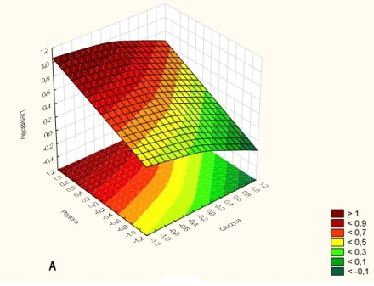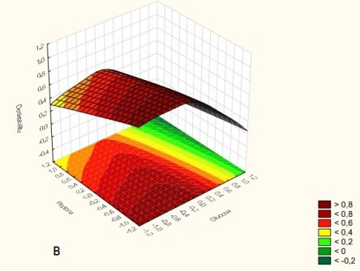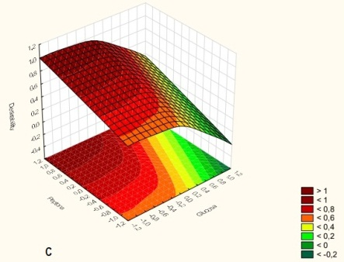

Figure 1. Surface-response graphs generated from the 2² statistical factorial design, utilizing peptone and glucose influence on the response factors: (A) Biomass, (B) Carotenoids content and (C) Zeaxanthin production.
4. Conclusions
As reported for the genus Chryseobacterium: β-carotene, β-cryptoxanthin and zeaxanthin were detected. Carotenoids identified from Antarctic bacteria constitute an alternative for further biotechnological application towards a more sustainable way of pigments production.
References
- Britton G. 1995. Structure and properties of carotenoids in relation to function. FASEB J. 9:1551–1558
- Margesin R, Miteva V. (2011) Diversity and ecology of psychrophilic microorganisms. Res Microbiol 162:346–361
- Margesin R, Schinner F, Marx JC, Gerday C. (2008) Psychrophiles, from Biodiversity to Biotechnology. Springer, Berlin
- Uchino O, Bojkov RD, Balis DS, Akagi K, Hayashi M, Kajihara R (1999) Essential characteristics of the Antarctic-spring ozone decline: update to 1998. Geophys Res Lett 26:1377–1380
- Vila, E., Hornero- Méndez, D., Azziz, G., Lareo, C., Saravia, V. 2019. Carotenoids from heterotrophic bacteria isolated from Fildes Peninsula, King George Island, Antarctica. Biotechnology Reports 20

