Mixing Studies Relating to Process Development for New Generation Automotive Coating Formulations
H. Yu^{1,2}, S. Tsochataridou², K. Parsons¹, K. Wojtas², C. D. Rielly², Gül Özcan-Taskin²
¹ MacDermid Enthone Industrial Solutions, Wantage, Oxon, OX12 7BZ, UK; ² Loughborough University, Department of Chemical Engineering, Loughborough, LE11 3TU, Leicestershire, UK
*Corresponding author: herrick.yu@macdermidenthone.com
Highlights
- Sawtooth and 45°PBT impellers were studied to characterise their blending performance over the turbulent and transitional regimes at two scales of operation.
- Numerical modelling results under selected conditions could be validated with data.
- Experiments performed using liquids that simulate the physical properties of coating formulations have led to the development of a process for the manufacture of high performance automotive coatings.

1. Introduction
A formulation can require the introduction of several additives in different forms into a liquid and hence single and multiphase mixing processes (dispersion of agglomerates of solids or immiscible liquid droplets) are performed during manufacture. It is desirable to use the same equipment throughout the process or even for different products. In this study, the blending performance of a sawtooth impeller, which is typically used for dispersion processes, was investigated in comparison to that of the mixed flow pitched blade turbine (PBT). Blending performance of different types of sawtooth impellers has not been studied as widely as the PBT ^{[1]}. The study has been performed in support of process development for a new formulation coating for automotive applications. Simulant liquids were chosen to replicate the viscosity of the additives used in the new formulation coating allowing a range of Reynolds numbers to be covered at different scales of operation.

2. Experimental
Experiments were conducted using two tanks of a diameter of T= 0.13 and 0.30 m, equipped with 4 equally spaced wall baffles. The liquid height was equal to the tank diameter (H = T). Either a sawtooth impeller, R500, (SPXFlow) or a 6-blade 45° pitched blade turbine (PBT) was used. These were of a diameter of around half the tank diameter. Water and glycerol solutions of a viscosity range of 0.001 to 1.2 Pa s were used as simulant liquids to replicate the properties of the formulation and added liquids, some of which are of hazardous nature. Physical property differences taken into consideration^{[2]} when preparing tracers. Power input was calculated from the measured torque value using torquemeters. Flow pattern observations and mixing time measurements were performed from the colourisation/decolourisation method by adding Na₂S₂O₃ into the aqueous mixtures in the presence of starch-iodine solution.
Under selected conditions numerical simulations were performed with STAR CCM+ 13.02 using the, moving reference frame approach.
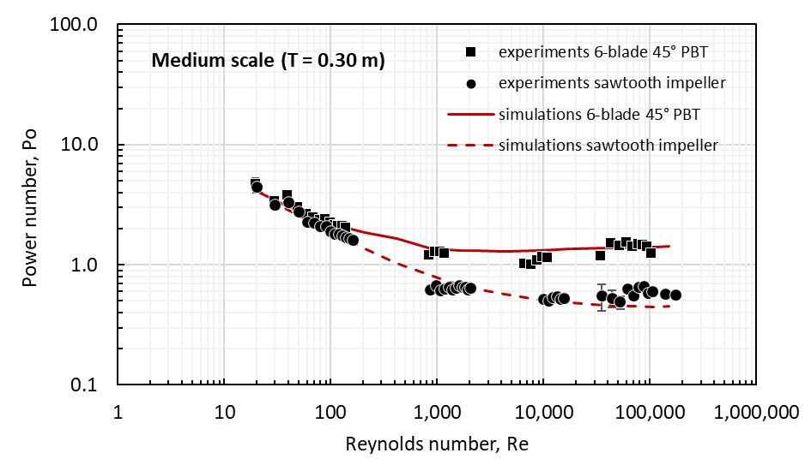
3. Results and discussions
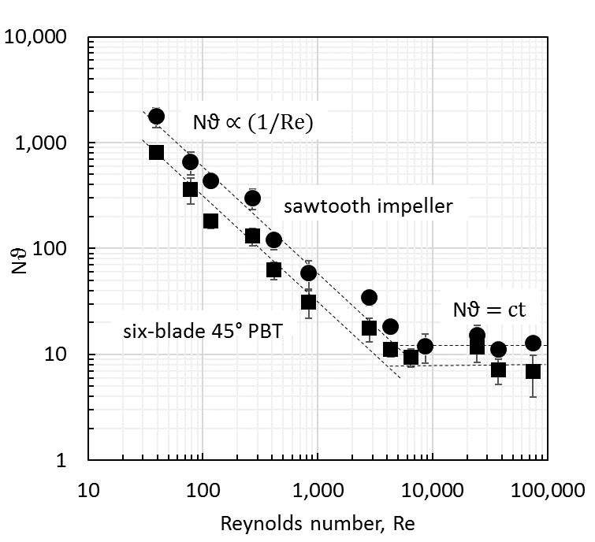
Power numbers obtained from numerical simulations were in agreement with those determined experimentally for both impellers with a higher value of the characteristic power number for the PBT compared to the sawtooth impeller as expected (Figure 1). These could be used to calculate the power input over a range of conditions. Figure 1: Characteristic power curves, T= 0.30 m
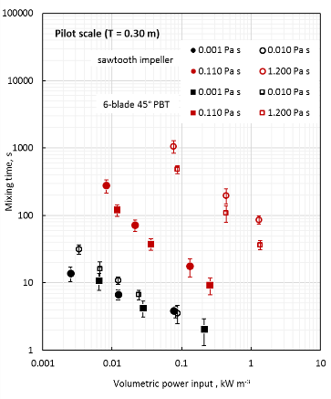
Results from blending experiments have shown that the dimensionless mixing time (Nθ) is inversely proportional to the Reynolds number with higher Nθ values for the sawtooth impeller (Figure 2). When mixing time results are compared on the basis of volumetric power input, the performance of both impellers Figure 2: Dimensionless mixing time over Figure 3: Mixing times at ct P/V appeared to be a comparable. a range of Re, T= 0.30 m (red are data in transitional regime)
Trends were similar in the smaller T= 0.13 m tank.
4. Conclusions
Power and flow characteristics of sawtooth impellers were studied over a range of Reynolds numbers using simulant liquids that replicate the viscosity during the manufacture of a new formulation automotive coating at two scales of operation. Numerical simulations performed under selected conditions showed good agreement in predicting the power input and hence can be used for different designs. Mixing times compared on the basis of constant volumetric power input were found to be comparable for the two impellers. Further work is underway in a larger scale tank.
Acknowledgements The authors gratefully acknowledge the InnovateUK project nb132726 and contribution in kind by SPX Flow.
References
- Grenville, R.K. (1992) PhD thesis, Cranfield Inst of Tech.
- Jones P.N.; Özcan- Taşkin, G. N. (2005) Chem. Eng and Tech. Vol 28, 8, p: 908- 914. DOI 10.1002/ceat.200500012

