**Molecular Dynamics Simulations of Confined Water inside Stacked Graphene Oxide Membranes**

*One-Sun Lee*

*Qatar Environment and Energy Research Institute, Hamad Bin Khalifa University, Doha, Qatar*

Stacked graphene oxide (GO) is an emerging membrane with the application of desalination. However, the structure and dynamics of water molecules and ions inside GO membrane is not known, and this has proven to be a hindrance in understanding how this system functions. Here, we investigate the dynamic behavior of water inside GO membrane using computational approach. We developed four different models of GO membrane with different interstice distance (*d*) between GO sheets (*d* = 7, 9, 11, and 13 Å in Figures 1 (A) and (B)), and performed molecular dynamics simulations of water (SPC/E model) inside each membrane. The measured diffusion coefficients (in unit of ×10–5 cm2/sec) of water are 0.3 (*d* = 7 Å), 0.9 (*d* = 9 Å), 1.2 (*d* = 11 Å), and 1.5 (*d* = 13 Å). To understand the retarded diffusion of water with narrower interstice distance, we analyzed the hydrogen bond autocorrelation relaxation and the rotational relaxation. The molecular rotation is described by the first and second-rank Legendre polynomials,

 (1)

 (2)

using the molecular body-fixed axes (See Figure 1(C)). We found that the hydrogen bond lifetime is longer in the GO membrane with the narrower interstice distance, and the rotation relaxation of water is also slower in the GO membrane with the narrower interstice distance (Table 1). Therefore, we concluded that the diffusion of water is retarded by the hydrogen bond with the hydroxyl or epoxy groups of GO membrane. Our simulation result would be a useful theoretical source for designing new carbon-based membranes for desalination.

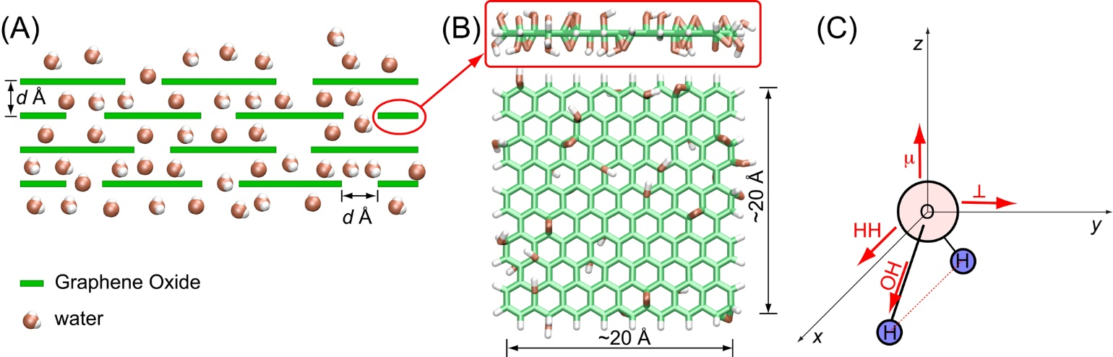

**Figure 1**. (A) Schematic representation of the penetration of water through the interstices of stacked GO membrane. (B) Snapshots of the side and top view of GO used in the simulations. (C) Coordinates of water molecule for the analysis of rotation dynamics.

**Table 1**. Rotational correlation time (ps) of water inside stacked graphene oxide

|  |  |  |  |  |  |  |
| --- | --- | --- | --- | --- | --- | --- |
| *d* (Å) | 7 | 9 | 11 | 13 | ∞* | ∞** |
|  | 12.2 | 6.9 | 5.7 | 5.3 | 4.3 | - |
|  | 31.8 | 11.1 | 7.9 | 6.8 | 4.7 | 4.761 |
|  | 10.9 | 5.1 | 4.2 | 3.7 | 2.9 | - |
|  | 18.5 | 8.3 | 6.5 | 5.7 | 4.5 | - |
|  | 14.8 | 4.9 | 3.4 | 2.9 | 2.0 | 2.02 |
|  | 18.3 | 6.1 | 3.8 | 2.8 | 1.6 | 1.921 |
|  | 32.4 | 9.2 | 4.8 | 3.2 | 1.2 | - |
|  | 13.4 | 4.8 | 3.3 | 2.7 | 1.8 | 1.953 |

∞* Bulk water (simulation)

∞** Bulk water (experiment)

References:

1. Sansom, M. S. P.; Kerr, I. D.; Breed, J.; Sankararamakrishnan, R., Water in channel-like cavities: Structure and dynamics. *Biophys. J.* **1996,** *70* (2), 693-702.

2. Halle, B.; Wennerstrom, H., Interpretation of magnetic-resonance data from water nuclei in heterogeneous systems. *J. Chem. Phys.* **1981,** *75* (4), 1928-1943.

3. Ludwig, R., NMR relaxation studies in water-alcohol mixtures - the water-rich region. *Chem. Phys.* **1995,** *195* (1-3), 329-337.