Thin RuOx films deposited on Ti: Influence of preparation parameters on the electrochemical performances
Giovanni Sotgiu^{1*}, Monica Orsini¹, Serena De Santis¹, Elisabetta Petrucci²
1 Department of Engineering, University of di Roma Tre, Via Vito Volterra, 62 - 00146, Roma ;
2 Department of Chemical Engineering Materials & Environment, Sapienza University of Rome, Rome, Italy, Via Eudossiana, 18 - 00184, Roma
*Corresponding author: giovanni.sotgiu@uniroma3.it
Highlights
- Ruthenium oxide electrodes have been prepared by spin-coating deposition
- Electrochemical characterization was performed by cyclic voltammetry
- Electrochemical performance was affected mostly by number of cycles and rotation speed

1. Introduction
Metal Oxide electrodes consist of an electrocatalytic thin film of noble metals oxides coating a Platinum or Titanium support. They have been successfully used in the chloro-alkali industry for the last 30 years. In more recent years different compositions (Mixed Metal Oxide MMO), have been extensively used with a view to both fundamental understandings of the processes involved and for treatment of wastewater [1], [2].
Preparation conditions, for instance, the solvent used during preparation, the nature of the oxide precursor and the calcination temperature, affect the physical properties of oxide electrodes [3]. Electrodes were prepared by several techniques: thermal decomposition, sputtering, electrochemical deposition, CVD. The thermal decomposition is the most common technique and the film can be deposited on the substrate by drop-cast, spin-coating, dip coating.
In previous works [4], [5] we have prepared different types of MMO and studied their electrochemical performances. In a standard procedure, the films were obtained by drop-cast. This method is very simple but unfortunately, it is not easy to obtain a uniform and well-controlled film.
In this work, we prepared thin RuOx film by spin-coating, a more accurate and controllable technique. In particular, we studied the influence of different process parameters on the electrochemical performances of electrodes. The investigated parameters were the number of depositions, the speed of spinning, volume, concentration, and aging of precursor solutions.
2. Methods
The cleaning procedure and the precursor solution preparation were described elsewhere [4]. Titanium samples (1.5 cm × 2.0 cm), were coated with the solution containing the precursor by spin coating using Polos SPIN150i / 200i. A variable number of depositions were made and after each of them the sample was dried in an oven at 100°C for 10 min. After the last deposition, a thermal treatment was conducted at 450°C for an hour.
The electrodes obtained were analyzed on the basis of polarization measurements and cyclic voltammetry in aqueous solutions containing Na₂SO₄.The scan rate was fixed at 50 mV/s and the potential range chosen was between -0.2 V and + 1.12 V (vs SCE)
3. Results and discussion
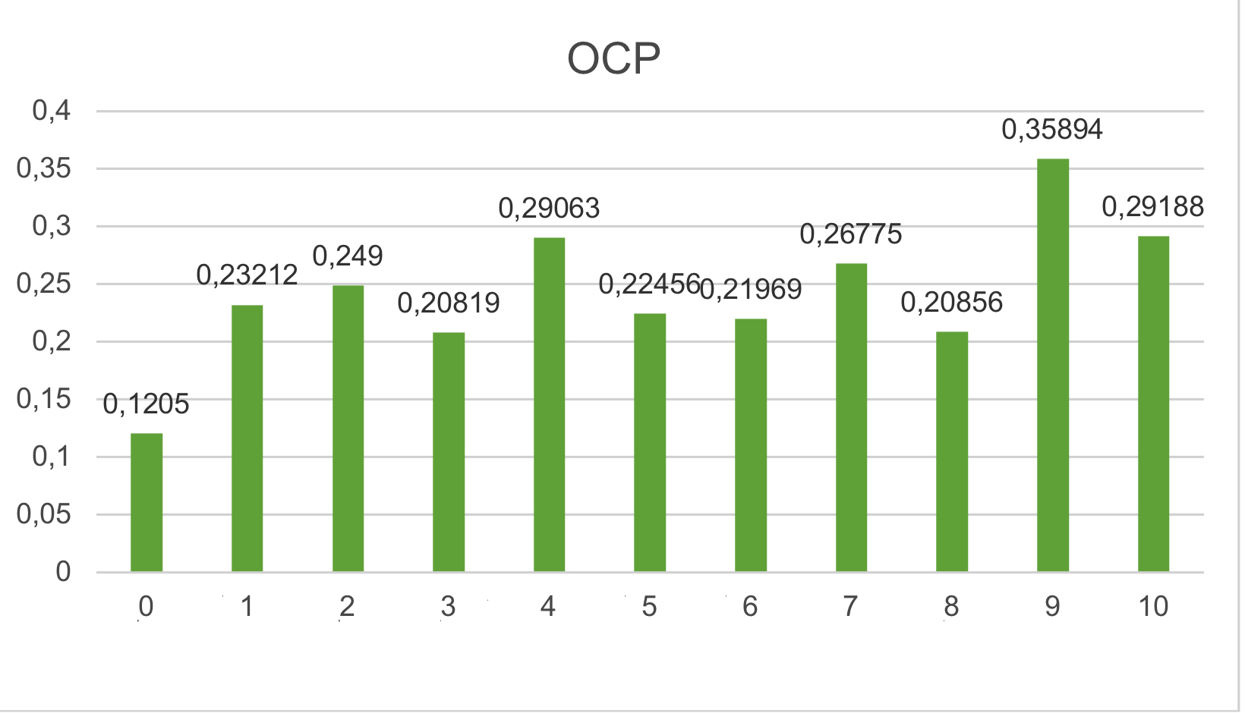
The sample prepared are presented in Table 1. As expected and confirmed by a simple visual analysis, a greater number of depositions results in a more uniform and thick film; also a lower rotation speed leads to a more homogeneous film.
Item | Speed  [rad/s] | N° deposits | Molarity [mol/L] | Volume  [μL]
1 | 500 | 3 | 0.1 | 10
2 | 500 | 3 | 0.1 | 20
3 | 1000 | 3 | 0.1 | 20
4 | 250 | 3 | 0.1 | 20
5 | 500 | 1 | 0.1 | 20
6 | 500 | 2 | 0.1 | 20
7 | 500 | 6 | 0.1 | 20
8* | 500 | 3 | 0.1 | 20
9* | 500 | 3 | 0.05 | 20
10* | 500 | 3 | 0.01 | 20
Table 1. Prepared samples. * Freshly prepared solution Figure 1. OCP values for the samples
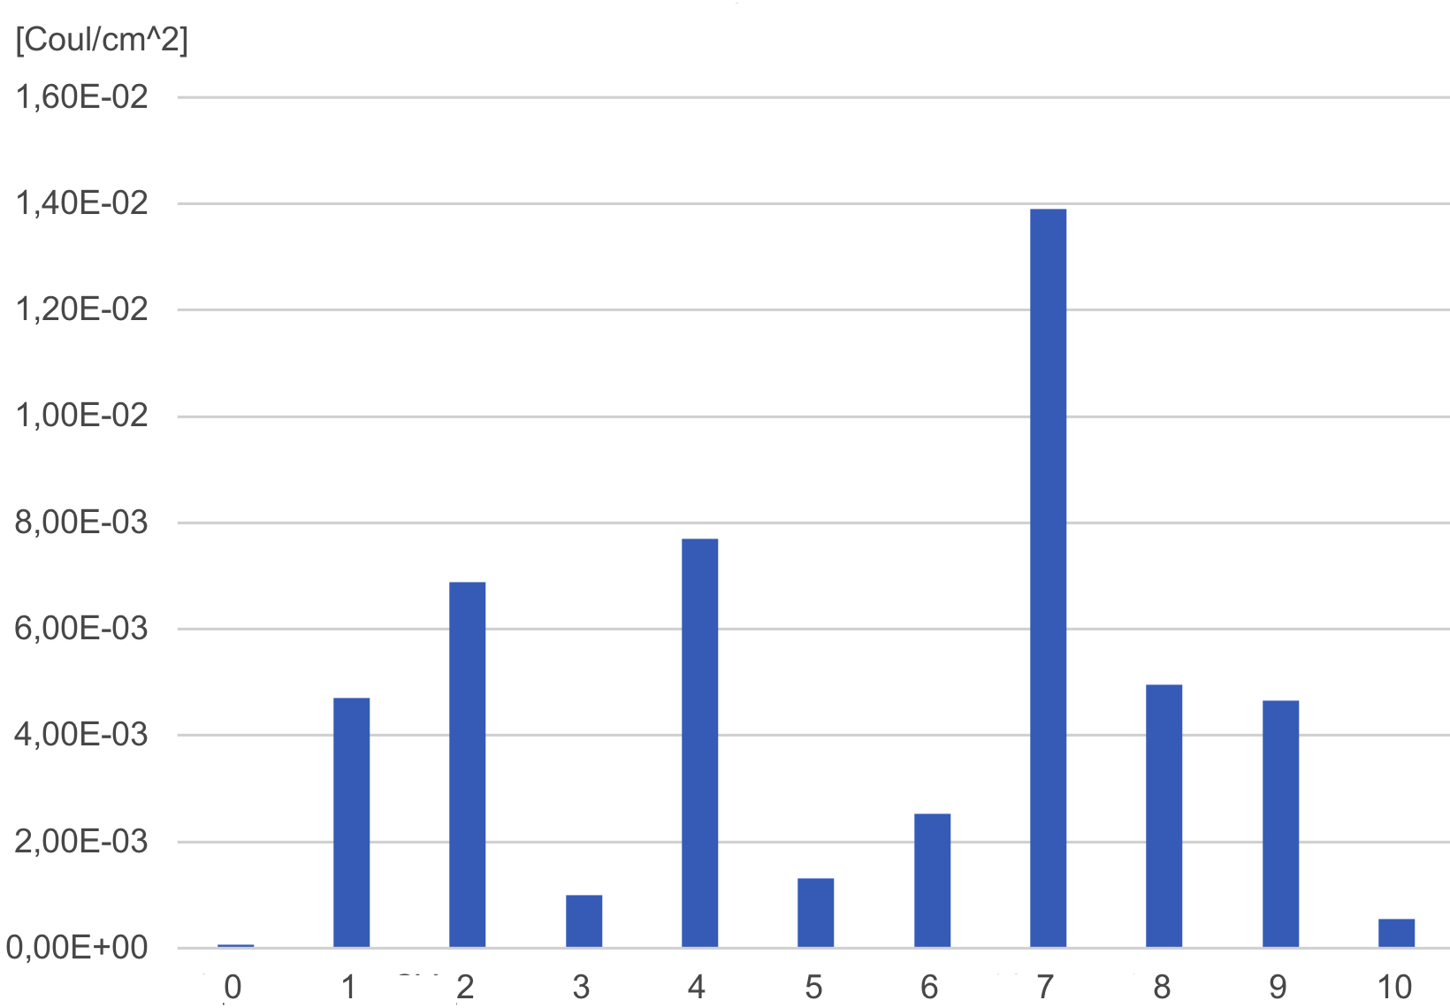
Preliminary results show that all samples have similar and positive values of OCP in the range between 0.2 and 0.35 V. Total charge calculated from voltammograms is reported in Figure 2. The best value is found for sample 7 (greater number of depositions), followed by sample 4 (lower speed of deosition). The worst results are recorded in samples 3 (higher speeds), sample 5 (lower number of depositions) and sample 10 (most diluted solution). The accelerated life tests to evaluate the electrodes durability are still in progress.
4. Conclusions Figure 2. Q* values for the samples
We prepared several types of RuOx thin films by spin-coating. Cyclic voltammograms indicate that the total charge (Q*) increases with increasing thickness and homogeneity of the obtained film. Moreover, the electrochemical performances of electrodes obtained from aged solutions are better than the corresponding electrodes obtained with freshly prepared solutions.

References
- S. Stucki, R. Kotz, B. Carcer, W. Suter, J. Appl. Electrochem. 21 (1991)
- G.R.P. Malpass, R.S. Neves, A.J. Motheo Electrochimica Acta 52 (2006)
- S.Trasatti, Electrochemistry of Novel Materials, Frontiers of Electrochemistry, VCH, 1994
- E. Petrucci, D. Montanaro, M. Orsini, G. Sotgiu, J. Electroanal. Chem. 808 (2018) 380.
- G. Sotgiu, D. Montanaro, M. Orsini, E. Petrucci, Chem. Eng. Trans. 57 (2017) 1639.

