Synergistic interaction of co-encapsulated Saccharomyces cerevisiae and Metarhizium brunneum used for biological pest control
Katharina Hermann¹², Pascal Humbert¹, Anant Patel¹
1 Bielefeld University of Applied Sciences, WG Fermentation and Formulation of Biologicals and Chemicals, Faculty of Engineering Sciences and Mathematics, Interaktion 1, 33619 Bielefeld, Germany; 2 Bielefeld University, WG Multiscale Bioengineering, Technical faculty, Universitätsstraße 25, 33615 Bielefeld, Germany
*Corresponding author: khermann1@fh-bielefeld.de
Highlights
- Calcium alginate-based formulation acts as microfermenter for the entomopathogenic fungus M. brunneum
- Co-encapsulation of S. cerevisiae improves sporulation of M. brunneum
- Co-encapsulation of S. cerevisiae and M. brunneum leads to steep oxygen gradients in alginate beads as revealed by microelectrode measurement

1. Introduction
In the last few years wireworm damage has become an increasing problem in both conventional and organic potato cultivation. Wireworms are polyphagous soil dwelling larvae of click beetles (Agriotes spp.) and even low populations lead to severe economic losses since they can live up to five years in soil. Wireworms use CO₂ gradients established in soil by plant roots to locate potential hosts. However, effective plant protection products are currently not available since chemical insecticides have recently been restricted or abandoned. Consequently there is a tremendous need for alternative biological control options. In previous work, a biological bead formulation for wireworm control was developed, based on an attract-and-kill approach that exploits the insect’s behavior [1-4]. The calcium alginate beads contain both Saccharomyces cerevisiae that produce CO₂ as an attractant and the entomopathogenic fungus Metarhizium brunneum Cb15 III acting as the kill component. Additionally, a nutrient supply is added. When the beads are placed in soil, they absorb its moisture, thereby initiating the CO₂ production process as well as the growth of fungus out of the beads. Virulent aerial conidia are formed on the bead’s surface. Therefore the co-formulation represents a “microfermenter” [5] that needs to be investigated in more detail. Co-cultivation can alter cell growth [6] and, moreover, lead to morphological and physiological changes possibly resulting in attenuated virulence induced by contact-dependent interaction [7]. Hence, the main objective was to investigate the synergistic interaction of Saccharomyces cerevisiae and Metarhizium brunneum inside the bead.
2. Methods
M. brunneum was grown in submerged culture for 48 h at 25 °C and 150 rpm in shaking flasks with baffles. Mycelial biomass and blastospores were separated by vacuum filtration.
The encapsulation suspension was prepared by mixing sodium alginate and sterile native corn starch. Then, S. cerevisiae and M. brunneum biomass were added. For bead formation, the suspension was dripped into a sterile CaCl₂ solution. Diameter of beads was 4-5 mm. Subsequently, beads were dried, resulting in a bead diameter of 3 mm.
Formed aerial conidia were rinsed off from the bead surface with a 0,1% Tween 80 solution and conidial concentrations were determined by counting conidia with a Thoma cell counting chamber
Microelectrodes (Unisense, Denmark) with a diameter of 50 µm were used measuring oxygen-, pH- and temperature gradients. For this, beads were fixed, and microelectrodes inserted stepwise (100 µm) into the beads with a manual micromanipulator.
3. Results and discussion
We found that co-encapsulation of S. cerevisiae enhanced the sporulation of M. brunneum from the beads significantly (Figure 1), probably serving as nitrogen source, since they consist of 80% nitrogen.
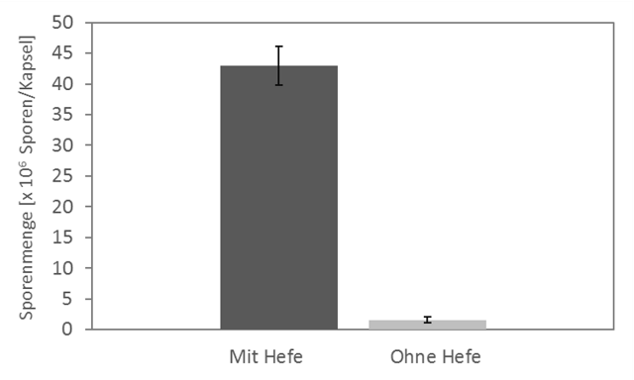
Aerial conidia [x10⁶ / bead]
b
a
without S. cerevisiae
with S. cerevisiae

Figure 1: Sporulation of M. brunneum on alginate beads with and without S. cerevisiae. Different letters above bars indicate significant differences based on t-test at p < 0.05 (means ± SD, n = 4).
Further analysis revealed steep oxygen gradients when S. cerevisiae is added to the formulation (Figure 2), indicating oxygen limitations in the center. Diffusion limitation in alginate beads can limit cell growth and lead to metabolic changes [8, 9]
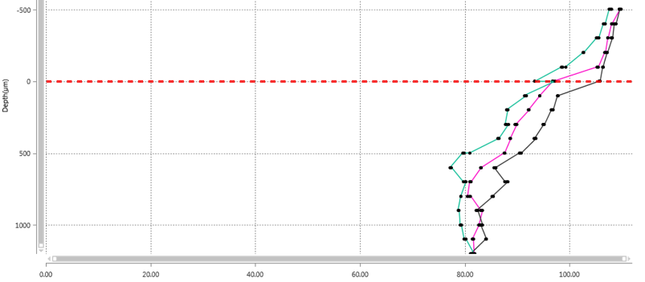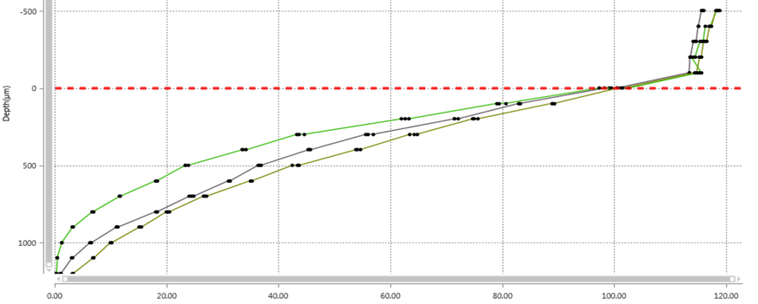
Figure 2: Oxygen gradients in alginate beads loaded with starch and M. brunneum (top) and with starch, M. brunneum and S. cerevisiae (bottom). Abscissa in mV. Red dotted line indicates bead surface.
4. Conclusions
Preliminary results indicate a biological impact of co-encapsulation on fungal development, especially sporulation. A novel method for bead analysis was established in order to examine the physicochemical and biochemical processes. Future work will focus on small-scale submerged co-cultivation (BioLector Pro).
The influence of oxygen limitations will be examined and circumvented by reducing both bead diameter and cell concentration in order to improve efficacy.
References

[1] Humbert, P., Vemmer, M., Giampa, M., Bednarz, H., Niehaus, K., & Patel, A. V. (2017). Co-encapsulation of amyloglucosidase with starch and Saccharomyces cerevisiae as basis for a long-lasting CO 2 release. World Journal of Microbiology and Biotechnology, 33(4), 71.
[2] Humbert, P., Przyklenk, M., Vemmer, M., & Patel, A. V. (2017). Calcium gluconate as cross-linker improves survival and shelf life of encapsulated and dried Metarhizium brunneum and Saccharomyces cerevisiae for the application as biological control agents. Journal of microencapsulation, 34(1), 47-56.
[3] Schumann, M., Patel, A., Vemmer, M., & Vidal, S. (2014). The role of carbon dioxide as an orientation cue for western corn rootworm larvae within the maize root system: implications for an attract‐and‐kill approach. Pest management science, 70(4), 642-650.
[4] Schumann, M., Patel, A., & Vidal, S. (2013). Evaluation of an attract and kill strategy for western corn rootworm larvae. Applied soil ecology, 64, 178-189.
[5] Przyklenk, M., Vemmer, M., Hanitzsch, M., & Patel, A. (2017). A bioencapsulation and drying method increases shelf life and efficacy of Metarhizium brunneum conidia. Journal of microencapsulation, 34(5), 498-512.
[6] Ström, K., Schnürer, J., & Melin, P. (2005). Co-cultivation of antifungal Lactobacillus plantarum MiLAB 393 and Aspergillus nidulans, evaluation of effects on fungal growth and protein expression. FEMS Microbiology Letters, 246(1), 119-124.
[7] Bor, Batbileg et al. “Morphological and physiological changes induced by contact-dependent interaction between Candida albicans and Fusobacterium nucleatum.” Scientific reports vol. 6 27956. 14 Jun. 2016,
[8] Irrgang, S., Baumgärtl, H., Schlosser, D., Zimelka, W., & Schmauder, H. P. (1993). Investigations of the oxygen supply in Ca‐alginate beads and microcapsules loaded with Penicillium raistrickii using a microelectrode. Journal of basic microbiology, 33(5), 311-321.
[9] Ogbonna, J. C., Matsumura, M., & Kataoka, H. (1991). Effective oxygenation of immobilized cells through reduction in bead diameters: a review. Process biochemistry, 26(2), 109-121.

