Effect of Hofmeister series ions on BSA and DNA adsorption on salt-tolerant interaction chromatography (STIC) membrane
Tomáš Kurák, Milan Polakovič*
Department of Chemical and Biochemical Engineering, Institute of Chemical and Environmental Engineering, Faculty of Chemical and Food Technology, Slovak University of Technology, Radlinského 9, 81237 Bratislava, Slovakia
*Corresponding author: milan.polakovic@stuba.sk
Highlights
- Single- and bi-component adsorption of BSA and DNA was studied.
- Salt type and concentration has significant effect on binding capacity on salt tolerant membrane
- DNA adsorption on STIC had similar behavior to that of multimodal adsorbents

1. Introduction
Most mAb purification processes include at least one ion exchange chromatography step. Salt tolerant adsorbents are novel materials which are a useful complement to conventional ion exchangers and hydrophobic resins. They maintain binding capacity even in higher salt concentration. This leads to a reduction in the number of operations in downstream separation train. Moreover this opens space for seeking good selectivity in wider salt concentration range.
2. Methods
Model macromolecules used in adsorption experiments were BSA and salmon DNA. Thermodynamics of protein binding was studied for single-component solutions of BSA or DNA and their binary mixture. Experiments were carried out using 96 well plates filled with Sartobind STIC membrane adsorbent. Loading solutions passed through membrane in the well by centrifugal force or a single well was used as a membrane module using the FPLC system ÄKTA (GE Healthcare, Uppsala, Sweden). Four different buffers (phosphate, tris, bis tris, bis tris propane) were chosen to examine effect of pH on protein binding. The influence of salt type and ionic strength was examined for a spectrum of anions (SO42-, HPO42-, Cl-, SCN-,F-) and cations (NH4+, Na+, Mg2+, K+)
3. Results and discussion
Firstly, the influence of pH and buffer type was examined. It was shown that pH affects the binding capacity of both BSA and DNA similarly as in case of conventional anion exchangers. It was however observed that the buffers containing polyvalent salt inhibited strongly binding of BSA but they enhanced adsorption of DNA. Secondly, the influence of salt type and ionic strength on the binding capacity was examined for several anions and cations. The selected ions span the whole Hofmeister series so salts with both chaotropic or kosmotropic effects were investigated here. Chaotropic salts decreased BSA binding capacity with increasing ionic strength but not as rapidly as polyvalent kosmotropic salts (Fig. 1). On the other hand, increasing salt concentration, even of polyvalent salts, had different effect on DNA adsorption. Binding capacity had a maximum at certain salt concentration. The observed effect can have more general implications for the application of multimodal adsorbents in protein purification. This behaviour can be used to optimize separation conditions (e.g. salt concentration, buffer system and pH).
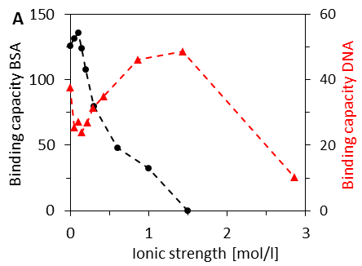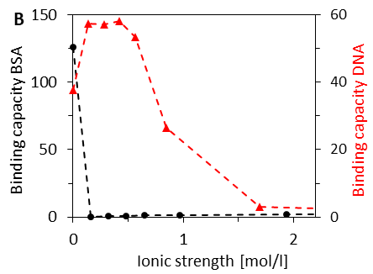
Figure 1. Influence of ionic strength on BSA and DNA binding capacity in the presence of (A) NaCl (B) Na2SO4
4. Conclusions
This work helps to clarify the effect of the composition of the mobile phase on the adsorption of single and bi-component solutions on the salt tolerant membrane adsorbent. The results of the influence of buffer and salt types, pH, and ionic strength on the adsorption equilibrium of BSA and salmon DNA on the Sartobind STIC membrane contribute to understanding of process performance and optimal design of chromatographic separation processes.
5. Acknowledgements
This work was supported by the grant from the Slovak Research and Development Agency (Grant number: APVV-16-0111).

