Tolerance Improvement of Xylose-Utilizing Yeast Strains on Acetic Acid by Evolutionary Engineering.
Ja Kyong Ko¹, Soo Rin Kim², Youngsoon Um¹, Sun-Mi Lee^{1,*}
¹ Clean Energy Research Center, Korea Institute of Science and Technology (KIST), Wharang-ro 14 gil 5, Seongbuk-gu, Seoul 136-91, Republic of Korea; ² School of Food Science and Biotechnology, Kyungpook National University, Daegu, Republic of Korea
*Corresponding author: smlee@kist.re.kr
Highlights
- Acetic acid derived from biomass severely inhibits xylose fermentation of yeast.
- Evolutionary engineering strategy was applied to improve acetic acid tolerance.
- Evolved yeasts could serve as platform strains for biofuel production from biomass.

1. Introduction
The presence of inhibitors in the lignocellulosic biomass hydrolysates are inevitable bottlenecks for achieving economic cellulosic ethanol production by Saccharomyces cerevisiae. The yeast tolerance toward acetic acid, released during the pretreatment of lignocellulose, needs to be improved for the efficient fermentation of un-detoxified biomass hydrolysates. Specifically, acetic acid stress is more severe on xylose fermentation resulting in decreased cell growth, xylose utilization rate and ethanol yield than glucose fermentation. In this study, an evolutionary engineering strategy was applied to improve fermentation performance of the engineered xylose-utilizing yeasts under acetic acid stress.
2. Methods
We attempted to evolve the two engineered strains harboring xylose isomerase (XUS-E) [1] and oxidoreductase (DY4)-based pathways using serial sub-culturing in synthetic medium with xylose as a sole carbon source in the presence of acetic acid at pH 5. After 13 rounds of exponential phase transfer, the evolved strains, XUS-AE57 and DY4-AE1, were obtained. Transcriptomic characterization of evolved strains through RNA sequencing was performed using tools from Ebiogen, Inc. (Seoul, Republic of Korea).
3. Results and discussion
The evolved strain, XUS-AE57, with xylose isomerase pathway could efficiently convert xylose to ethanol with yields of 0.43-0.47 g ethanol/g xylose even in the presence of 2-5 g/L acetic acid (Figure 1). This strategy not only achieved ~1.7 fold higher level of ethanol yields, but also improved xylose utilization rate by >2 folds. For DY4AE1 harboring an oxidoreductase pathway, the xylose utilization rate was significantly enhanced by ~2.3 fold. To understand the molecular mechanisms underlying the improvement in the acetic acid tolerant phenotypes, the global transcript profiles of the evolved strains grown under acetic acid stress were analyzed by using RNA sequencing.
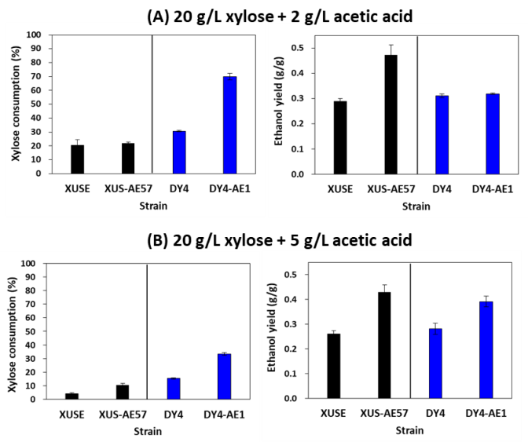
Figure 1. Xylose fermentation performance of the control (XUSE and DY4) and evolved strains (XUSAE57 and DY4AE1) under 2 and 5 g/L acetic acid stress.

4. Conclusions
XUSAE57 and DY41 strains could serve as robust platform strains of Saccharomyces cerevisiae for biofuels/biochemicals production from lignocellulosic biomass.

References
- J.K. Ko, Y. Um, S-M. Lee, Bioresour. Technol. 222 (2016) 422-430.
- P. Tran Nguyen Hoang, J.K. Ko, G. Gong, Y. Um, S-M. Lee, Biotechnol. Biofuels. 11 (2018) 268.

