A simulation study to evaluate the potential of semi-transparent solar panels coupled with a closed intensified photobioreactor
Julien Louveau¹, Jeremy Pruvost¹, Mariana Titica¹, Navid Moheimani²
1 University of Nantes, Oniris, CNRS, GEPEA, UMR 6144, 44602 Saint-Nazaire Cedex, France
2 Murdoch university WA 6150, Murdoch, Australia
*Corresponding author: Julien.louveau@eut.univ-nantes.fr
Highlights
- A model coupling semi-transparent solar panels and photobioreactors has been developed
- Synergies and trade-offs between biomass and electricity coproduction were analyzed

1. Introduction
In contrast with open ponds, closed photobioreactor (PBR) technology allows a tight process optimisation which leads to significant productivity enhancement. Nevertheless, when set outdoor (to benefit from natural sunlight), these PBRs are sensitive to climatic fluctuations. Ensuring optimal growth conditions becomes critical. This especially concerns the temperature as enclosed culture volumes tends to overheat [1]. Then, active temperature control could become prohibitive in terms of energy needs.
As microalgae only need a small portion of the solar light (the photosynthetic active range: PAR, [400 – 700] nm), removing the unnecessary light (infra-red: IR and ultra-violet: UV) could reduce the heating of the PBR. To filter the incoming light, the use of semi-transparent solar panels (PV) has been suggested by [2]. Those solar panels are able to capture and convert into electricity some specific radiations depending on their wavelength. Other radiations are transmitted and can be used for biological conversion. Coupling a PBR and a semi-transparent solar panel opens then the perspective to coproduce biomass and electricity while preventing the overheating of the PBR.
In this context, the work presented here has investigated, with a model-based approach, the impact of such coupling on PBR’s thermal behaviour, microalgae productivity and electricity production.
2. Methods
The investigation of this study has been done by numerical simulation. Three validated models from the literature were coupled to set a predictive model able to simulate PBR-PV associations. It aims to maximize biomass production while decreasing energy needs. A generic thermal model [1] was used to determine the thermal behaviour of the PBR and the amount of energy required for temperature control. The range of operating temperature was fixed to [15 – 34]°C which is considered suitable for microalgae growth without significant loss in productivity (Todisco et al,. 2019). Second, a microalgae growth model [3] was used to calculate the productivity of the culture in solar radiation conditions, considering light alone limits growth. Finally, an electricity production model [2] was used to compute the production of the solar panel. Different light filters (solar panels) have been tested. Numerical simulations have been performed considering a thin-film solar photobioreactor: AlgoFilm© (figure 1) [1]. The meteorological data used describes the average weather of a year for the city of Nantes. In all simulations, the input light was set in spectral form.
3. Results and discussion
Different simulation scenarios were performed, with a view to analyse synergies and trade-offs between biomass and electricity coproduction. An example of results is presented in Figure 2.
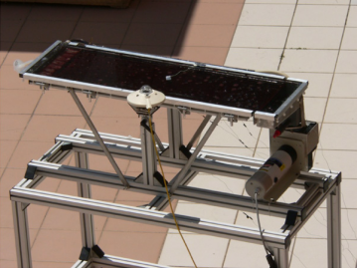  figure 1: The thin-film solar photobioreactor [1] | 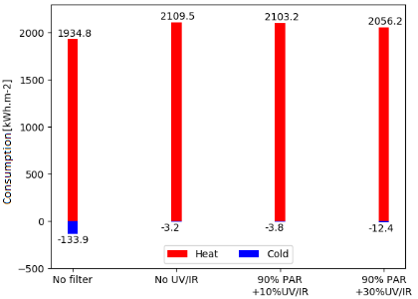  figure 2: Cumulated energy consumption
The simulation study revealed that the use of semi-transparent solar panels allows a significant reduction in PBR’s cooling needs. However, it also results in an important raise in heat needs. In winter, with the tested weather, the nights can be as cool as 0°C, thus keeping the reactor at the lower set point requires a large amount of energy (figure. 2). This is particularly true for the considered reactor which has been designed to prevent overheat (large contact area with the ambient air for a small volume). Thus, adding a solar panel was found detrimental for the winter period. Those results points out the necessity to find a compromise. For example, passive cooling and electricity production are increased by reducing the PAR transmitted to the culture. This was found to have a major impact on the reactor heating. It however reduces the biomass productivity (10% to 40% loss). Our model was found useful to obtain input data for a techno-economic analysis which would help to define an association strategy of such a promising hybrid system.
4. Conclusions
An integrated model was developed to simulate PBR-PV association, for the optimal design of a hybrid solar PBR maximizing biomass production while decreasing energy needs. This study showed that the use of semi-transparent solar panels significantly reduced the overheating of our solar PBR. It could however induce negative effects, such as the increase in heating need during the night. Predictions were found useful to determine the best compromise in terms of biomass and electricity production, but also energy saving for thermal regulation. Such a tool also enables to investigate other climates such as Australia where the monthly average temperature reaches 20°C. As the reactor could be warmer even in the night, this may be an interesting passive cooling solution for this location.
References
[1] V. Goetz, F. Le Borgne, J. Pruvost, G. Plantard, et J. Legrand, « A generic temperature model for solar photobioreactors », Chemical Engineering Journal, vol. 175, p. 443‑449, nov. 2011.
[2] D. Parlevliet et N. Moheimani, « Efficient conversion of solar energy to biomass and electricity », Aquatic Biosystems, vol. 10, no 1, p. 4, 2014.
[3] J. Pruvost, F. Le Borgne, A. Artu, J.-F. Cornet, et J. Legrand, « Industrial Photobioreactors and Scale-Up Concepts », in Advances in Chemical Engineering, vol. 48, Elsevier, 2016, p. 257‑310.

