CO₂ crossover in electrochemical CO₂ reduction cells suited for long-time operation at industrially relevant operating conditions
David Reinisch¹, Christian Reller¹, Bernhard Schmid², Nemanja Martic¹, Ralf Krause¹, Karl Mayrhofer³, Günter Schmid^{1*}
1 Siemens AG, Günter-Scharowsky-Straße 1, 91058 Erlangen, Germany; 2 Friedrich-Alexander University Erlangen-Nürnberg, Department of Chemistry and Pharmacy, Egerlandstr. 1, 91058 Erlangen, Germany;
3 Helmholtz Institute Erlangen-Nürnberg for Renewable Energy, Egerlandstr. 3, 91058 Erlangen, Germany
*Corresponding author: guenter.schmid@siemens.com

Highlights
- Electrochemical CO₂ reduction at 300 mA/cm² at Faradaic Efficiencies > 80%
- Stable operation for 7000+ hours
- Reduction of CO₂-crossover by more than 95%

1. Introduction
The electrochemical CO₂ reduction allows to create valuable products from “waste” CO₂ coming from industrial processes, and cheap, renewable energies. Among the different possible electrolysis products, CO is the most promising for industrial application in the near future and thus, has drawn a lot of interest. By now the technology has passed the fundamental catalytical research stage, and different setups have been reported that perform stable, at high faradaic efficiencies for over 1000 hours at industrially relevant current densities [1,2]. In order to keep up with the rapid industrial application plans [3], research is shifting from catalyst design to engineering the electrolysis process and to upscaling of the setups.
2. Methods
The electrochemical experiments were performed in a commercially available flow cell. The different gas streams were quantified, and their composition analyzed via gas chromatography.
3. Results and discussion
Among the stable systems published, the mixed-electrolyte approach detailed in [1] is especially suited for rapid scaling and industrial application, since it does not require expensive ion-selective membranes and is not based on novel, research-level materials. By improving the GDE and the overall system setup, the cell could be operated stably at more than 80% faradaic efficiency for 7000 hours at current densities of 300 mA/cm² (Figure 1).
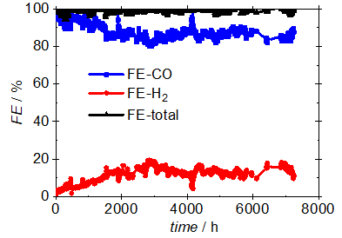
Figure 1. Faradaic efficiencies of a CO₂-electolysis cell operating stably for over 7000 hours
As the technology moves towards industrial application, the transport of CO₂ across the cell becomes an important issue, that has been mostly neglected so far. Due to the formation and neutralization of carbonates, this transport is intrinsic to CO₂ electrolysis and needs to be dealt with [1,2,4]. Here different approaches to minimize the CO₂ transport across the electrolysis cell are introduced, discussed and tested. All methods keep the advantages of a mixed-electrolyte system and work with the previously tested cathodes. By implementing these methods, the CO₂ transport could be reduced by over 95% (Figure 2).
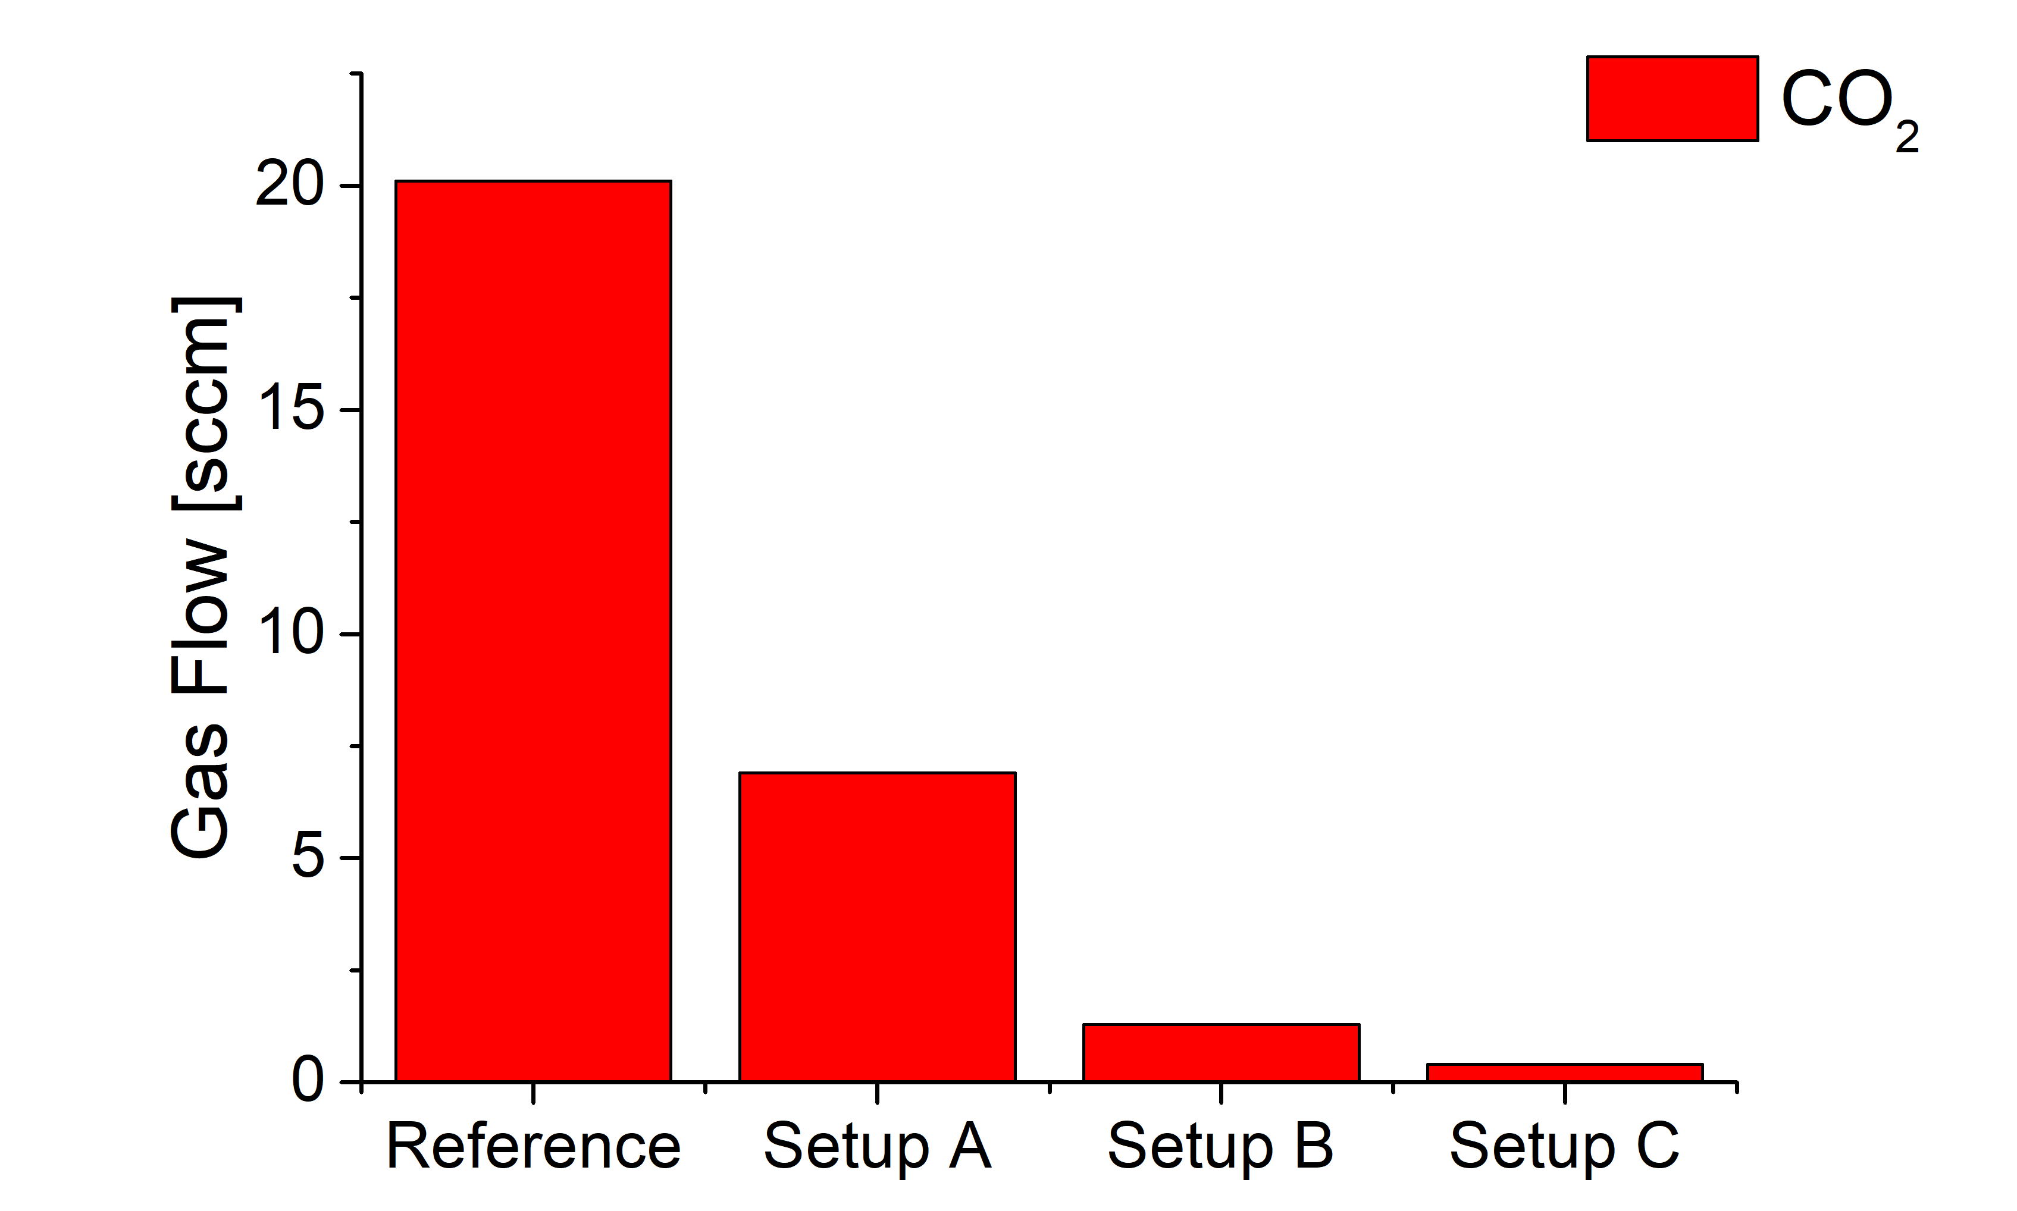
Figure 2. CO₂ content in the anode gas for different setups. Compared to the standard, reference case, the crossover could be reduced by more than 95%.
4. Conclusions
CO₂ electrolysis cells with liquid electrolytes are a viable candidate for near-time industrial application. As in all current approaches, the CO₂ transport across the cell needs to be accounted for and solving this problem is crucial for a successful industrial implementation of this process. The results here show, that an adequate design of the electrolysis setup can achieve this target while maintaining industrially relevant operating conditions without relying on ion-selective membranes.
References
- T. Haas, R. Krause, R. Weber, M. Demler, G. Schmid; Nat. Catal. 1 (2018) pp. 32-39
- J. Kaczur, H. Yang, Z. Liu, S. Sajjad, R. Masel; Front. Chem. 6 (2018) 263
- https://corporate.evonik.com/en/Pages/article.aspx?articleId=106259
- A. Pătru, T. Binninger, B. Pribyl, T. Schmidt; J. Electrochem. Soc 166 (2019) F34-F43

