Biotechnological recycling of platinum group metals and gold from post-consumer products
Yasuhiro Konishi*, Norizoh Saitoh, Toshiyuki Nomura
Department of Chemical Engineering, Osaka Prefecture University
1-1, Gakuen-cho, Naka-ku, Sakai, Osaka 599-8531, Japan
*Corresponding author: yasuhiro@chemeng.osakafu-u.ac.jp
Highlights
- The use of Shewanella bacteria and baker's yeast to recover precious metals.
- Bioreductive deposition of PGMs from the leachate of spent catalysts at pH 6.
- Selective and efficient biosorption of Au from the CPUs leachate at pH 1.
- New biotechnologies to extract PGMs and gold from post-consumer products.

1. Introduction
Many post-consumer products, such as electronic goods and catalytic converters in cars, are important sources of precious and rare metals. Although conventional thermal and chemical techniques remain the best methods for recycling precious and rare metals, these metals have yet to be fully utilized. Therefore, further research and development is needed to fully recycle precious and rare metals from secondary sources. We believe that biological technologies now provide an attractive and eco-friendly alternative strategy. This paper describes our research results from using new biotechnologies to fully recycle platinum group metals (PGMs) from spent automotive catalysts and gold from electronic waste.
2. Results and discussion
We focused on using the metal ion-reducing bacterium, Shewanella algae, to recover PGMs from the aqua regia leachate of spent automotive catalysts (Figure 1). The Shewanella bacteria were able to reduce PGMs ions (Pd(II), Pt(IV) and Rh(III)) in the catalyst leachate as metallic nanoparticles on the bacterial cells at room temperature and pH 6 within 60 min, using formate as the electron donor.
We also employed baker's yeast, Saccharomyces cerevisiae, as a commercially available biomaterial for collecting gold ions from the aqua regia leachate of spent central processing units (CPUs) from electronic waste (Figure 2). The baker's yeast was able to rapidly and effectively collect only gold ions from the CPUs leachate at pH 1 within 10 min. Importantly, baker's yeast did not react with other heavy metal ions, such as copper, nickel, and iron.
This flow diagram compares the conventional wet chemical process with our new bioprocess for recycling PGMs and gold (Figure 3). Our new bioprocess integrates a complex multistep method into a single-step procedure that separates and concentrates the precious metal from a leaching solution. Unlike conventional processes, the benefits of this process include a significant reduction in energy consumption and material consumption, and a low environmental impact.
Our highly efficient bioprocess could be introduced at local collection points for post-consumer products and operate as a regionally distributed technology for fully recycling metal resources from post-consumer products, which will lead to the sustainable use of precious metals.
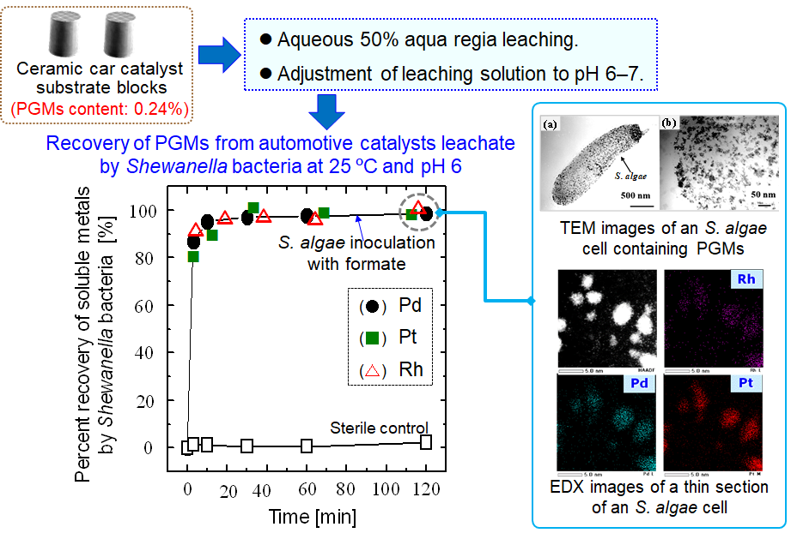

Figure 1. Microbial recovery of platinum group metals (PGMs) from aqua regia leachate of spent automotive catalysts.
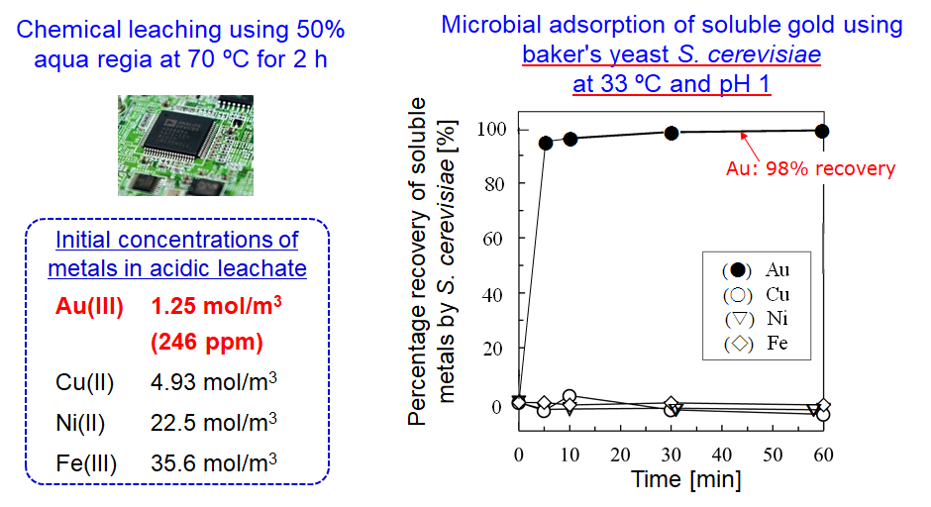

Figure 2. Selective recovery of gold in aqua regia leachate of CPUs at pH 1, 33°C, and 16 kg-dry yeast/m³.
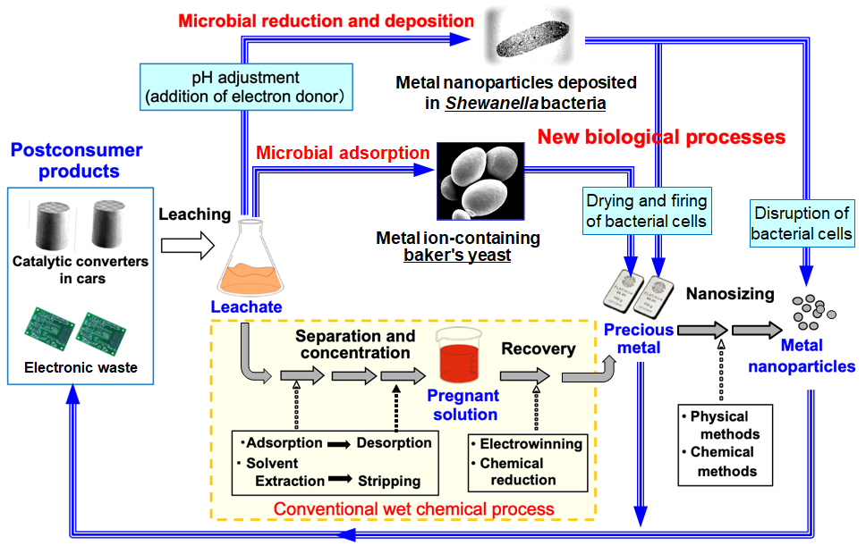

Figure 3. Sustainable use of platinum group metals and gold through biotechnological recycling.
3. Conclusions
We successfully developed new biotechnologies to extract PGMs from spent automotive catalysts and gold from electronic waste.

