Fluid dynamics of stirred photobioreactor cuvette
Tomáš Juřena*, Jiří Hájek, Jiří Vondál
¹Institute of Process Engineering, Faculty of Mechanical Engineering, Brno University of Technology, Technická 2, 616 69 Brno, Czech Republic
*Corresponding author: jurena@fme.vutbr.cz
Highlights
- Modelling approach for bioreactors is described
- Methods of data analysis from CFD models are critically assessed
- Results of fluid dynamics simulation in a mixed, bubbled cuvette are given

1. Introduction
The modeling of bioreactors is a broad sense multi-disciplinary, as it involves fluid dynamics, multiphase flow and mass transfer, radiative energy transfer, and also the growth of the living cells [1]. The complex modelling is however only just emerging [2] and there are many questions that can be answered by simpler models that do not include a complex description of a photobioreactor, only some of the relevant processes [3]. Assessment of parameters connected to mixing and flow pattern can be safely assumed independent of the light intensity and growth dynamics of microalgae.
The modelling of fluid dynamics in a stirred vessel may be performed by any of several approaches, which differ by their inherent assumptions, limitations and answers that they can provide. In the case of a stirred laboratory photobioreactor, its typical structural components include rectangular glass walls, a magnetic stirbar, several sensors (e.g. thermometer, CO₂ probe) and aerator tube. The fluid dynamical system is then composed of three main components, namely the medium, the algae and bubbles. Physical characterization of all the three components is relatively simple.
The purpose of this contribution is comprehensive characterization of the fluid dynamics in a typical laboratory cuvette using computational fluid dynamics (CFD). Model properties, components and numerical performance are critically assessed as well.
2. Methods
The modelling is based on Euler-Lagrange approach, where bubbles and/or algae are tracked in Lagrangian framework, while the medium is described in Eulerian framework as a Newtonian liquid. Governing equations are discretized and solved by the finite volume method.
For all intents and purposes related to fluid dynamics, the medium is water. In this work, we use fresh water, without loss of generality. The cuvette is a standard laboratory equipment, in our case with a volume of about 400mL. The algae exist in a wide variety of species and strains, but for the purpose of fluid dynamics we need to distinguish them only by size and shape. In this work, we focus on microalgae that are coccoid in shape and their size (diameter) is around 2.5μm. The characterization of bubbles is slightly more difficult, as a bubble may change its shape and even size. The size change is caused either by shedding small bubbles from large ones or by merging (coalescence).
Special care is given to mesh quality and independence of the results on the mesh is documented. The results are reported with focus on choosing the best available parameters that characterize the fluid dynamics meaningfully with respect to the purpose of the photobioreactor. Scalar indicators are sought to provide a global perspective of the system. Local indicators are used sparingly.
3. Results and discussion
The results cover fluid dynamics model development for the specific case of a cuvette equipped with a stirbar, aerator and two probes, as illustrated In Figure 1. Results also include analysis of fluid flow properties in several studied scenarios with different stirbar rotation velocities.
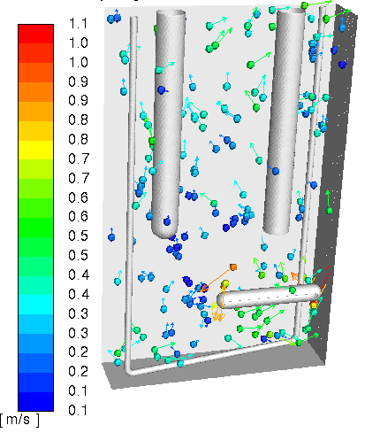
Figure 1. Bubbles colored by their velocity, also shown are their velocity vectors
4. Conclusions
Modelling methodology for fluid dynamics in a photobioreactor including mesh properties has been developed. Suitable indicators and statistics have been defined to characterize the operating conditions.
References
[1] D. Fuente, C. Lizama, J.F. Urchueguía, J.A. Conejero, Journal of Quantitative Spectroscopy and Radiative Transfer 204 (2018) 23–26.
[2] J. Cheng, W. Guo, Y. Song, S. Kumar, K. Ameer Ali, J. Zhou, Bioresource Technology 269 (2018) 1–8.
[3] J.C.M. Pires, M.C.M. Alvim-Ferraz, F.G. Martins, Renewable and Sustainable Energy Reviews 79 (2017) 248–254.

