Synthesis of graphene oxide - gelatin aerogels and their evaluation as hemostatic agent
Katherina Fernández¹, Jessica Borges¹, Sebastián Guajardo¹, Claudio Aguayo²

¹ Biomaterials Laboratory, Department of Chemical Engineering, Faculty of Engineering, University of Concepción, Concepción, Chile.
² Department of Pharmacy, Faculty of Pharmacy, University of Concepción, Concepción, Chile.
*Corresponding author: kfernandeze@udec.cl
Highlights
- GO-G aerogels were synthetized by microwave assited reaction
- The aerogels have a high blood absorption capacity (over 70%)
- The blood cells were retained by aerogels

1. Introduction
Actually, the developing of science and nanotechnology has allowed the synthesis of new materials with biomedical applications. Among them, the graphene and its oxidated forms, such as graphene oxide (GO), have been used in this area for their biological, chemical, physical and mechanical properties [1]. An important application of this material is to be functionalized with biocompatible polymers, as gelatin (G),to obtainGO-G aerogels.These aerogels are materials that present low density, high surface area,and porous structures [2]. Based in this properties, it is possible use them in the biomedical field,as a hemostatic agent, in the control of profuse bleeding generated in wounds. The aim of this study was synthesized GO-G aerogels by microwave assisted reaction, to evaluate their surface properties and hemostatic performance, in order to validate its use as a hemostatic agent.
2. Methods
The GO-G aerogels were developed to different synthesis conditions (pH and GO-G ratio) [1], to analyze the influence of these factors on the physicochemical properties of the biomaterials synthesized. Subsequently, the capacity absorption of the synthesized aerogels on phosphate-buffered saline (PBS) was determined, simulating of pH wound conditions. The internal structure of the synthesized aerogels was evaluated by scanning electron microscope (SEM), to observe the blood cell adhesion to the structure of these materials. Also, a droplet of fresh blood was dropped onto the GO-G aerogels surface at different exposure times (30 to 240 seconds) to evaluate the process of blood absorption. Finally, the blood absorption capacity assays and in vitro dynamic whole-blood clotting by absorbance determination were developed [3] using 50 microliters of fresh blood to conditions similar to the previous ones, was carried out to evaluate the hemostatic performance of these aerogels.
3. Results and discussion
Among the developed aerogels, those synthesized at basic conditions and a greater proportion of gelatin had the higher PBS absorption capacity (up to 65%), indicating that these materials could have a better interaction with external media such as blood. Also, the SEM images showed that there was an adhesion of red blood cells in the materials synthesized (see Figure 1) and this phenomenon increased proportional to the content of GO in the aerogels synthesized, as seen in the Figure 1b); regardless of pH conditions used in the synthesis. This phenomenon can explain due the interactions between GO and blood components, favoring the hemostatic performance of these aerogels. Finally, all the synthesized aerogels, had blood absorption capacities higher tan 70%, in a maximum time of 240 seconds, which can favor the control of profuse bleeding and validate that use as possible hemostatic agent.

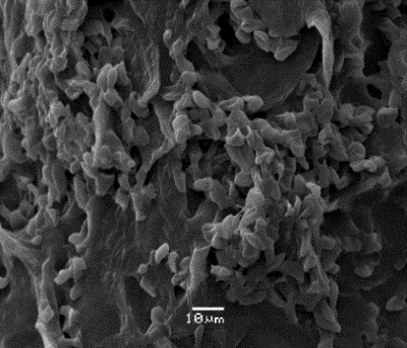
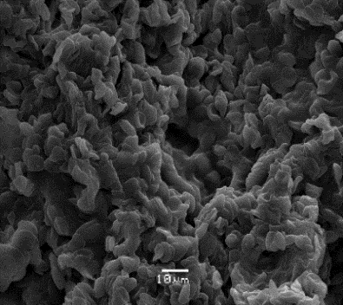
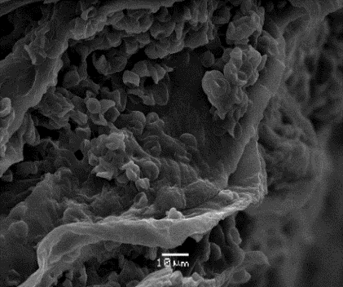
a)
c)
b)
Figure 1 SEM images a) GO-G aerogels at basic pH and 1:15 GO-G ratio, b) GO-G aerogels at acid pH and 1:10 GO-G ratio, c) GO-G aerogels at neutral pH and 2:25 GO-G ratio.
4. Conclusions
The studied showed the possibility of the use of GO-G aerogels as hemostatic agents according to the internal structure and blood absorption capacity reported.

References
[1] Chen, G., Qiao, C., Wang, Y., & Yao, J., Australian Journal of Chemistry, 2014, 67(10), 1532-1537.
[2] Ma, Y & Chen, Y., Natl Sci Rev, 2015, 2 (1), 40-53.
[3] Quan, K., Li, G., Yuan, Q & Wang X. Colloids and Surfaces B: Biointerfaces 132, 2015, 27-33.

