Predictive Direct Numerical Simulation of Peclet number in small fixed beds
Matthieu ROLLAND¹, Vittorio Petrazzuoli¹, Vasileios Sassanis¹, Vincent Ngu¹, Lionel Gamet¹
1 Process Intensification dept, IFP Energies Nouvelles, 69360 Solaize, France
*Corresponding author: matthieu.rolland@ifpen.fr
Highlights
- CFD workflow to compute Pe in small size fixed beds using DEM and OpenFOAM
- Accurate prediction of Pe numbers using first two moments of age distribution
- Local Pe depends on local structural features
- CFD prediction allows to study small trends without experimental errors

1. Introduction
Over the decades, fixed bed reactors for catalyst testing have faced a reduction in size and now they commonly have diameters below 1 cm, the limit being the catalyst pellet size (~1-3 mm). The advantages of these reactors are numerous: less catalyst used, less amount of reactant used and of wastes produced, better temperature control, reduced safety risks and easier implementation of parallel reactor systems [1]. Those reactors were designed for catalyst screening, so that hydrodynamics was not really an issue as long as the ranking and uncertainty were correct. As those reactors produce a large amount of data, a new question arises: can we use those results to build models for catalyst performance prediction? This work aims at improving our understanding of the hydrodynamics of these small reactors using CFD tools.
2. Methods
The work is based on a workflow mimicking the real usage of fixed bed reactors. In a first step, we pack spherical particles in cylindrical reactors using a Discrete Element Method package (Grains3D [2], Figure 1). Then we compute the steady state hydrodynamics in those reactors using the simpleFoam solver (Figure 1) from the OpenFOAM suite [3] augmented with the simulation of the moments of age distribution [4]. The outputs of the simulation are the mass flux weighted averages of the first and second order moments of age in many cross-sections of the reactors. Using the classical formula, we then compute the Peclet number (Pe) for any sub-volume in the reactor as:
$$Pe=2 \frac{τ^{2}}{σ^{2}}=2\frac{(m_{1, outlet}^{}-m_{1, inlet}^{})}{\left(m_{2, outlet}^{}-m_{1, outlet}^{2}\right)-\left(m_{2, inlet}^{}-m_{1, inlet}^{2}\right)}$$
Simulations have carried out for a common cylindrical reactor of 7.75 mm diameter and 187 mm long packed with spheres of 2 to 7 mm in diameter. Two layers, with 3mm thickness each, and free of particles, have been added at the top and bottom sides of the packing, respectively, to facilitate the numerical simulation of flow conditions near the inlet and outlet regions.
3. Results and discussion
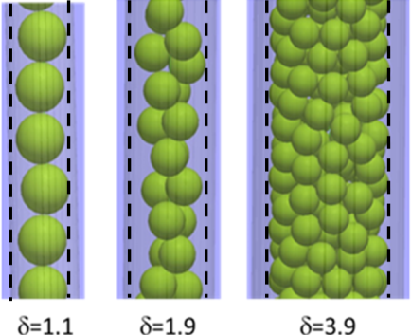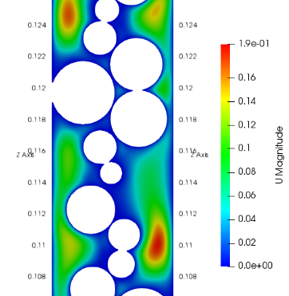
Figure 1: Left: Examples of packing, δ = D/d_{p}, - Right : Velocity magnitude in a reactor cut (d_{p} = 4 mm)
The CFD results match very well experimental data based on RTD [5] (Figure 2 - left). Local packing structures have a staircase impact on local Pe evolutions (Figure 2 - middle). The effect of molecular diffusion on Bodenstein number (Bo =Pe d_{p}/L) matches the literature [6] in the global shape and effect of Schmidt number (Figure 2 - right).
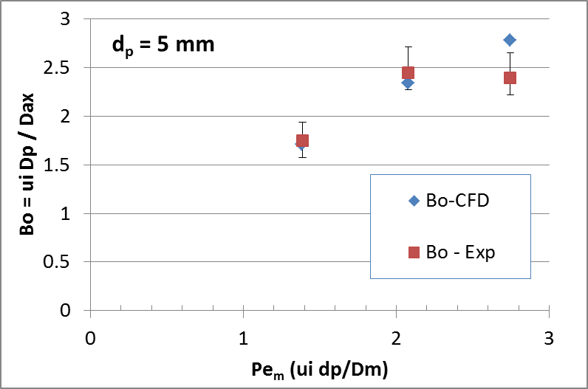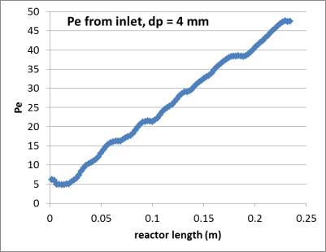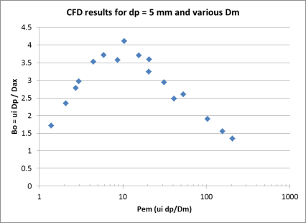
Figure 2: Left: Comparison experiments / CFD – Middle: plot of the evolution of Pe from inlet – Right: parametric study on velocity and molecular diffusion.
4. Conclusions
Our simulation workflow matches very well the experimental data and will be used to study precisely the effects of molecular diffusion, inlet velocity and reactor-to-particle diameter ratio on the plug flow behavior of fixed beds. We also plan to study the randomness effects on the results when the packings are repeated.
References
- Moulijn J., Pérez-Ramı́rez J., Berger R., Hamminga G., Mul G., Kapteijn F. (2003) High-throughput experimentation in catalyst testing and in kinetic studies for heterogeneous catalysis, Catalysis Today 81, 3, 457–471W.
- Wachs, A., Girolami, L., Vinay, G., & Ferrer, G. (2012). Grains3D, a flexible DEM approach for particles of arbitrary convex shape—Part I: Numerical model and validations. Powder Technology, 224, 374-389.
- Pozzobon, V., Colin, J., & Perré, P. (2018). Hydrodynamics of a packed bed of non-spherical polydisperse particles: A fully virtual approach validated by experiments. Chemical Engineering Journal, 354, 126-136.
- Liu, M., & Tilton, J. N. (2010). Spatial distributions of mean age and higher moments in steady continuous flows. AIChE journal, 56 (10), 2561-2572.
- Petrazzuoli, V., Rolland, M., Mekki Berrada, A., Schuurman, Y. (2019) Choosing the right packing in millimetric packed bed reactors, submitted at ECCE12.
- Delgado, J. M. P. Q. (2006). A critical review of dispersion in packed beds. Heat and mass transfer, 42(4), 279-310.

