Experimental Investigations on Dynamic co-Methanation of CO/CO₂ mixtures using Ni/Al₂O₃ Catalysts
Dominik Meyer¹, Jannik Schumacher¹, Jens Friedland¹, Robert Güttel¹
1 Institute of Chemical Engineering, Ulm University, Ulm, Germany
*Corresponding author: dominik.meyer@uni-ulm.de
Highlights
- Transient turn-over frequency calculated for unsteady-state co-methanation.
- Dynamic regimes in reactor behavior identified based on frequency response.
- Critical switching frequency identified for pseudo-steady-state behavior.
- Criterion deduced for tolerant operation under transient conditions.

1. Introduction
The increasing utilization of regenerative resources in the chemical value chain induces new challenges in the operation strategy of chemical reactors. As an example, the chemical storage of regenerative energy via the power-to-X process (PtX) provides an option to store fluctuating electrical energy via water electrolysis and subsequent hydrogenation of carbon oxides. The formed methane can be stored and transported in the existing gas grid. However, this scenario implies a dynamic behavior of the process chain, depending on the installed storage capacity. As the storage of large quantities of electrical energy and hydrogen is not yet feasible, the necessity of an unsteady-state operation of the methanation reactor becomes likely.
An interesting carbon source for PtX are industrial exhaust gases, such as coke oven gas, which consist of a mixture of CO and CO₂ [1], which can be subject to strong fluctuations in composition. For the steady-state case the co-methanation mechanism is widely investigated [2]. However, for the unsteady-state case only little is known, even though a profound understanding of the dynamic methanation of CO/CO₂ mixtures is essential for the implementation of the co-methanation in a sustainable energy scenario based on renewables. The present contribution will discuss the strong interrelation between the unsteady-state behavior of the reactor and the frequency of feed composition alteration for methanation on a Ni/Al₂O₃ catalyst. Based on experimental results, conclusions on the effect of the frequency on the underlying transport mechanisms will be drawn.
2. Methods
The experiments are performed in an isothermal packed-bed reactor (length 20 mm, diameter 2 mm) using a self-prepared Ni/Al₂O₃ catalysts (Ni loading 5 wt%, particle size 800 µm, 200 mg). Two gas lines with different compositions (line 1: 0.8 H₂/0.1 CO₂/0.1 He; line 2: 0.8 H₂/0.1 CO/0.1 Ar) are switched by means of a 4-way valve with a frequency between 0.0083 and 0.25 s⁻¹ and a split of 0.5. Both gas lines contain a different inert gas as internal standard for measuring the residence time behavior under reaction conditions. The effluent was analyzed by a mass spectrometer with sampling time of 0.5 s providing sufficient temporal resolution. Prior to dynamic experiments, the as-made catalyst was reduced and the catalytic behavior was studied under steady-state conditions for various feed compositions and in a temperature range of 260 to 310 °C and 2 bar. The dynamic experiments were then performed under the same conditions.
3. Results and discussion
Figure 1 shows selected results in the phase plane. The fraction of either reactants or products at the reactor outlet are displayed as a function of the internal standard, according to our previous work [3]. The deviation of the profiles from a linear function between the steady-state conditions allow to conclude on the inherent transient system behavior. For example, the negative deviation of the CO fraction from the linear correlation in the increasing branch (Figure 1 a), lower red curve) indicates either a stronger adsorption of CO at the Ni surface or a more pronounced conversion into methane compared to CO₂. Since the mass balance is fulfilled and a limit cycle is reached for several consecutive periods, the data can be evaluated quantitatively. In this regard, Figure 1 b) indicates an increase in methane productivity upon periodic operation, as indicated be the upward shift of the limit cycle compared to the expected steady-state system.
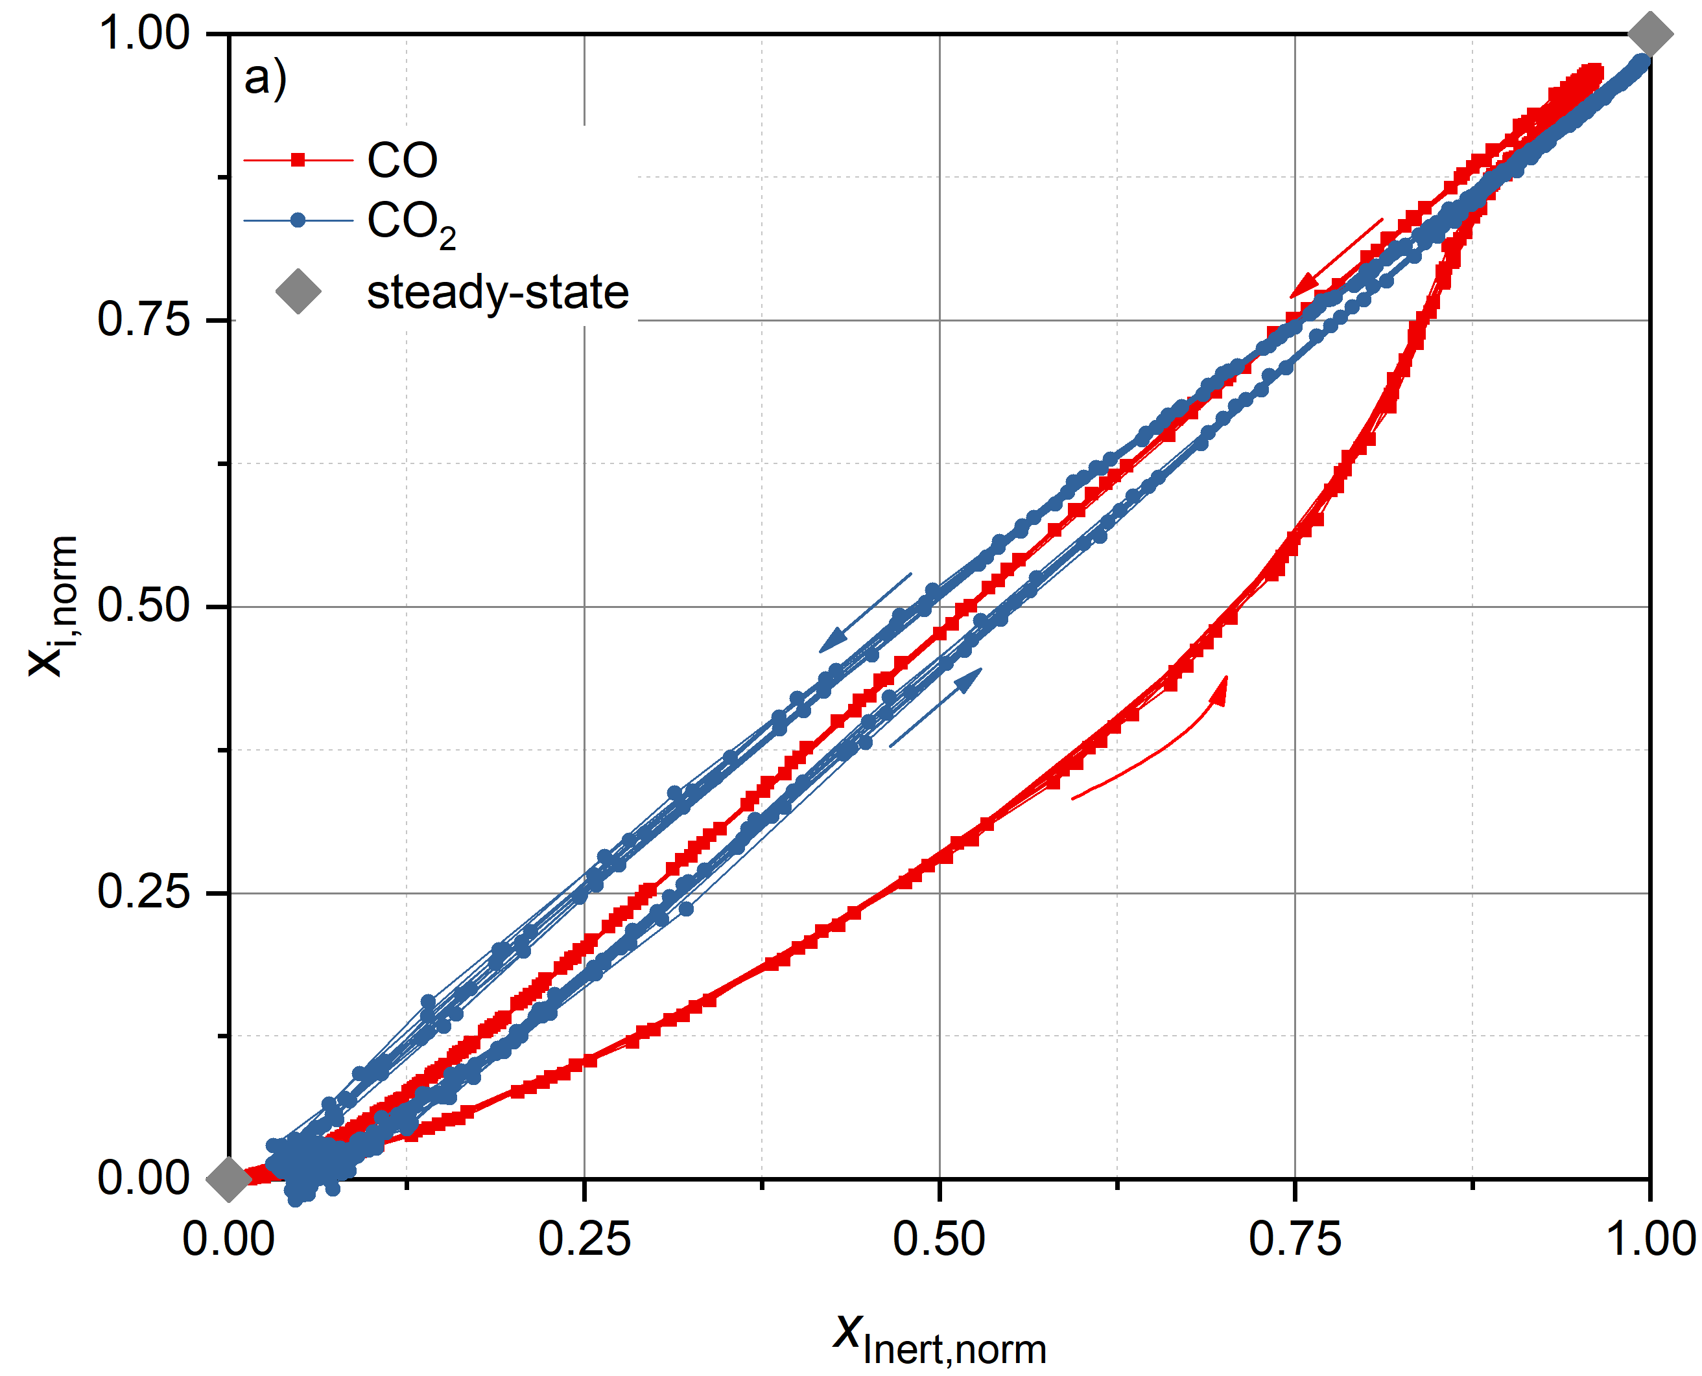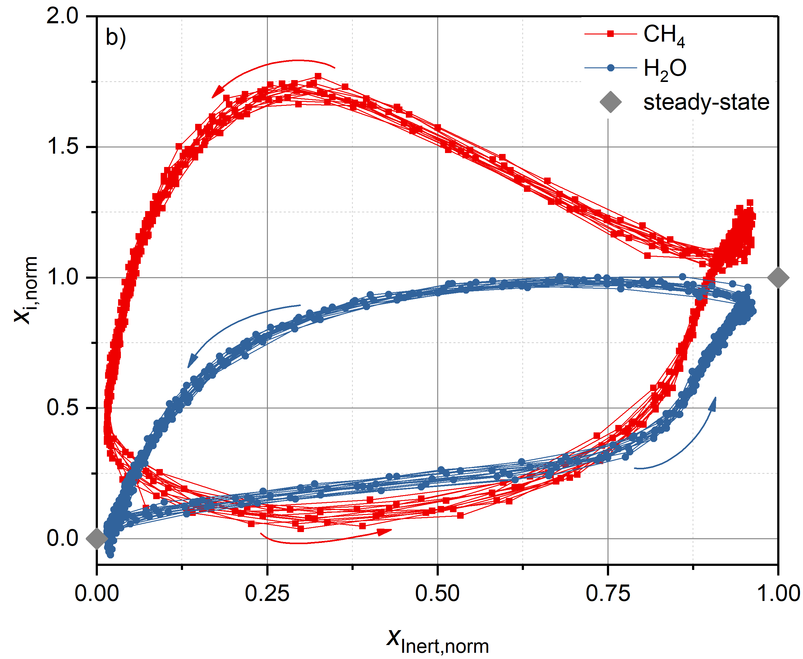
Figure 1. Limit cycle of the reactants (a) and products (b) in the phase-plane upon periodic exchange of CO with CO₂, period duration 30 s, T = 573 K, p = 2 bar, H₂/carbon source/inert = 8/1/1.
4. Conclusion
We present experimental results on the dynamics of the CO/CO₂ co-methanation on Ni-based catalysts. The different behavior of the reactive species indicates differences in interaction strength between those species and the active catalyst surface, which allows to deduce on the basic reaction mechanism. By quantitatively analyzing the dynamic change in the molar flow rate, we are able to determine a transient turn-over frequency (TOF) for methane formation and to compare it to the steady-state case value. Finally, we link the frequency response of each of the reactants to either the quasi steady-state, the full transient regime or the relaxed steady-state according to [4]. This provides to identify a tolerant operation window for fluctuating inlet compositions.

References
[1] M.A. Schöß, A. Redenius, T. Turek, R. Güttel, Chem. Ing. Techn. 86 (2014) 734–739.
[2] G.D. Weatherbee, C.H. Bartholomew, J. Catal. 77 (1982) 460–472.
[3] B. Kreitz, J. Friedland, R. Güttel, G. Wehinger, T.Turek, Chem. Ing. Techn. (2019) in press.
[4] D. Meyer, J. Friedland, T. Kohn, R. Güttel, Chem. Eng. Technol. 40 (2017) 2096–2103.

