Thermostable cellulase and xylanase activity from Sulfolobus shibatae of potential application in lignocellulosic bioethanol production
Angela Boyce, Gary Walsh*
Department of Chemical Sciences and Bernal Institute, School of Natural Sciences, University of Limerick, Limerick, Ireland.
*Corresponding author: gary.walsh@ul.ie
Highlights
- In xylan-containing media at 75°C, S. shibatae produces cellulase and xylanase.
- The crude enzymes display optimum activity at 100°C and are thermostable.
- The crude enzymes display activity on pretreated straw lignocellulose at 90°C.
- Potential application in hydrolysis of lignocellulose for bioethanol production.

1. Introduction
Enzymes produced by thermophilic microorganisms are of growing interest in industrial applications due to their activity and stability at high temperatures [1]. Amid environmental concerns in relation to the use of fossil fuels, one such industrial application is in the enzymatic hydrolysis of lignocellulosic biomass to produce bioethanol, which can be used as an alternative transportation fuel. The enzymatic hydrolysis of lignocellulose is currently undertaken at 40-50°C and process improvements are necessary to achieve competitive bioethanol production [2]. Increasing the hydrolysis temperature by using thermostable enzymes active at higher temperatures offers several potential advantages including: higher reaction rates, improved hydrolysis performance, decreased hydrolysis times, increased substrate solubility and lower viscosity, reduced risk of contamination and lower cooling costs following thermal pretreatment [2,3]. The identification and characterization of novel thermostable lignocellulose-degrading enzymes suitable for this application is therefore of interest. This study describes the production and initial characterisation of thermostable cellulase and xylanase activities from the archaea Sulfolobus shibatae with emphasis on determining potential suitability for lignocellulosic bioethanol production.
2. Methods
Sulfolobus shibatae B12 (DSM 5389) was grown at 75°C in Sulfolobus medium [4] containing 0.05% (w/v) yeast extract and 0.1 % (w/v) xylan. After 8 days, the cells were removed by centrifugation and the resulting supernatant (crude enzyme) was concentrated by ultrafiltration using a 10 kDa membrane. Enzyme activity was determined by measuring the amount of reducing sugars released from carboxymethyl cellulose (CMC) or xylan using the dinitrosalicyclic acid method [5].
3. Results and discussion
The thermophilic archaea Sulfolobus shibatae was found to produce thermostable cellulase and xylanase activities when grown in xylan-containing media. Upon determination of the effect of temperature on enzyme activity using CMC as substrate, maximum activity was observed at 100°C with over 70% of maximum activity observed in the temperature range 90-105°C (Figure 1). The crude xylanase activity also had an optimum temperature of 100°C with over 70% of maximum activity observed in the temperature range 85-105°C. Maximum activity on both CMC and xylan was observed at pH 4.
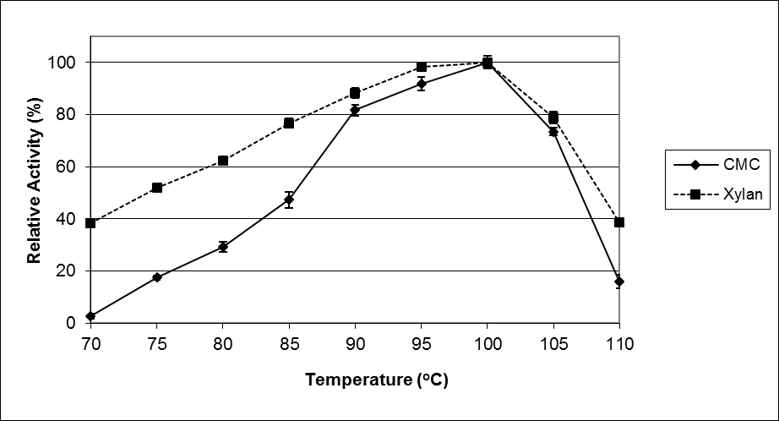
Figure 1. Effect of temperature on the crude enzyme activity from S. shibatae on the substrates CMC and xylan. Data expressed as a percentage of maximum activity.
Upon assessment of enzyme thermal stability, 86% of original activity on CMC and 64% of original activity on xylan was detected after incubation of crude enzyme at 80°C for 30 hours. At 95°C, the crude enzyme retained 44% and 23% of original activity on CMC and xylan, respectively, after 24 hours and at 100°C, 63% of original activity on CMC was detected after 30 minutes compared to 41% of original activity on xylan.
The crude enzyme produced by S. shibatae was capable of hydrolysing pretreated straw lignocellulose. After 6 hours at 90°C, the amount of reducing sugars released at pH 3.5 was approximately twofold the amount released in the corresponding control samples without enzyme. The crude enzyme also rapidly decreased the viscosity of CMC solution at 90 and 95°C.
4. Conclusions
The properties of the crude cellulase and xylanase activities produced by S. shibatae, in particular the high activity and stability observed at high temperatures and ability to hydrolyse straw lignocellulose at high temperature, strongly indicate potential suitability for use in the production of cellulosic bioethanol. While further studies are necessary to confirm industrial applicability, potential uses include the prehydrolysis/liquefaction of pretreated lignocellulose and/or as a component of thermostable enzyme cocktails for hydrolysis of pretreated lignocellulose to fermentable sugars. Moreover, these enzymes may also be of interest in other biotechnological processes undertaken at high temperatures.
References
- F. Akram, I.U. Haq, W. Imran, H. Mukhtar, Renewable Energy. 122 (2018) 225-238.
- A.K. Patel, R.R. Singhania, S.J. Sim, A. Pandey, Bioresour Technol. 279 (2019) 385-392.
- A. Boyce, G. Walsh, Appl Microbiol Biotechnol 99 (2015) 7515-7525.
- http://www.dsmz.de/microorganisms/medium/pdf/DSMZ_Medium88.pdf
- G.L. Miller, Anal Chem 31 (1959) 426-428.

