Experimental investigation of hydrodynamics and mass transfer of viscous non-Newtonian fluids in stirred tanks.
Haider Ali¹, Jannike Solsvik¹
¹Department of Chemical Engineering, NTNU-Norwegian University of Science and Technology, Trondheim, Norway
*Corresponding author: jannike.solsvik@ntnu.no
Highlights
- Hydrodynamic and mass transfer of viscous non-Newtonian fluid in a stirred tank.
- Bubble size distribution changes with the height of tank.
- Bubbles size reduces in the stirrer vicinity.
- Rheology of liquids affects the bubble distribution in a stirred tank.

1. Introduction
Stirred tanks massively attract the bioprocess and chemical industries because of their cost-effectiveness. Improved mixing conditions and high heat and mass transfer rates are the prominent characteristics that make stirred tanks suitable for the fluids with complex rheology (non-Newtonian behavior) [1]. A mechanical stirrer enhances the mixing in the stirred tank by breaking the gas bubbles and increasing the turbulence of the liquid. However, the use of highly viscous non-Newtonian fluids significantly reduces the mixing process that consequently affects the performance of a stirred tank [2].
The objective of this study is to experimentally investigate the hydrodynamics and mass transfer characteristics of viscous non-Newtonian fluid in a stirred tank. A more detailed analysis of bubble-liquid mass transfer is obtained in this work because of the combined use of the two types of probes. That is, with the knowledge of the local dissolved concentration of oxygen along with the local bubble size distribution, the overall mass transfer coefficient can be analyzed in further details by splitting it into its components of liquid side mass transfer coefficient and interfacial area. In contrast to previous studies, where an overall bubble size is assumed for the whole tank unit, this study provides detailed information on the bubble size distribution at various local tank positions. Improved knowledge on mass transfer in non-Newtonian liquids is crucial for operation of many fermentations processes. The experiment is first performed to measure the hydrodynamics and mass transfer properties of Newtonian (water) liquid. Then viscous Newtonian (glycerol), and non-Newtonian (Carboxymethylcellulose sodium) fluids will be experimented to examine the effects of fluid rheology. Various gas volumetric flow rates, stirrer speeds, and probe positions are considered to examine their effects on the bubble size distribution, gas holdup, and mass transfer coefficient.
2. Methods
This study used a 15.0 L laboratory scale stirred tank made of plexiglass and with a working volume of 11.0 L. The gas was bubbled in the stirred tank by a ring sparger with 0.06 m diameter. The sparger consists of 32 holes with a diameter of 0.0005 m. A Rushton turbine stirrer with six blades (0.07 m in diameter) and clearance of 0.045 m was used to prompt stirring in the tank. Dissolved oxygen concentration and bubble size distribution were measured at four different vertical positions (0.055 m apart) of the stirred tank. The gas volumetric flow rate and stirring speed varied from 1.0×10⁻⁴ to 1.4×10⁻⁴ m³/s and 10 to 13.33 1/s respectively. An optical dissolved oxygen probe (InPro 6870i Mettler Toledo, Switzerland) and photo optical probe (VI Kr SOPAT, Germany) were used to measure dissolved oxygen concentration and bubble size distribution. The overall mass transfer coefficient was measured with the dynamic gassing-in method [3]. The rheological properties (apparent viscosity etc.) of the viscous liquids will be measured using rheometry.
3. Results and discussion
Figure 1 shows the bubble size distribution for the different vertical probe positions. The volumetric gas flow rate is 1.0×10⁻⁴ (m³/s), stirrer speed is 10 (1/s), and the frame rate of the optical probe is 5 (Hz) for these results. The breaking of the bubble by the stirrer produces significantly small size bubbles in the first position (stirrer vicinity). The size of bubbles starts to increase as they move away from the stirrer (second position) because of the coalescence. The large size bubbles recorded at the third and fourth positions suggest that the bubble coalescence is dominant in these regions. The Sauter mean diameter is 0.95 mm for the first position, 1.78 mm for the second position, 2.15 mm for the third position, and 2.04 mm for the fourth position.
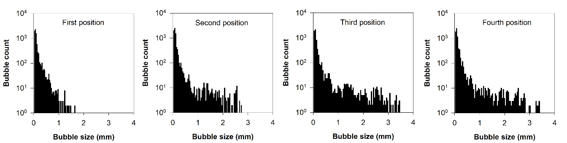
Figure 1. Bubble size distribution for different probe positions.
4. Conclusions
This experimental study investigates the hydrodynamics and mass transfer characteristics of viscous non-Newtonian fluid in a stirred tank. The study uses different gas volumetric flow rates, impeller speeds, and probe or positions to examine their effects on the bubble size distribution, gas holdup, and mass transfer coefficient. Initially, the bubble size distribution in the water was measured at four different probe positions. The coalescence produces large size bubbles in the regions that are quite distant from the stirrer. Use of viscous Newtonian and non-Newtonian fluids will increase the coalescence that consequently affects the bubble distribution in the tank. Therefore, experiments will be carried out to measure hydrodynamics and mass transfer of viscous Newtonian and non-Newtonian fluids.
References
- S. S. de Jesus, J. Moreira Neto, R. Maciel Filho, Biochem. Eng. J. 118 (2017) 70–81.
- A. Story, Z. Jaworski, M. Major-Godlewska, G. Story, Chem. Eng. Res. Des. 138 (2018) 398–404, 2018.
- F. Garcia-Ochoa, E. Gomez, Biotechnol. Adv. 27 (2009) 153–176.

