Defluidization behaviour due to sintering of industrial reactive powders
Domenico Macri^{1*}, Paola Lettieri¹
¹Department of Chemical Engineering, University College London, London WC1E 7JE, UK
*Corresponding author: domenico.macri@ucl.ac.uk
Highlights
- The defluidization behaviour of mixtures of coke and titanium ores were studied
- Early stages of sintering process were experimentally simulated
- Sintered materials were analyzed by optical, chemical and mechanical tests

1. Introduction
Fluidized bed reactors are used in a wide range of industrial chemical processes and they are particularly useful in high temperature systems thanks to their ability to provide high heat transfer rates and rapid solids mixing which lead to isothermal and more controllable conditions. Their applications spread the environmental, chemical, energy and process industries. For example, they are a key technology in the petroleum industry, catalytic chemicals synthesis processes, combustion and gasification of solid fuels (coal, wastes and biomass), metals productions and many more.
Operations below incipient fluidizing conditions in combustion-type operations can lead to particles aggregation and sintering which change the characteristics of the bed and could cause bed defluidization with consequential unscheduled process downtime and additional costs.
However, the details of the physical processes under such conditions are still not well understood. Despite the countless researches that have been done so far, such processes still disclose unrevealed features and challenge the researchers worldwide.
The objective of this work is to assess the influence of operative conditions on the fluidization behaviour of mixtures of petroleum coke and different titanium ores industrial reactive powders.
The fluidization behaviour of several mixtures have been studied at process temperatures ranging from ambient up to 950 °C in a specially designed heated fluid-bed reactor, where the early stages of the sintering process were experimentally simulated.
2. Methods
In order to tackle the problem of assessing the defluidization behaviour of powders at operative conditions, the early stages of the sintering process were experimentally simulated in the fluidization rig for the mixtures of coke, rutile and slag by blowing air into the fluidized bed for a certain time ^{[1]}. The effects of high temperature and air flowrate were investigated systematically in different fluidization regimes. Fundamental fluidization tests were also carried out on the spent systems (i.e. after combustion and cooled down to ambient conditions) and compared to the fresh ones. The reactor was then emptied and the aggregates collected for further off-line examinations: mechanical properties evaluation by means of a vibrated plate friability test, optical and chemical composition assessment by SEM/EDX analysis.
Fundamental fluidization tests were also performed using the unique X-ray Imaging technique available at UCL, which enabled to visualize the internal flow pattern inside the metallic reactor and to obtain quantitative information. Simultaneous measurements of local temperatures and pressure drop across the bed were carried out in order to detect possible aggregation and sintering phenomena.
3. Results and discussion
The tests showed that combination of operative conditions and coke characteristics have a significant role on the formation of the aggregates and on their properties. In particular, the mechanical strength of the aggregates was found to be strongly dependent on the coke particles size and the operating fluidizing regime: they appeared more friable with when larger coke particles size and low air flowrates were employed. The SEM/EDX analysis permitted the inspections of the bridges among particles and the assessment of the chemical composition of the sintered material. The results suggested that only particles of rutile and slag were involved in the formation of the sintered bridge (with a particular enrichment of Al-Si phase in the bond) and no relevant bonding structures involving coke particles were found.
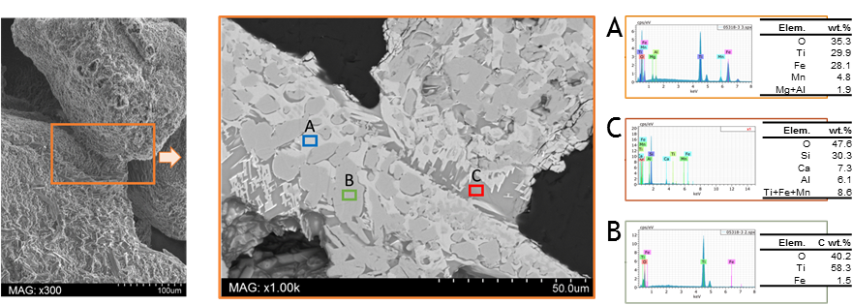
Figure 1. Example of SEM image and EDX spectrum on a sintered bridge
4. Conclusions
Inspections of the fluidization performance of different mixtures of titanium ores and coke showed that a number of factors are responsible for the onset of defluidization due to particles aggregation, such as rutile’s nature, coke particles size, operative fluidization regime, etc.
The basis for a fundamental understanding of the investigated industrial process has been delivered by successfully reproducing and controlling the early stage stages of the sintering processes in a small pilot scale fluidized bed at temperature far below the real operative one. Moreover, a clear relationship between the characteristics of the final aggregates and the operative conditions was found.
References
- D. Macri, Study of defluidization behaviour of industrial reactive particles, Doctorate Thesis, UCL (University Coll. London).

