Shape modification of needle crystals using polymer additives and temperature cycling
Wei li¹, Brahim Benyahia¹, Chris Rielly¹
1 Department of Chemical Engineering, Loughborough University, Loughborough, Leics, LE11 3TU, UK
*е-mail: w.li@lboro.ac.uk

Highlights
- Additives combined with temperature cycling helps to produce more equant shape crystals
- Optimized closed-loop temperature cycling can eliminate fines and agglomerates
- Polymer additives affect growth on specific crystal faces
- Seeded and mill-aided processes can further improve aspect ratio of needle crystals

1. Introduction
Crystal products which have a needle-like morphology tend not to compress well into tablets, and hence more equant shaped crystals are preferred for the secondary manufacturing process. Lovastatin has been studied in this work and is an active pharmaceutical ingredient widely used for the treatment of hypercholesterolemia. However, it forms needle-like crystals and is notorious for its poor processability and difficult formulation. High aspect ratio needle crystals often have poor processability for the filtration washing and drying stages [1]. Needle crystals are often brittle, and breakage results in fines and dust in the working environment. In the current work, lovastatin cooling crystallizations were conducted using polymer additives, namely polypropylene glycol (PPG-4000), coupled with temperature cycling profile using a direct nucleation control (DNC) approach [2], to improve the aspect ratio. This high-molecular-weight, high-boiling point polymer additive can block specific fast-growing crystal surfaces through a hydrogen bonding effect [3]. Hence, they modify the morphology, by inhibiting unwanted elongated growth in the length of the crystal and provide a selectively preference for growth on the short sides.
2. Methods
  - Materials:
Lovastatin, ethyl acetate, polypropylene glycol (PPG)
  - Equipment:
400ml crystallizer, process analytical tools were used to measure the particle counts, particle length, temperature and concentration profile.
  - Process:
- Cooling crystallization from saturation temperatures of 35°C to 10°C in the absence and presence of polymer additives was investigated
- DNC approach was applied to produce size and shape modification, using continuously heating and cooling cycles effectively by indirectly control growth and dissolution mechanisms
- Combination of polymer additives and temperature cycling effect were studied
- Different startup and nucleation conditions were studied, including classical seed addition and wet-mill facilitated nucleation
3. Results and discussion
Fig 1 shows PAT data and PVM images for batch cooling crystallizations. The in situ PVM images indicated that the aspect ratio was not improved much for crystallizations with linear cooling profiles (Fig 1b) and varying amounts of PPG, although the nucleation time and nucleation rate were suppressed with increasing mass of polymer additives. The particle counts, concentration and temperature time histories showed that an improved DNC method with PPG additives can shorten the isolation temperature cycle time (Fig 1c & e) and reduce the aspect ratio of the crystals. With an optimised temperature cycle process, agglomeration was not observed and fines were removed by dissolution. Furthermore, wet-mill-aided and seeded DNC can be applied for further shape modification of lovastatin crystals (Fig 1d & f).
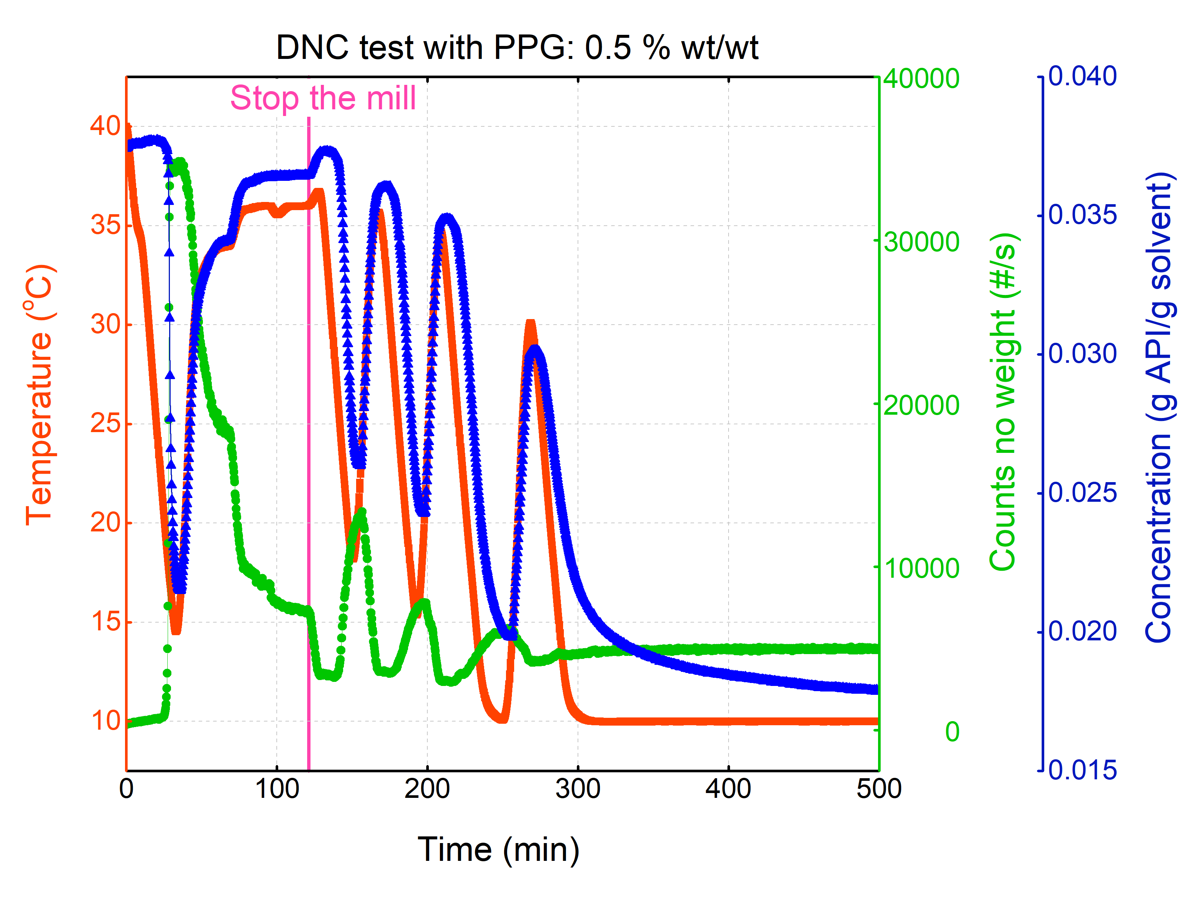  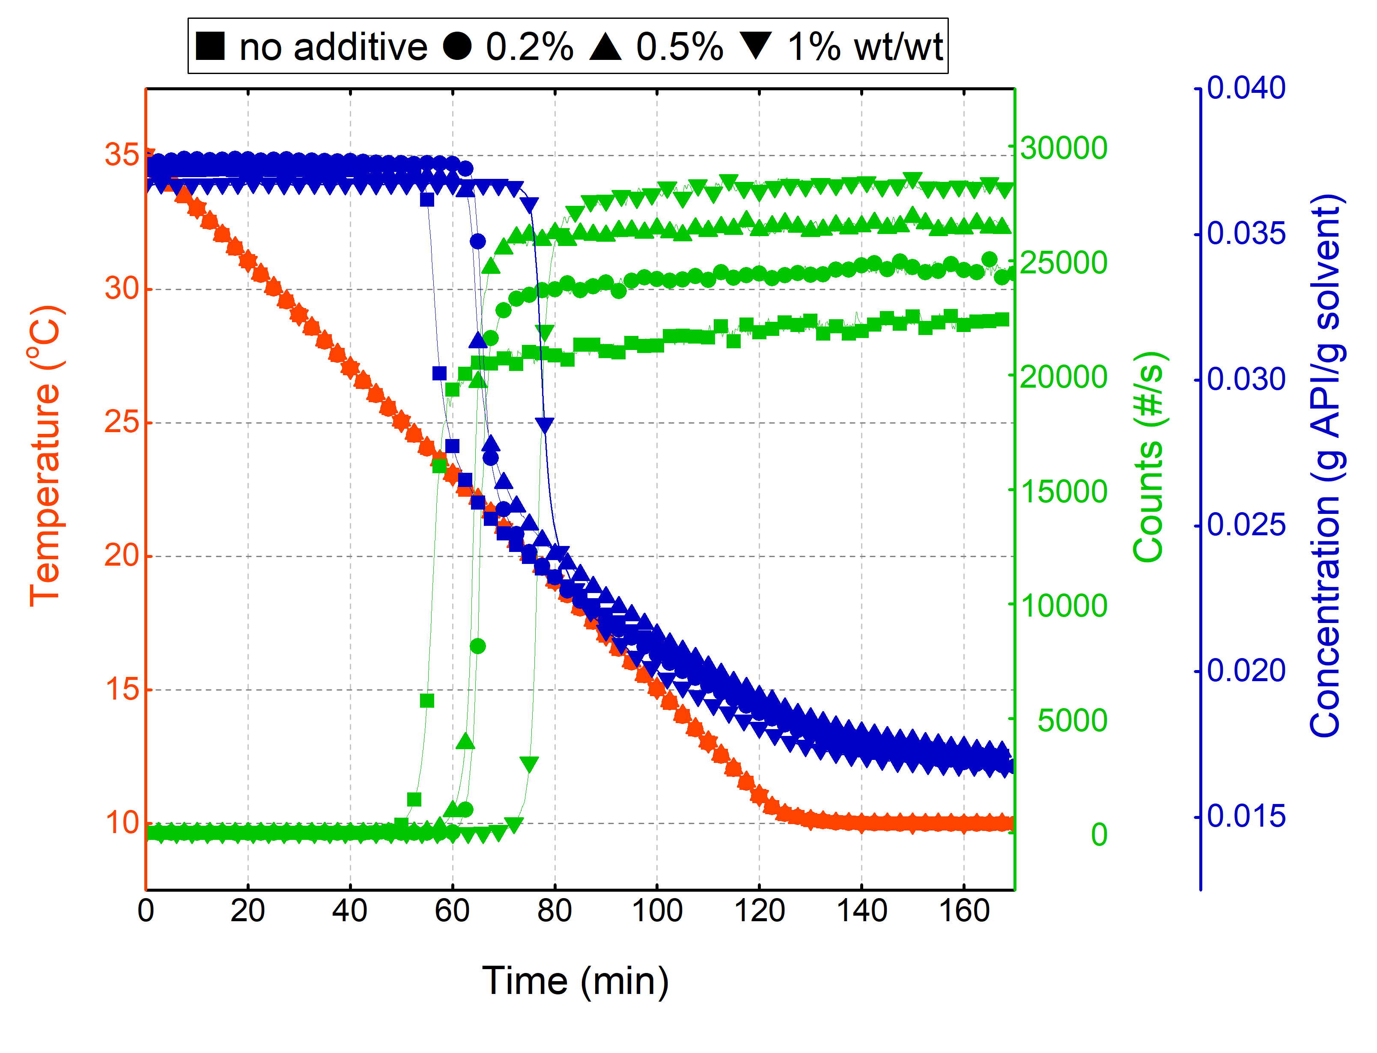  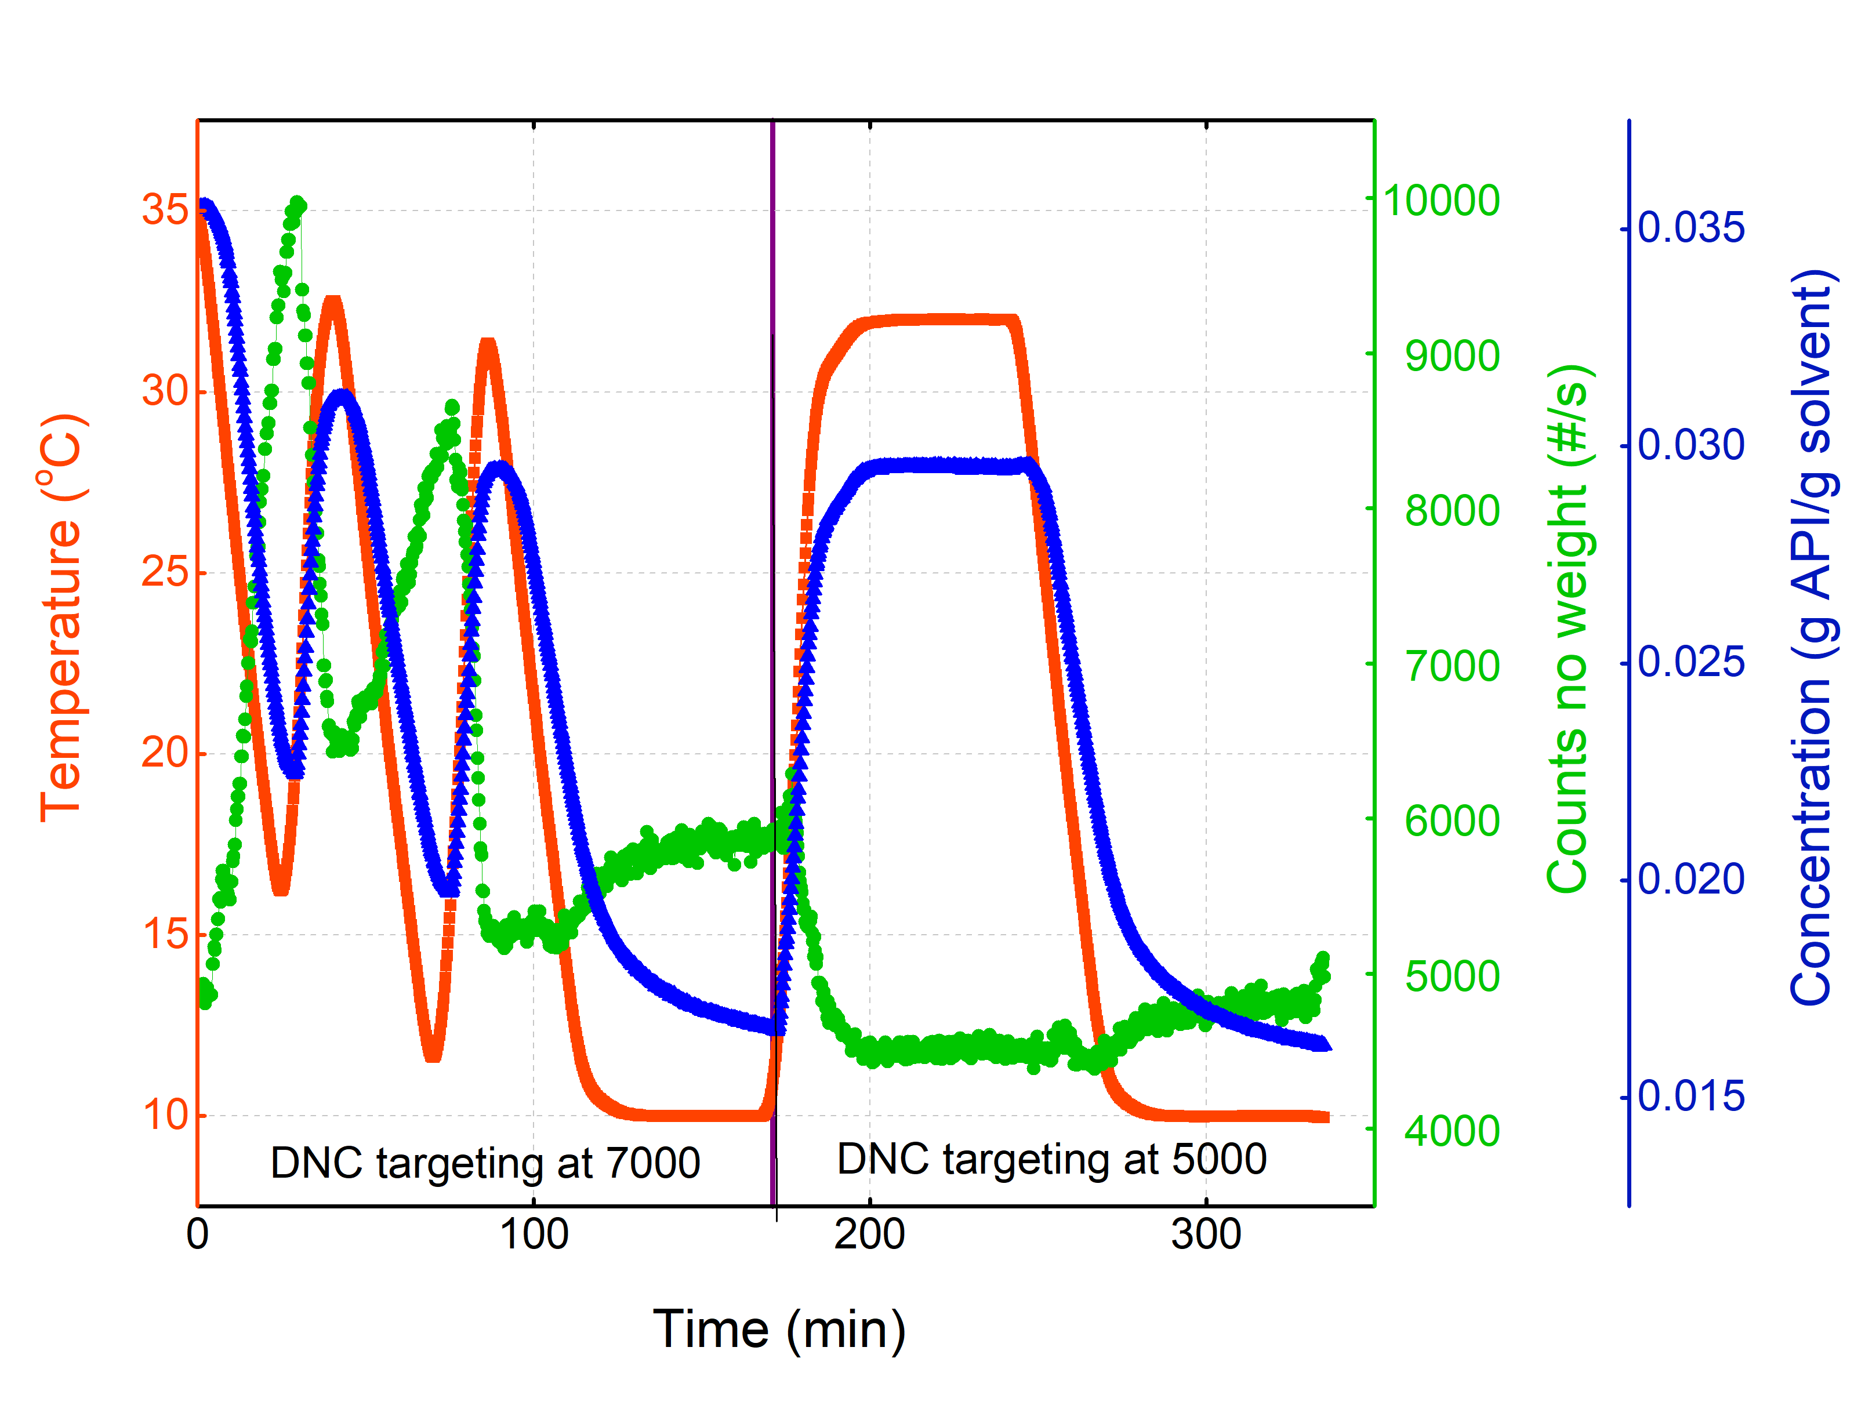  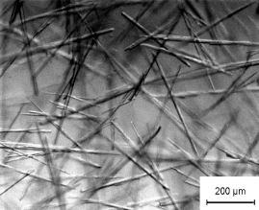  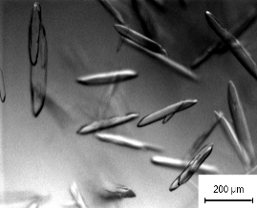  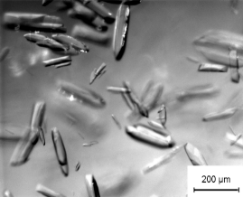  (a) | (c) | (e)
(b) | (d) | (f)
Figure 1. FBRM counts/s ⎯ temperature ⎯ and concentration ⎯ against time profiles and in situ PVM images captured of the final crystals for: (a) and (b) Linear cooling crystallization of lovastatin/ethyl acetate system; (c) and (d) Lovastatin/ethyl acetate/PPG-4000 system with mill-aided DNC T cycling crystallization; (e) and (f) Lovastatin/ethyl acetate/PPG-4000 system with seeded DNC T cycling crystallization
4. Conclusions
Additions of a polymer additive PPG-4000 on the linear cooling crystallization of lovastatin in an ethyl acetate solvent were investigated, resulting in a delay in the start of nucleation with increasing concentration of additives. Application of an optimized DNC approach (with and without polymer additives) was compared with a benchmark cooling crystallization. The aspect ratio was more significantly improved using a combination of temperature cycling from DNC and the presence of the polymer additive. The crystal size and shape distribution can be further improved by different seeding approaches.
References
- M.A. Lovette, M.F. Doherty, Cryst. Growth Des. 13 (2013) 3341–3352.
- M.R. Abu Bakar, Z.K. Nagy, A.N. Saleemi, C.D. Rielly, Cryst. Growth Des. 9 (2009) 1378–1384.
- T. Vetter, M. Mazzotti, J. Brozio, Cryst. Growth Des. 11 (2011) 3813–3821.

