Nanofiltration for Arsenic Removal from natural contaminated groundwaters in Calabria Region (Italy)
A. Figoli¹, I. Fuoco², C. Apollaro², R. Mancuso³, G. Desiderio⁴, R. De Rosa², B. Gabriele³, A.Criscuoli¹
¹Institute on Membrane Technology (ITM-CNR), I-87036 Rende (CS) Italy; ²Dept. of Biology, Ecology and Earth Sciences (DIBEST), University of Calabria, I-87036 Rende (CS) Italy; ³LISOC Group, Department of Chemistry and Chemical Technologies, University of Calabria, I-87036 Rende (CS) Italy; ⁴DeltaE, University of Calabria, I-87036 Rende (CS) Italy. *Corresponding author: a.figoli@itm.cnr.it
Highlights
- Arsenic removal by Nanofiltration
- Membrane application for water purification
- Arsenic contaminated groundwater purification

1. Introduction
Arsenic is a toxic inorganic pollutant for both the environment and human health. The removal of arsenic is one of most problematic targets of hydrogeochemical research (Bhattacharya et al. 2002). The WHO drinking water guideline for As has been set to 10 μg/L and it has been adopted by many countries as a drinking water standard (WHO, 2001). For reaching this new value, several separation techniques have been studied. Membrane technology is one of these and pressure driven operation as nanofiltration (NF) and reverse osmosis (RO), often applied on synthetic solutions, have been already proved to accomplish the arsenic value below the drinking water standard (Figoli et al., 2016; Ahmad et al. 2017). In this study, NF has been applied for treating As contaminated groundwaters, coming from an area located in the Sila Massif (Calabria, Italy). Sila Massif represents the major morphostructural high of the Ionian margin of north-eastern Calabria and fall in the northern sector of the Calabrian Peloritan Arc (CPA). The water samples collected, labeled GW1, GW2, GW3, have interacted with the Calabride Complex formed by Hercynian and pre-Hercynian gneiss, granite and phyllite, which underwent intense weathering processes (Van Dijk et al., 2002). The performance (water flux and arsenic rejection) of the membranes has been evaluated too.

2. Methods
The three water samples (GW1, GW2, GW3) differ by the arsenic concentration, which is about 60, 120 and 430 ppb, respectively. The As is present mainly in the pentavalent form (As(V)). NF experiments were performed by using a laboratory pilot unit (SEPA CF). Four types of membrane modules commercialized by GE Osmonics, named HL (Polyamide), DK (proprietary thin-film) and CK (cellulose acetate) and by Microdyn Nadir, named NP030P (Polyethersulfone), were used. The samples, before and after membrane treatment, were analyzed, determining the major elements HPLC (Dionex ICS 1100). The total arsenic was evaluated by ICP-MS, Perkin Elmer/SCIEX, Elan DRCe.

3. Results and discussion
In Figure 1, it is reported the water flux plotted versus the trans-membrane pressure (TMP) variation, for the GW2 sample (feed stream). All the investigated membranes show a linear increase of water flux at higher TMP. In particular, only the NF membrane Type HL shows much higher water flux compared to the other ones, which could be explained by the polymeric nature of the material as well as by its higher pore-size. The same results have obtained also for the other GW samples containing a lower and higher concentration of As(V).
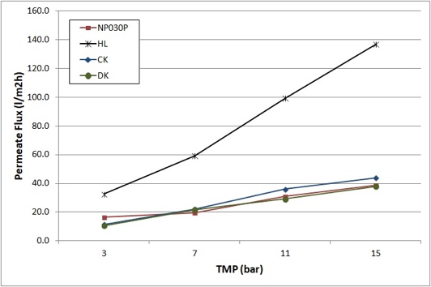
Figure 1. Effect of TMP on permeate flux for GW2 contaminated As(V) sample.
In Figure 2, it is reported the As(V) rejection and the arsenic concentration detected in the permeate (purified water) after the membrane treatment of GW2 contaminated As (V) sample.

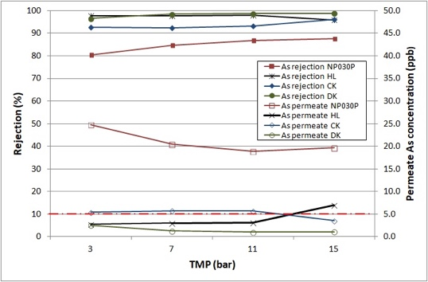
Figure 2: Effect of TMP on rejection (%) and permeate arsenic concentration for GW2 contaminated As(V) sample
The results show that all the investigated NF membra-nes, except the NP030P, reject the As(V) and that the As(V) concentration in the purified permeate water is below the WHO drinking water limit value of 10 µg/L.
4. Conclusions
The results clearly report that NF can be considered a valid technique for arsenic removal in the natural water, producing a permeate (purified water) with the As(V) concentrations within the allowed WHO limits for most of the membrane investigated.
5. Acknowlegment
The work has been supported by the project “AsSe” n. CUP: J28I17000030006, cofunded by Fondo FESR POR Calabria FESR FSE 2014-2020-Azione 1.2.2.
References
Bhattacharya, P., Frisbie, S.H., Smith, E., Naidu, R., Jacks, G., Sarkar B. 2002. Arsenic in the Environment: A Global Perspective. In: B.Sarkar (Ed.) Handbook of Heavy Metals in the Environment, Marcell Dekker Inc., New York, pp. 147-215.
Figoli, A., Hoinkis, J., Bundschuh, J. 2016. Membrane Technology for Water Treatment, Removal of toxic trace elements with emphasis on arsenic, fluoride and uranium, CRC Press, Taylor and Francis Group, ISBN978-1-315-73523-8.
WHO, Guideline for drinking-water quality: Arsenic in drinking water. Fact Sheet No. 210. Geneva. Switzerland, World Health Organization (2001).

