**Obtaining the True Process Value of the Fragmentation Kinetic Function (FKF) For The Breakage of Silica Flocs in Taylor Couette Flow Via Population Balance Simulation.**

Y.K. Leong1, P.I. Au, J.S. Liu, Y. Wang

*1 Department of Chemical Engineering, The University of Western Australia, Crawley, Australia 6009*

*\*Corresponding author: yeekwong.leong@uwa.edu.au*

**Highlights**

* A method for determining experimental FKF data presented
* Computed and experimental PSD matched.
* FKF data cannot be determined experimentally.
* FKF values very large for small flocs.

**1. Introduction**

The breakage or fragmentation kinetic function (FKF) of a given father size floc breaking to form two specific daughter size flocs cannot be measured experimentally. Indirectly it can be determined from the FKF model used to solve the population balance equation for floc fragmentation subjected to meeting two conditions: i) the computed and experimental particle size distribution function (PSDF) matched at all fragmentation time and ii) the PSDF data at zero fragmentation time was the input in the computation1. The fragmentation of compact polyelectrolyte-bridged silica flocs in a narrow gap concentric cylinder flow cell was investigated in the laminar Taylor vortex flow regime at Taylor number of 26000. A past study showed that the FKF values are smaller for large flocs as they tend to migrate to the low shear region1. Monodispersed SiO2 particles of 0.34 m were coated with a low Mw cationic PEI and then bridged with a high Mw anionic polyacrylamide flocculant.

**2. Methods**

This dimensionless PBE expressed in log-form given by2:

 (1)

Is solved directly after being converted to ordinary differential equation by MOL. X ≡ log10V, V = v/vmax, N = (vmax)2n/mF, KF = kF/kFmax, τ =t/tscale and dV = loge10×10XdX. The experimental time scale tscale must be used in the computation so that the simulated and experimental results are comparable.1The FKF used for 200rpm is:,

.

Continuous particle size distribution (PSDF) data at zero fragmentation time was the input in the computation to solve Eqn 1 to obtain temporal PSD data.

**3. Results and discussion**

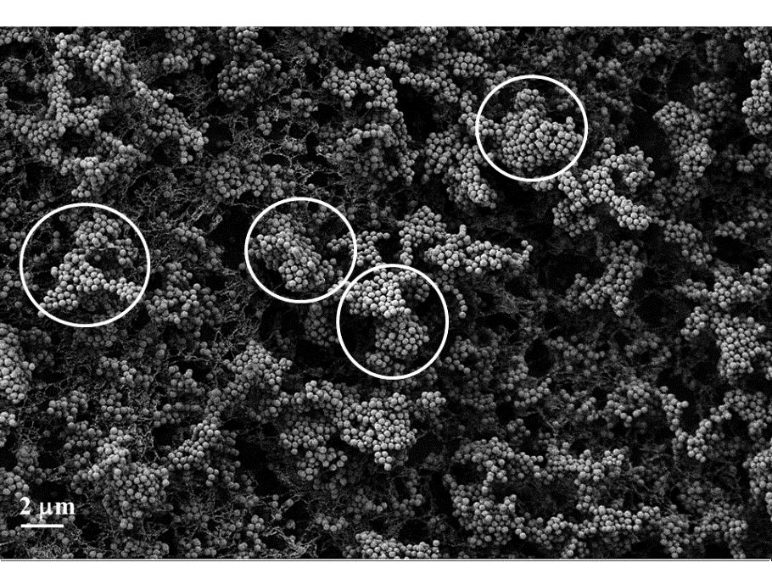The discrete and continuous PSD for fragmentation in Taylor Couette flow at 200 rpm are shown in Figure 1(a) PSDF in (b).

**Figure 1.** Temporal a) PSD and b) PSDF during fragmentation, and c) compact fragmented silica flocs.

****The comparison between computed and experimental PSDF is shown in Figure 2 for dimensionless time  a) 0 and 1, b) 0.24 and c) 0.68. The agreement are considered good. This means the the FKF data used in computation and some of which are shown in Figure 3 represents the experimental values.

**Figure 2.** Computed and Experimental temporal PSDF comparison are various fragmentation time.



**Figure 3.** FKF data used in the PBE represent the true process values.

**4. Conclusions**

Computed and experimental PSDF matched at all fragmentation time. The FKF data used thus represent the true process value.

**References**

1. P.I. Au, J.S. Liu, W. Zhang, S.B. Sun, Y.K. Leong, *Colloids Surf. A*. 52 (2018) 48-58.
2. Y.L.Yeow, J.L. Liow, Y.K. Leong, *AIChE J*. 58 (2012) 3043-3053.