Use of a filter press as a reactor for heterogeneous Fenton advanced oxidation: Experimental evaluation and CFD simulation
José Luis Trigueros Soto, J. Esteban Durán*
School of Chemical Engineering, University of Costa Rica, San José, 11501, Costa Rica
* Corresponding author: esteban.duranherrera@ucr.ac.cr
Highlights
- A filter press was used as a reactor for heterogeneous Fenton AOP
- Caffeine degradation of 20% was achieved using 3 g of catalyst and 0.38 L/min
- CFD model provided insight on the hydrodynamics and multiphase interactions inside the reactor chambers

1. Introduction
Fenton process is a well-known technology that has been applied on the treatment of industrial wastewater containing non-biodegradable organic pollutants. However, because of the many drawbacks of conventional homogeneous Fenton process (e.g. sludge generation), considerable effort has been put in the development of heterogeneous Fenton systems. Unfortunately, most of the works has focused on catalyst development [1], and little research has been done on the development of proper reactor configurations for utilizing such heterogeneous catalysts. This study explores the use of a filter press as a heterogeneous catalytic reactor for the Fenton reaction utilizing iron-modified diatomite as catalyst [2]. Experimental data and computational fluid dynamics simulations (CFD) were used to characterize this novel reactor so it can be later scale up for commercial implementation.
2. Methods
Residence time distribution (RTD) experiments [3] using one filter press frame were performed in order to understand the hydrodynamics inside the reactor and to evaluate the CFD model. NaCl was used as a tracer; after a concentrated salt shot was spiked at the reactor inlet, its concentration was measured at the outlet with a conductivity meter. Also, CFD simulations of this same experiment were performed using Ansys Fluent.
Different experiments were performed to determine the effect of various operational factors (number of filter plates, catalyst load per plate, and flow rate) on the reactor performance. To assess the reactor performance, the degradation of caffeine (as model pollutant) was spectrophotometrically measured under steady state conditions. With these data, it was possible to approximate reaction kinetics and to compare experiments with CFD predictions. A multiphase Eulerian approach was used for the CFD model and transient state simulations were performed using Ansys Fluent.
3. Results and discussion
Using the RTD experiment measurements, it was possible to obtain the C and E curves to characterize the homogeneous hydrodynamics inside of the filter press. With these experimental data, it was possible to evaluate the steady state simulation. CFD simulations were in close agreement with the experimental curves. Good-mixing patterns are found in the reaction chambers, mainly due to the tangential inlet flow.
Fig. 1 shows a picture of the filter press with five frames, three of them loaded with the iron-modified catalyst. The side view allows seeing particle suspension and mixing promoted by the tangential inlet flow (bottom right-side). Caffeine conversions of 20% were obtained using 3 g of catalyst per chamber and 0.38 L/min flowrate.
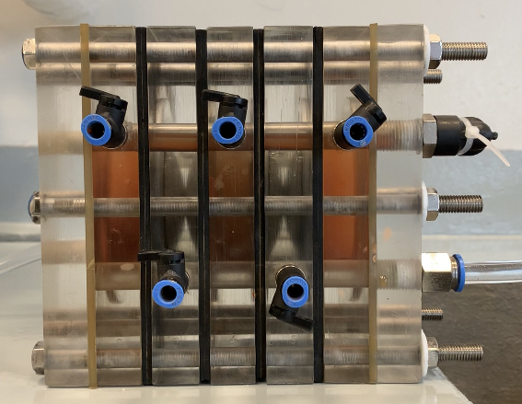  (a) | 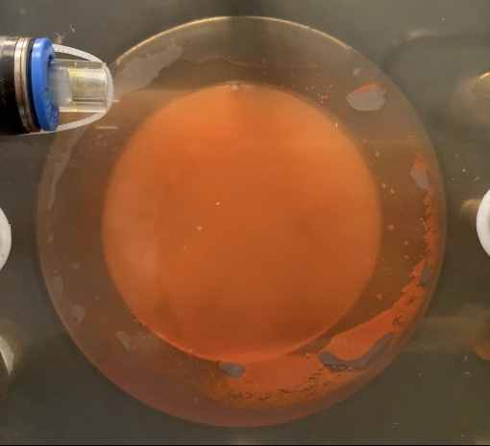  (b)
Figure 1. Filter press reactor equipped with five frames, three loaded with iron-modified diatomite (a); side view of reaction chamber
In the congress presentation we will further discuss our experimental and simulation results.
4. Conclusions
A filter press used as a reactor for advanced oxidation processes using the heterogeneous Fenton reaction was characterized and simulated using CFD. The computational model was very useful for providing insight on the multiphase interaction and hydrodynamics inside the reaction chambers. It is recommended to further investigate the suitability of using this system in industrial scale water and wastewater treatment plants.
References
- P.V. Nidheesh, RSC Advances 5 (2015) 40552–40577.
- J.E. Duran, A. Araya, S. Arguedas, Proc. IOA & IUVA World Congress (2013).
- H.S. Fogler, Elements of Chemical Reaction Engineering, forth ed., Pearson Ed., New York, 2006.

