Supercritical Precipitation of PHB as a Potential Carrier for Antioxidant Delivery
Facundo Mattea*^{1,2}, Valentina Sosa³, Matías Dalmasso³, Javier Galfioni³, Joaquín Orejas³
1 Universidad Nacional de Córdoba. Facultad de Ciencias Químicas. Dpto. de Química Orgánica. Cba., Arg.; 2 Instituto de Investigación y Desarrollo en Ingeniería de Procesos y Química Aplicada, IPQA, CONICET. Cba., Arg.;3 Universidad Nacional de Río Cuarto, Facultad de Ingeniería, Dpto. de Tecnología Química.
*corresponding author: fmattea@gmail.com
Highlights
- PHB, a biodegradable polymer was precipitated by supercritical fluid technology.
- Solvent selection is essential for the precipitation and future antioxidant inclusion
- Antioxidants were extracted and concentrated from green tea

1. Introduction
Supercritical antisolvent process (SAS) is widely being used to micronize pharmaceutical and nutraceutical compounds. The advantage of SAS over other conventional processes is that thermal degradation is avoided in the active compounds as the operating temperature is near to room temperature. Therefore, the micronization of thermally labile compounds such as antioxidants or colorants has been widely studied by SAS with carbon dioxide as antisolvent [1]. Also, by the coprecipitation of biodegradable polymers and active compounds it is possible to produce formulations with controlled release of the active compound prolonging its effect over time. The selection of the solvent is essential in this process, it must meet the solubility requirements for both the active compound, the polymer or carrier, and be miscible or form a single phase with the antisolvent fluid. On this study, two different solvents were used for an ultrasound assisted extraction of catechins and antioxidants from green tea, and to study the precipitation of a biodegradable polymer, namely Polyhydroxybutyrate (PHB) by means of the supercritical antisolvent process.
2. Methods
In the antioxidant extraction, 5.0 gr of green tea was extracted with 300 mL of the selected solvent assisted by ultrasound in an ultrasonic bath (Testlab TB04) for 30 minutes at 160 W. The total polyphenol content was quantified by the Folin-Ciocalteu. A scheme of the antisolvent precipitation process can be observed in Figure 1. In a typical experiment the whole process is filled with carbon dioxide and stabilized at the desired pressure and temperature and CO2 flowrate, then 250 mL of solution containing the polymer or active compounds is pumped into the precipitation unit, afterwards the solution inlet is stopped, and a certain amount of CO2 is introduced to remove any remaining solvent from the formed particles. The formed particles are retained by a metallic frit placed inside the precipitation unit.
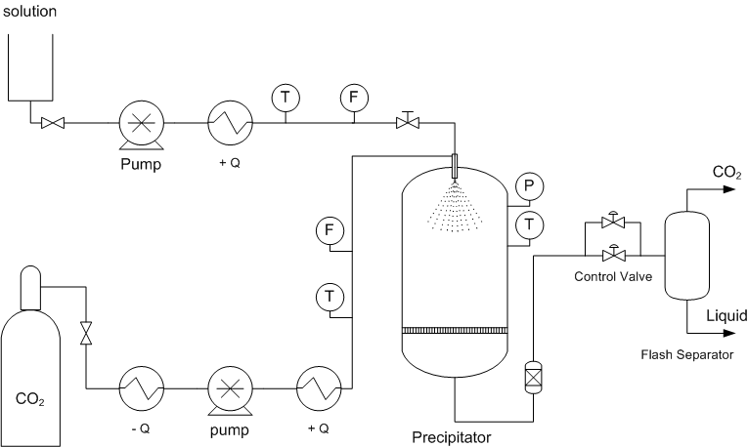
Figure 1. Antisolvent precipitation process scheme.
3. Results and discussion
The total amount of extracted polyphenols expressed as mg of polyphenol per gram of green tea was 3.02 for DCM and 126.06 for 1,3-dioxolane. The solubility of catechins in DCM is very low compared to other typical solvents like ethanol or water, however PHB has no appreciable solubility in those typical solvents. The precipitation of PHB from DCM solutions rendered particles with a mean size of 1.42 μm with a needle shape by using a pressure of 120 bar, temperature of 40°C, CO2 flow of 4Kg/h, solution flow of 1-2 mL/min and PHB concentration of 0.5 g/L. For the precipitation from 1,3-dioxolane similar operation conditions were used and concentrations of PHB ranging from 0.26 g/L to 0.75 g/L, obtaining particles with a mean size of 1.95 μm.
Figure 2. A) commercial PHB size distribution and morphology (left), B) particles of PHB obtained by supercritical antisolvent process from DCM solutions.
PHB microparticles obtained from SAS with DCM had a mean particle size of 1.42 μm with a variance of 0.94 μm, with represent a 53.2 % reduction on the mean size and 90.6 % reduction on the variance, compared from the commercial powder which has a mean size 3.04 μm of with a variance of 9.97 μm.
4. Conclusions
Both DCM and 1,3-dioxolane are suitable solvent for the precipitation of PHB with the CO2 antisolvent process. DCM is not as good as 1,3-dioxolane for the extraction of catechins and the later may be preferred for the coprecipitation and formation of antioxidant sustained delivery compound based on PHB.
References
- V. Prosapio, L. De Mrco, E. reverchon, The J. of Superc. Fluids. 138 (2018) 247-258.

