Evaluation of extraction of fermentable sugars from banana peels (Musa cavendish)
María Lara Triana¹, Edna Méndez Mondragón¹, Dionisio Malagón-Romero^{2*}, Mauricio Bernal Morales³, Dolly Montoya Castaño³
1 Semillero Procesos Industriales, Universidad ECCI; 2 Universidad Santo Tomás-Universidad ECCI; 3 Instituto de Biotecnología, Universidad Nacional de Colombia
*Corresponding author: dionisiomalagon@usantotomas.edu.co
Highlights
- The banana peel is a waste rich in fermentable sugar.
- The best sugar extraction is with water.
- The extraction is not the best method to use all banana peel.

1. Introduction
Due to the high volumes of banana production in Colombia, large amounts of waste have been generated (97.8 million boxes by the end of 2017, which represents approximately 29.3 million waste generated) [1]. The banana peel is a valuable source of bioactive compounds according to researchers[2] and constituting 30%-40% of a banana fruit[3], thus it is necessary to develop new alternatives to convert this waste generated into value-added products. Due to the high amount of soluble sugars, recent researches have been showing that banana peel is used as substrate to produce animal feed, organic acids, bio fertilizer, industrial enzymes, medicinal uses and energies clean by biological processes[4]. Through the development of this project, it is desired to use this waste for the extraction of fermentable sugars which can be a useful source of sugars.
2. Methods
Banana Peel was washed, dried, ground, sieved, and then was subjected to a granulometric analysis. It was collected about 20 kg of waste in different plantations near Bogotá (Colombia). Waste collected was characterized for determining humidity content and dry matter using the procedure described in the literature consulted[5]. The morphology and the content of carbon, nitrogen, and oxygen were determined from scanning electron microscopy with energy dispersive X-ray spectrometry (SEM-EDS) of samples of the banana peel to obtain an approximate data. Finally, the extractions of sugar in the pretreated material was carried out by the alkaline hydrolysis, acid hydrolysis and with water, evaluating the temperature and concentration parameters in a reflux system. The design of experiment was done for the alkaline hydrolysis with NaOH where two temperatures (40°C and 70°C) and two concentrations of the base (1% and 2%) were evaluated. The extraction with water was done at the same temperatures, finally, the extraction with acid hydrolysis was carried out with HCl at a concentration of 0,29M at 40°C. Additionally, all samples were exposed during 90 minutes in duplicate to evaluate the kinetics of the process taken samples every 30 minutes. Samples were centrifuged, the sugar extracted was determined by DNS according to the guide protocol[6].
3. Results and discussion
The average particle size was 0.9727 mm ± 0.115 for the Banana peel. The banana peel have a high percentage of moisture (86.84 % ± 1.56). This value is similar to reported by Dormond [7]. The nitrogen present in the peel is about 9.26-9.36%, the oxygen is about 64.78-69.54% and the carbon is approximately 6.89-6.99%. The picture 1.d) shows the morphology of the different particles that appear with an irregular size. For the alkaline hydrolysis the best results were obtained at a concentration of 1% and a temperature of 40 °C as shown in Figure 1.a). The acid hydrolysis is shown in Figure 1.b). Results obtained have shown a better extraction compared to the alkaline extraction at 40 °C. In both hydrolysis shows a decrease in the sugar concentration over time this could be due to the denaturing of carbohydrates due to the high concentration. Finally, the extraction with water showed the best results in the hole experiment, as it shows the figure 1.c). The best condition was obtained at 70°C. For this extraction, it was calculated that 0.2 grams of sugar are obtained for each gram of processed banana peel and the total sugars obtained was 6.1252 g/L which is the expected because is similar with reported by Kurtoğlu and Yildiz[8]. Between the extraction protocols observed, there are no significant differences in fermentable sugars extracted because the approximation of the maximum value is 6 g / L for all of them. However, the high extraction of fermentable sugars begins at zero minutes with water.
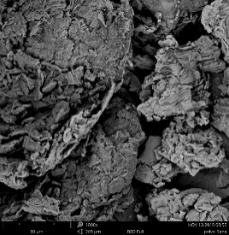
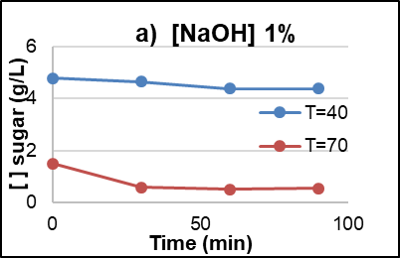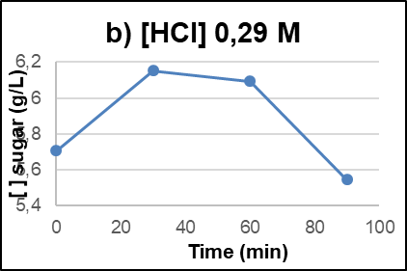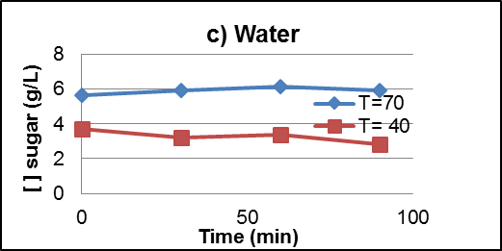
d) SEM
Figure 1. Kinetics of the different extractions.
4. Conclusions
It was observed that the amount of soluble sugars is higher with water compared with alkaline and acid treatment. Additionally, in alkaline conditions and water assays at initial time presents the higher extraction of fermentable sugars. These sugars could be used as substrate for fermentative process.
References
[1] G. Jaramillo and L. Zapata, “Aprovechamineto de los residuos sólidos orgánicos en Colombia,” Universidad de Antioquia, 2008.
[2] P. D. Pathak, S. A. Mandavgane, and B. D. Kulkarni, “Fruit peel waste : characterization and its potential uses,” vol. 113, no. 3, 2017.
[3] P. D. Pathak, S. A. Mandavgane, and B. D. Kulkarni, “Valorization of banana peel : a biorefinery approach,” vol. 32, no. 6, pp. 651–666, 2016.
[5] B. K. Dadzie and E. Orchard, “Evaluación rutinaria postcosecha de híbridos de bananos y plátanos : criterios y métodos,” International Network for the improvement of Banana and plantain. pp. 1–75, 1997.
[5] G. L. Miller, “Use of Dinitrosalicylic acid reagent for determination of reducing sugar,” Analytical chemestry, vol. 31, no. 3, pp. 426–428, 1959.
[6] U. D. C. Rica et al., “Evaluación preliminar de la cáscara de banano maduro como material de ensilaje, en combinación con pasto King Grass ( Pennistetum purpureum. (Nota técnica),” p. 21, 2011.
[7] G. K. Ğ. Lu and S. Yildiz, “Extraction Of Fructo-Oligosaccaride Components From Banana Peels,” vol. 24, no. 4, pp. 877–882, 2011.

