CO₂ reduction utilizing perovskites as photocatalysts in a versatile 3D printed microreactor
Jose A. Santamaría Cordero1^{1,2}, Leslie W. Pineda^{2,3}, Marisol Ledezma^{2,3}, J. Esteban Durán^{1,2}
1 School of Chemical Engineering; 2 Electrochemical and Chemical Energy Recearch Center (CELEQ); 3 School of Chemistry, University of Costa Rica, San José, 11501, Costa Rica
*esteban.duranherrera@ucr.ac.cr
Highlights
- Several perovskites were synthetized; Cs₃Bi₂I₉ (1.94 eV) was chosen for evaluation
- A maximum CO yield of 163.87 µmol/g_{cat}·h was obtained
- Highest CO₂ reduction was obtained at 42.5 µL/min and 150 mW/cm²

1. Introduction
In recent years, research activities in the field of CO₂ reuse to produce synthetic fuels have been greatly stimulated by the growing concern about the effect of CO₂ emissions on global warming and fossil fuel dependency issues. A particularly emerging and promising technology for this process is perovskite-based heterogeneous photocatalysis. Perovskite oxides are promising photocatalysts due to their high catalytic activity, good stability, long charge diffusion lengths, and compositional flexibility that allows precise bandgap and band edge tuning. Furthermore, once an efficient catalyst is developed, the next step is to incorporate it in photoreactors capable of commercially produce the synthetic solar fuels. Multiple designs have been proposed and tested; however, limitations due to diffusional processes (mass transfer) and proper distribution of incident radiation on the reactor, hinder the efficient performance of the photocatalytic system. In this sense, microreactors have emerged as an excellent technological alternative to minimize these inconveniences and maximize the production of solar fuels. In this work, several perovskites were synthetized, characterized and Cs₃Bi₂I₉ photocatalytic activity was evaluated using a homemade 3D-printed photo-microreactor.
2. Methods
Perovskites such as Cs₄CuX₂Cl₁₂ with X: Bi, La, Al, Fe, Cr; Cs₃X₂Cl₉ with X: Sb, Bi, La, Al, Fe; Cs₄SnX₂Cl₁₂ with X: Sb, La, Al, Fe, Cr; Cs₃Bi₂I₉ and Cs₃Sb₂I₉ were synthetized. Band gap calculations were performed using UV-Vis Diffuse Reflectance measurements through Kubelka-Munk (K-M) model and Tauc’s plot. Furthermore, some of them were characterized by means of SEM/EDX, ICP, XRD, Stylus Profilometry and Quantum Yield. The microreactor was designed to fit inside a MicronitTM chip holder and in a way that different catalyst-coated glass slides could be easily loaded and tested in the same reactor (see Fig. 1). It was printed using HIPS with a reactor chamber of 25.9 mm x 25.9 mm x 0.5 mm. Synthetized perovskites were coated in glass slides by drop casting and spin coating. A solar simulator (OrielTM LCS-100) was used as radiation source. 99.99 % CO₂ was bubbled in a NaOH solution and then pumped into the reactor using a syringe pump. The samples at the outlet of the reactor were analyzed by GC-TCD (Shimadzu 2014) with a 30 m Carboxen® 1010 column.
3. Results and discussion
Calculations for direct and indirect band gap through Tauc’s plot showed results varying from 1.07 eV to 3.36 eV, indicating promising activities in the visible spectrum for some of the synthetized perovskites. Within the synthetized perovskites, Cs₃Bi₂I₉ was chosen for evaluating its photocatalytic activity. CO₂ measurements in the liquid phase at the inlet and outlet of the reactor showed up to 67 % conversion, suggesting that CO₂ was being consumed. Furthermore, the presence of CO, a known product of CO₂ photoreduction, was detected in the product samples, thus leading to believe the photocatalytic reduction of CO₂ with the Cs₃Bi₂I₉ was achieved. The effects of operating parameters such as liquid flowrate and light intensity were then evaluated. CO was quantified obtaining concentrations from 1.07 mmol/L up to 6.15 mmol/L and yields from 89.71 µmol/g_{cat}·h up to 163.87 µmol/g_{cat}·h. These results are comparable to methanol yields obtained by Cheng et. Al [1] (111 µmol/g_{cat}·h) and Cheng et. al [2] (454.6 µmol/g_{cat}·h) in UV-microreactors using TiO₂ as catalyst. Analyzing the effect of liquid flowrate (see Fig. 2), the gas-phase concentration of CO at the outlet of the reactor increases as flowrate decreases, as a consequence of higher residence times. However, the amount of CO generated per gram of catalyst per hour (yield) shows a peak value at middle flowrate, due to mass transfer improvement in the reactor. Also, experiments performed using different light intensities showed that yield and CO concentration increase with higher light intensity; this due to the generation of more electron-hole pairs which enhances the reaction rate.
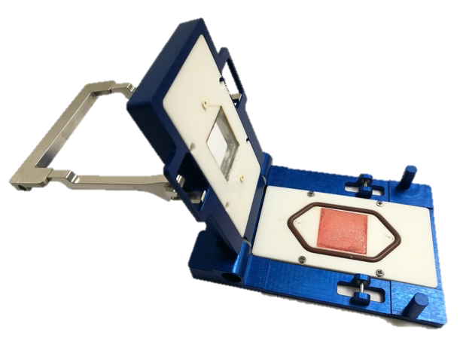
Figure 1. Microreactor | Figure 2. Effect of liquid flowrate on CO yield and concentration in gas phase.
4. Conclusions
Synthetized perovskites showed promising band gap values in the visible region; Cs₃Bi₂I₉ (1.94 eV) was chosen to evaluate its photocatalytic reduction of CO₂ in a planar 3D printed microreactor. CO₂ conversions of up to 67 % were determined and CO was identified as a product of the reaction. A maximum CO yield of 163.87 µmol/g_{cat}·h was measured and the effects of liquid flowrate and light intensity were analyzed, determining that maximum yield is achieved at 42.5 µL/min and 150 mW/cm².
References
- X. Cheng, X. Zhu, R. Chen, Q. Liao, X. He, S. Li, L. Li, Int J Hydrogen Energ 41 (2016) 2457–2465.
- X. Cheng, R. Chen, X. Zhu, Q. Liao, L. An, D. Ye, X. He, S. Li, L. Li, Energy 120 (2017) 276–282.

