A Discrete Modeling Approach for Excess Gibbs-Energy Models Coupled with Random Sampling of Molecules.
Christoph Mayer¹, Thomas Wallek¹
1 Graz University of Technology, Institute of Chemical Engineering and Environmental Technology, Inffeldgasse 25/C, 8010 Graz, Austria
*Corresponding author: cmayer@tugraz.at
Highlights
- Condensed phase equilibrium calculations
- Ab initio distinction between isomers
- Intrinsic configurational information

1. Introduction
Thermodynamic models for fluid phase equilibria calculations, such as equations of state and activity coefficients, are being challenged by the need to describe complex and/or strongly oxygenated molecules. In this context, previous papers proposed ‘discrete modeling’ as a novel approach to incorporate a more detailed molecular picture into thermodynamics from scratch. The approach is characterized by the rigorous use of Shannon information as thermodynamic entropy. As a proof of concept, the thermal and caloric equations of state, heat capacity and Maxwell-Boltzmann distribution for ideal gas were derived on the basis of discrete states of individual molecules [1-2]. To further extend this approach to strongly interacting condensed-phase systems [3], a previous application of discrete Markov-chains to thermodynamic modeling [4] was modified and extended from a flat lattice towards a three-dimensional, Ising-type lattice model. The initial step of this model was the description of spherical molecules [5]. In this paper, it is extended and coupled with a force field-based random sampling algorithm to account for real substances, beyond spherical molecules.
2. Methods
From the whole lattice system, a small, three-dimensional subgroup resp. cluster of sites is picked out as a representative part of the system and the basis for thermodynamic modeling. Its stepwise formation is described by starting from one lattice site and successively adding further nearest-neighbor sites using conditional probabilities in terms of discrete Markov-chains. Such clusters can be treated as statistically independent subsystems, yet account sufficiently for cooperative effects due to molecular interactions inside the cluster. The according probability of occurrence of clusters can more vividly be rewritten in terms of probabilities of pairwise interactions which are also used by the quasi-chemical approximation by Guggenheim and derived approaches. Next, the internal energy and the Shannon entropy of the system are formulated on the basis of these pairwise probabilities. The Shannon entropy is then used equivalently to thermodynamic entropy. Constrained minimization of the free energy yields the equilibrium distribution for the probabilities of pairwise interactions. For non-spherical molecules, a random sampling algorithm is used to determine energetic interactions between molecules in a cluster together with its respective probability of occurrence.
3. Results and discussion
First, the model is derived for spherical molecules of equal size with uniform surface properties. For given system parameters like composition and interchange energies, the resulting equilibrium properties of the system, i.e. internal energy and entropy, are compared to those derived from Monte-Carlo simulations and to the quasi-chemical approximation by Guggenheim [6]. The latter represents an important limiting case, because practically all state-of-the art activity coefficient models reduce to the Guggenheim approach in the case of uniform spheres. Figure 1 compares the new model to data from Monte-Carlo simulations for spherical molecules. It is evident that the new approach considerably improves representation of Monte-Carlo data, compared to the quasi-chemical approximation, particularly at strong molecular interactions. Consequently, the new model could be used as a more precise alternative to the quasi-chemical approximation. In order to allow more realistic molecule models, it is coupled with a force field-based random sampling algorithm.
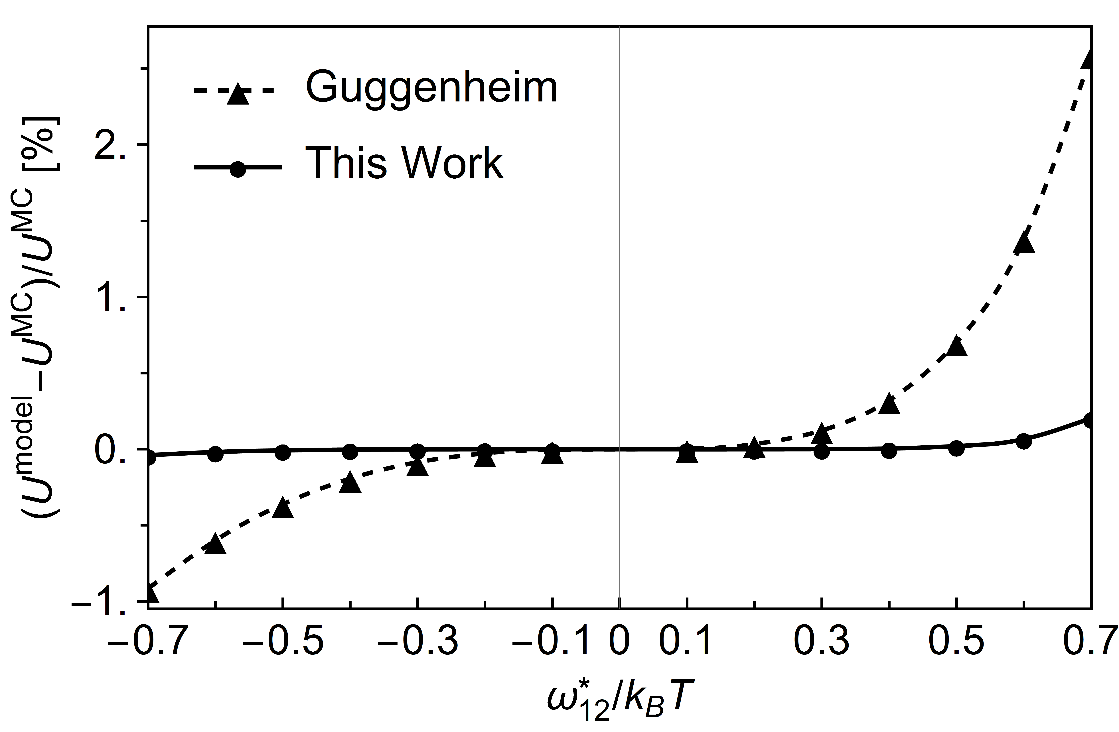
Figure 1. Relative deviation for the internal energy, U, between the models and Monte-Carlo (MC) data for a simple cubic lattice with 50³ sites at a global composition of x₁ = 0.3. ω*₁₂/k_{B}T is the dimensionless interchange energy.
4. Conclusions
Due to its better representation of spherical molecules and its intrinsic ability to distinct between isomers by using clusters as modeling basis, the proposed approach is a promising basis for further developing the method towards an activity coefficient model for liquid mixtures.
References
- Pfleger M., Wallek T., Pfennig A. Constraints of Compound Systems: Prerequisites for Thermodynamic Modeling Based on Shannon Entropy. Entropy 2014, 16, 2990-3008.
- Pfleger M., Wallek T., Pfennig A. Discrete Modeling: Thermodynamics Based on Shannon Entropy and Discrete States of Molecules. Ind. Eng. Chem. Res. 2015, 54, 4643-4654.
- Wallek, T., Pfleger, M., Pfennig, A. Discrete Modeling of Lattice Systems: The Concept of Shannon Entropy Applied to Strongly Interacting Systems. Ind. Eng. Chem. Res. 2016, 55, 2483–2492.
- Vinograd V.L., Perchuk L.L. Informational Models for the Configurational Entropy of Regular Solid Solutions: Flat Lattices. J. Phys. Chem. 1996, 100, 15972-15985.
- Wallek, T., Mayer, C., Pfennig, A.: Discrete Modeling Approach as a Basis of Excess Gibbs-Energy Models for Chemical Engineering Applications, Industrial and Engineering Chemistry Research 2018, 57, 1294–1306.
- Guggenheim E.A. Mixtures. Oxford at the Clarendon Press, 1952.

