Modelling of a hydrogen production from solar and wind under Aspen Plus
Lokmane Abdelouahed*, Mohamad Zaher, Andres Martinez, Bechara Taouk, Lionel Estel
Normandie Univ, INSA Rouen Normandie, UNIROUEN, Laboratoire de Sécurité des Procédés Chimiques, LSPC EA-4704, 76000 Rouen, France
* Corresponding author: lokmane.abdelouahed@insa-rouen.fr
Highlights
- Hydrogen production from solar and wind.
- Coupling solar and wind energy under Aspen Plus.

1. Introduction
Renewable energy sources continue to increase their share of installed capacity worldwide. This increase is pushed by the commitment to avert the risks that conventional non-renewable sources pose to health, geopolitics, the economy and the environment. According to the IEA, the renewable energy sources represents 13.4 % of the total world total primary energy supply (oil 31.8 %, natural gas 21.6 %, Nuclear 4.9 %, coal 28.1%) [1]. On the other hand, solar photovoltaic and wind energy supply has grown of an average annual growth rate of 45 % and respectively 24 % between 1990 and 2015 respectively [1]. Hydrogen is one of these carriers that has attracted much support from across many countries across the world. In fact, it has the potential to become one of the main energy carriers of the future as it can be easily produced using renewable energy, stored using commercially available technologies and used throughout the entire energy system [2] [3]. Hydrogen is considered today a very promising form of energy carrier by its ability to serve a buffer between renewable sources and the different forms of energy demand. Water electrolysis is considered one of the most mature and clean method to produced hydrogen. Renewable energy sources continue to increase their share of installed capacity worldwide. This increase is pushed by the commitment to avert the risks that conventional non-renewable sources pose to health, geopolitics, the economy and the environment. According to the IEA, the renewable energy sources represents 13.4 % of the total world total primary energy supply (oil 31.8 %, natural gas 21.6 %, Nuclear 4.9 %, coal 28.1%) [1]. On the other hand, solar photovoltaic and wind energy supply has grown of an average annual growth rate of 45 % and respectively 24 % between 1990 and 2015 respectively [1]. Hydrogen is one of these carriers that has attracted much support from across many countries across the world. In fact, it has the potential to become one of the main energy carriers of the future as it can be easily produced using renewable energy, stored using commercially available technologies and used throughout the entire energy system [2] [3]. Hydrogen is considered today a very promising form of energy carrier by its ability to serve a buffer between renewable sources and the different forms of energy demand. Water electrolysis is considered one of the most mature and clean method to produced hydrogen.

2. Methods
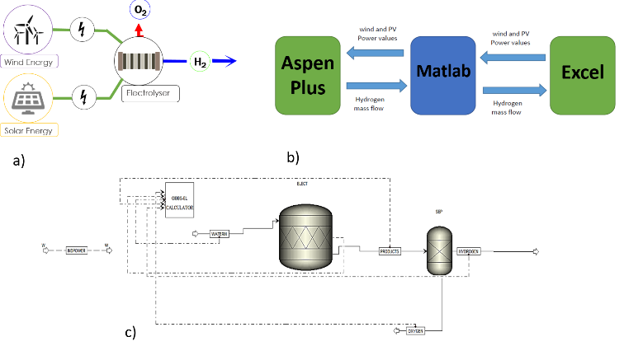
Figure 1: a) Global pilot scheme, b) Coupling Aspen Plus, Excel and Matlab and c) Modeling under Aspen Plus.
The objective of this work is to build a simulation model under Aspen Plus to estimate the hydrogen production from the electrolysis process using wind and solar energy as input power (Fig 1.a). This model will take into account the availability of solar and wind energy for different geographical locations and different PV and wind turbine technologies. The water electrolysis process is modeled in ASPEN PLUS and coupled with the renewable energy models thanks to Matlab and excel interaction. In the case study, the overall model shows a good performance and a high sensitivity to renewable energy availability.
3. Results and discussion
The water electrolysis process powered by renewable energy has been simulated in ASPEN PLUS. A case study in 2 geographical locations has been done to test the model. As a first validation, the results show a very good performance in reflecting the renewable energy availability between different locations and environmental conditions.
4. Conclusions
This work aims to create a techno-economic model and investment decision support tool that can technically and financially optimize the production and the commercialization of renewable hydrogen. The electrolysis simulation model can be enhanced by taking into account the over voltage and the faradic efficiency in an actual elecrtolyser. This will result in more power needed to obtain the same yield of hydrogen in the case of an ideal electrolyser.
References
[1] IEA, "Renewables Information," IEA publishing, Paris, 2017.
[2] [Online]. Available: http://www.nweurope.eu/media/3517/gencomm-smart-h2-positon-paper-march-2018.pdf.
[3] K. Mazloomi and C. Gomes, "Hydrogen as an energy carrier: Prospects and challenges," Renewable and Sustainable Energy Reviews, vol. 16, p. 3024–3033, 2012.

