Preferential Adsorption in Electrolyte Mixtures
Max F. Döpke¹, Remco Hartkamp¹
1 Process & Energy Department, Delft University of Technology, Leeghwaterstraat 39, 2628 CB Delft, The Netherlands
*Corresponding author: r.m.hartkamp@tudelft.nl
Highlights
- Preferential adsorption is driven by a balance between interactions
- Different surface sites show preference to different electrolytes

1. Introduction
Interfaces between aqueous solutions and oxide surfaces are critical to a plethora of industrial and biological systems. Solutions typically contain various monovalent and multivalent electrolytes. However, countless studies have considered solutions with only a single electrolyte to represent systems in which the concentration of one electrolyte is dominant, such as seawater.
Although such an approach may be appropriate for the study of bulk fluid properties, local properties at the solid-liquid interfaces can be highly ion specific. Consequently, even electrolytes that are present in small quantities can dominate the electric double layer (EDL) and thus play a key role in nanofluidic transport, sensing,¹ energy storage, sensing and electrochemical processes.
This study reveals the origin of preferential ion adsorption onto an amorphous oxide surface. Furthermore, we show how traditional electric double layer models fall short in predicting or fitting the ion distribution in the case of electrolyte mixtures.

2. Methods
Experimental techniques often rely on fitting measurement data to EDL models (such as variants of the Gouy-Chapman model) and macroscopic transport relations to infer quantities that cannot be directly measured.² Such simplified models disregard ion specificity and assume that the solid surface is flat and homogeneous and that fluid transport coefficients are constant in space. Alternatively, molecular dynamics (MD) simulations can provide detailed insight into the three-dimensional EDL structure and local transport properties, without the need for an assumed EDL model. As such, MD offers an appealing approach to gain detailed insight into interfacial properties and can aid in improving models and assumptions used for interpreting experimental measurements.

3. Results and discussion
Using all-atom MD simulations³ of NaCl-CaCl₂ solutions in a charged oxide nanochannel (Figure 1), we found that Na⁺ and Ca²⁺ ions were simultaneously adsorbed to the surface, with some surface sites showing a distinct preference for Na⁺ and others for Ca²⁺. Although Ca²⁺ ions experience stronger electrostatic attraction to the negatively charged surface sites, their large and strong hydration shell forms a steric hindrance at some of the surface sites, whereas the hydration shell of the Na⁺ ions does not suffer from the same hindrance. Using a metric to quantify the geometry of surface sites, ion-specific adsorption can be successfully predicted.
Turning to adsorption kinetics, Ca²⁺ ions were found to be adsorbed much longer than Na⁺, with adsorption times depending on the specifics of the surface site. As such, the presence of even small quantities of preferentially adsorbed ions can dramatically alter interfacial dynamics, including fluid-wall slip, interfacial viscosity enhancement, and conductance.
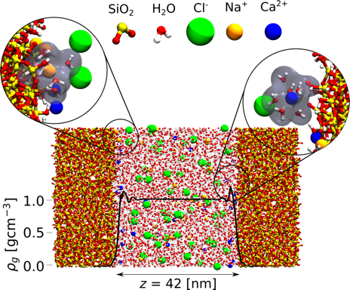
Figure 1. Channel configuration for simulations with fluid density overlaid on the channel. The left inset shows Na⁺ adsorption, with the hydration shell penetrating the wall. Right inset shows Ca²⁺ adsorption, with the hydration shell remaining intact.
4. Conclusions
Surface roughness, as well as placement and orientation of surface sites, severely impacts preferential adsorption. Insight from MD simulations into the relation between surface structure and preferential adsorption can help to interpret experimental measurements and can also be used to microengineer surfaces with selectivities for specific ions.

References
- R. Sivakumarasamy, R. Hartkamp, B. Siboulet, J.-F. Dufreche, K. Nishiguchi, A. Fujiwara, N. Clement, Nature Mater., 17, 464-470 (2018)
- R. Hartkamp, A.-L. Biance, L. Fu, J.-F. Dufreche, O. Bonhomme, L. Joly, Curr. Opin. Colloid Interface Sci., 37, 101-114 (2018)
- M.F. Döpke, J. Lützenkirchen, O.A. Moultos, B. Siboulet, J.-F. Dufreche, R. Hartkamp, in preparation

