3D-structuring of highly filled nanoparticle-reinforced epoxy composites by vibration-controlled nozzle
Lisa Windisch¹, Benedikt Finke¹, Carsten Schilde¹
¹ Institute for Particle Technology, TU Braunschweig, Volkmaroder Str. 5, 38104 Braunschweig, Germany
*Corresponding author: l.windisch@tu-bs.de
Highlights
- Composite materials with particulate contents up to 90 wt% can be achieved.
- Material combinations and powder layering can generate functionally graded components
- Composite samples can further be adapted locally by microdosing of fine powders with high resolutions and accuracies.

1. Introduction
Composite materials are the fundament for a wide variety of applications in areas such as aerospace, shipbuilding, or electromobility. Compared to pure materials, they make it possible to increase the efficiency of structures significantly. Additionally, by using nanomaterials, especially nanoparticles, product properties can be further improved, or even new properties can be achieved. Through 3D-structuring of components, properties can be adapted even more individually and locally, resulting in a wide variety of design possibilities. Especially when dealing with fine powders, precise and high-resolution dosing of materials remains a major challenge in research and development. Microdosing is relevant, for example, in the pharmaceutical industry for exact dosing of smallest amounts of active substances or in additive manufacturing processes for varying the properties of the powder bed.
2. Methods
Nanoparticles (CNTs, Carbon Black and AluC) as well as the intermixture of epoxy resin HexFlow RTM6 (Hexcel Corporation) and the corresponding diamine based hardener were dissolved in MEK using an ultrasonic dispersing device at 40 °C for 30 – 120 min with particulate contents of 1-5 wt% in the suspension. The stability of these suspensions against reagglomeration was characterized via transmission measurements using the Turbiscan Lab (Quantachrome, 25 °C) and particle size analysis via laser diffraction method (Nanophox, Sympatec). Subsequently, the solvent phase was evaporated for 90 min in a lab kiln at 50 °C. The remaining suspensions with solids content between 10 wt% and 90 wt% were grinded in a steel mortar. The composite powder was further processed by hot press molding at a temperature of 150 °C and a specific molding pressure of approx. 6 kN/cm² for 180 min. The unmolded composite cubes were polished for further characterization, e.g. measurement of the electrical (four-point measurement) and mechanical (nanoindentation with Berkovich tip; Triboindenter, Hysitron) properties or visual analysis by scanning electron microscopy (Helios G4 CX, FEI). The 3D-structuring was carried out using a self-constructed setup for piezo-controlled microdosing of fine powders. The experimental setup and the dosing behaviour were evaluated using model particles (boehmite, γ-AlOOH), whereby the influence of various particle properties such as surface roughness and bulk properties (e.g. flow properties) was investigated.
3. Results and discussion
The resultant mechanical, thermal and electrical properties show a distinct enhancement with increasing particulate content. By mixing and layering of powder based composite materials, tailor made functionally gradients like shown in Fig. 1 (left) have been generated. With CNT fillings maximal electric conductivities of 838 S/m at a content of 60 wt% have been achieved. Deviations can be seen in the peripheral areas of the specimens, caused by air inclusions in the composite structure due to the production process. Stabilization of the particulate material in the solvent matrix by additives showed a huge impact on the homogeneity of the samples. Specimen properties have further been adapted by local deposition of fine powder quantities. By varying dosing parameters like sonication energy, pulsation time and inner nozzle diameter a strong correlation between particle interactions and dosing behaviour was found. Powder quantities of down to 50 µg (V_{Powder heap} = 0.5 x 0.5 x 0.2 mm = 0.05 mm³) were deposited with high accuracy (Fig.1, right).

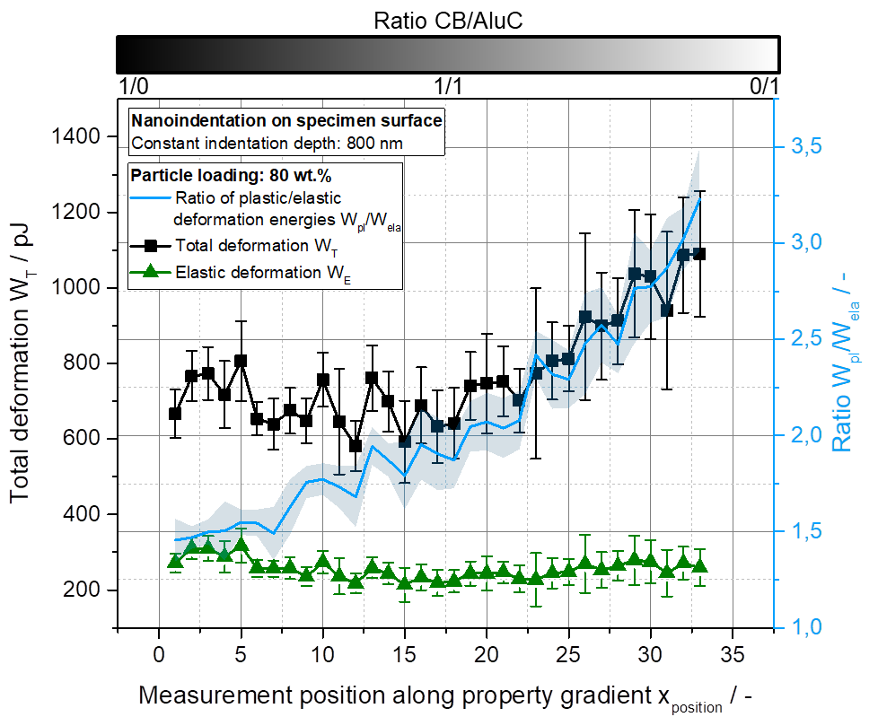
Figure 1. Property profile of a graded specimen with a CB and AluC content of 80 wt% (left) and micrometer ranged powder heaps deposited by vibration-controlled nozzle (right).
4. Conclusions
In this process high particulate loadings between 10 wt% to 90 wt% are realized. High loadings of filler materials have a great potential for an extraordinary modification and enhancement of epoxy resins and other polymers regarding thermal, electrical and mechanical properties and even though the processing is difficult, they are relevant for new design and construction concepts [1]. The resulting properties are investigated for various particle types, stabilization and loadings. By powder layering, functionally graded components have been generated. The gradient shows up as a clear profile in the measured values. An experimental setup for 3D-structuring of materials was successfully established and correlations between the dosing behaviour and the particle properties have been revealed, making it possible to produce tailor made components with individual properties.
References
- C. Schilde et al., Composites Science and Technology 117 (2015) 183–190.

