**Single crystals of metal-organic coordination complexes  
by using CO2 as antisolvent**

Margarethe Roskosz*\**1, Sabine Kareth1, Bert Mallick², Marcus Petermann1

1 Chair of Particle Technology, Ruhr University Bochum, Universitaetsstrasse 150, 44801 Bochum, Germany;

*2 Inorganic Chemistry II,* *Ruhr University Bochum*, Universitaetsstrasse 150, 44801 Bochum, Germany

*\*Corresponding author: roskosz@fvt.rub.de*

**Highlights**

* Gas antisolvent crystallization of metal-organic coordination complexes.
* Tunable crystal sizes and suitable crystals for single crystal X-ray diffractometry.
* Reduction of crystallization time compared to conventional methods.

**1. Introduction**

In pharmaceutical and fine chemicals industries, crystallization methods are well-established for the production of solid products. The driving force in crystal formation is supersaturation. Conventional techniques such as cooling or evaporative methods are not always suitable for producing fine and pure particles. Crystallization with compressed gases or supercritical fluids seems to be a promising alternative technique. One version of this technique is the gas antisolvent process (GAS). In this method, a gas is added to a solution, loaded with the desirable substance. The solvent power of the conventional solvent decreases, while a rapid volume expansion occurs. Supersaturation triggers off the precipitation of particles. [1-2]

Research on this method was focussing on precipitation of small and uniform crystals, modifying particle properties. We would like to introduce the GAS crystallization as a possible method for producing crystals large and clear enough for single crystal X-ray diffractometry. This analytical technique provides detailed information about the internal lattice of crystalline substances and is most commonly used for identification of crystal structures. The chosen class of metal-organic coordination complexes is a quite new one, in which direct structural solutions on the molecular level are important to reveal the chemical structure obtained. [3]

**2. Methods**

The gas antisolvent crystallization was tested on various metal-organic coordination complexes similar to the copper complex. These results are presented as example.

**Complex synthesis.** 0.1 g of copper(II) acetate and the organic linker, diethyl cyanomalonate, were dissolved in a 1:2 metal:ligand molar ratio in 70 ml chloroform and stirred for 24 h at room temperature. The metal-organic coordination complex was obtained as a precipitate in powder form, that was filtered and vacuum dried for 12 h.

**Gas antisolvent crystallization**. For the crystallization CO2 was used as an antisolvent. The experi-ments were carried out in a high-pressure view cell loaded with a solution of the metal-organic coordination complex in a chosen solvent. A crystallization time of 2 h, a pressure of 100 bar and a temperature of 40 °C were set. After the specified time, the autoclave was purged for 30 min with CO2. The precipitate was obtained as crystals. [4]

**3. Results and discussion**

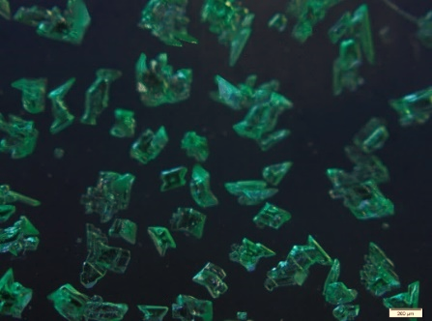The GAS crystallization was performed with three different starting concentrations, but same temperature and pressure profile. The products of the antisolvent crystallization were obtained as green crystals. With decreasing the initial concentration, a decreasing average size and an increase in uniformity of the crystals can be observed. Most of the crystals were obtained with a minimum size of 50-200 µm, sufficient for single crystal X-ray diffractometry (figure 1).

**200 μm**

**200 μm**

**200 μm**

**C**

**B**

**A**

**Figure 1.** Microscopic images of crystals from GAS crystallization from different starting concentrations;   
A: 15 mg/ml; B: 7.5 mg/ml; C: 5 mg/ml.

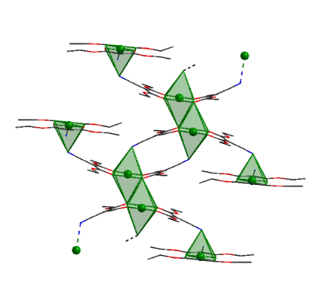The data sets from the X-ray analysis showed that the structure of the copper complex, obtained from the antisolvent crystallization, is a one-dimensional coordination polymer (figure 2). For comparison, the same copper complex was also crystallized by evaporating the solvent at room temperature. Crystals were obtained after days to weeks, depending on the concentration and the chosen solvent. Those data sets from the X-ray analysis showed the same one-dimensional coordination polymer, like from the GAS crystallization.

**+ Cu 2+**

**Figure 2.** Formation route of the copper complex build of diethyl cyanomalonate and copper(II) acetate.Molecular crystal structure obtained from single crystal X-ray data sets. (copper: green; oxygen: red; nitrogen: blue; carbon: black)

**4. Conclusions**

The use of CO2 as an antisolvent opens up new possibilities for the crystallization of metal-organic coordination complexes next to other solids. It was possible to get X-ray suitable single crystals from different starting concentrations. Compared to the conventional method, these crystals were obtained just in a few hours, instead of days or weeks. In this case no structural differences have been determined. Compared to the evaporation crystallization, this method would be a possible alternative to conventional crystallization methods.

**References**

1. P.M. Gallagher, ACS Symp. Ser. 406 (1989) 334-35.
2. J. Jung, M. Perrut, J. of Supercritical Fluids 20 (2001) 179–219.
3. L. Li, CrystEngComm 15 (2013) 4094-4098.
4. M. Roskosz, International Symposium on Supercritical Fluids (2018).