Characterization of macrophyte Eichhornia crassipes: potentiality of wetlands pruning wastes in thermo-conversion processes.
Eliane Cristina Braga Martins Gonçalves¹, Francisco José Moura^{1*}, Marcos Alexandre Teixeira²
¹Department of Chemical and Materials Engineering, Pontifical Catholic University of Rio de Janeiro (PUC-Rio), Rio de Janeiro, Brazil; ²Department of Agricultural and Environmental Engineering, Fluminense Federal University (UFF), Niterói, Brazil.
*moura@puc-rio.br
Highlights
- Evaluate of thermal conversion potential of E. crassipes.
- Physical-chemical characterization of the biomass.
- Determination of the biomass thermal properties.
- Potential use of the biomass for bioenergy production.

1. Introduction
In the search for a more sustainable and equitable energy for the future, the use of biomass residues from anthropic action arises as valuable source of raw material for bio or thermo-conversion, economically viable and ecologically sustainable. In this sense, aquatic macrophytes become interesting from the standpoint of their valorization as biomass source for energy production [1]. The objective of this paper was the fully characterization of the pruning wastes from macrophyte Eichhornia crassipes from secondary sewage treatment of wastewater treatment plant, in order to investigate the potential of the use of wetlands management control pruning residues for use as a renewable fuel.
2. Methods
The plant samples were analysed as a single whole fraction, including inflorescence, sheets, root and petioles. The characterization tests were based on the methodologies proposed by Soxhlet [2], Doc236 [3] and ASTM [4]. The thermogravimetric analyses were carried out in a simultaneous thermal analyser, model Netzsch STA449 - F3 Jupiter, according to following parameters: sample mass of approximately 10 mg, temperature programming (from 20°C to 900°C), inert gas (N₂), and heating rates of 10°C.min⁻¹, 15°C.min⁻¹ and 20°C.min⁻¹.
3. Results and discussion
The bromatological and chemical analyses are essential for the evaluation of this source of biomass for thermal-conversion processes. The bromatological composition values obtained were: extractive content (4.06 wt%), lignin (9.99 wt%), cellulose (20.11 wt%) and hemicellulose (28.59 wt%). As expected for aquatic biomass, carbon (40.24 wt%) and oxygen (35.28 wt%) presented the highest content. Hydrogen and nitrogen average values obtained were 5.03 wt% e 5.71 wt%, respectively. The analysed macrophyte presented high moisture (95.19 wt%), as expected. After forced drying, the moisture remained above 10 % (11.52 wt%) for the sample analysed. The high average value of ash content (16.07 wt%) can be attributed to the contribution of roots, which usually retain in their tissues high concentrations of insoluble materials such as silicates. E. crassipes samples also presented average values of 80.96 wt% for combustibility, 70.01 wt% for volatiles, 13.91 wt% for fixed carbon, with the ratio volatile/fixed carbon higher than 3.50. The higher heat value (HHV) is directly related to biofuels effectiveness. Biomasses with ash contents of less than 25% and HHV higher than 14.65 MJ.kg⁻¹ are considered energetically efficient [6]. The samples presented HHV average value of 15.89 MJ.kg⁻¹. According to thermogravimetric analysis of biomass (Figure 1), the TGA/DTG curves presented three distinct regions of mass loss relating to moisture reduction (I), hemicellulose and cellulose degradation (II) and lignin degradation (III). The region II presented the highest mass loss (39 - 44 %), due to the lower thermal stability of hemicellulose and cellulose. The increase of the heating rate changes the maximum mass loss of biomasses to higher temperatures.
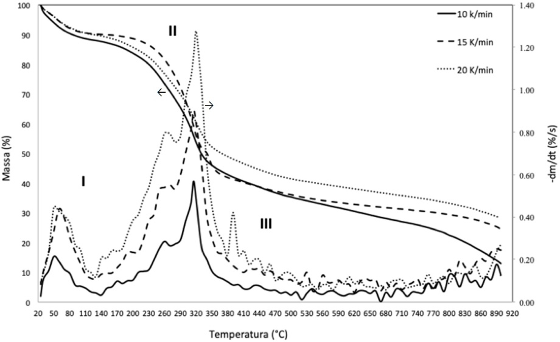
Figure 1. Influence of heating rates on TGA / DTG thermogravimetric curves.
4. Conclusions
The samples characterizations suggest that Eichhornia crassipes control pruning residues have potential for bioenergy production, especially biochar, associated with gasification rather than direct combustion process (due high ash content). High carbon and hydrogen contents affect positively the higher heat value of the biomass. High volatiles content (> 70%) increase the gas production. The biomass analysed presented HHV value of 15.89 MJ.kg⁻¹.
References
[1] Wetzel, R.G. (2011). Limnology: lake and river ecosystems, Londres: Academic Press, 850.
[2] Soxhlet, F. (1879). Die gewichtsanalytische bestimmung des milchfettes, Polytechnisches Journal, Erlangen, 232, 5, 461-465.
[3] EMBRAPA (2010). Documento 236: procedimento para análise lignocelulósica, Campina Grande: Centro Nacional de Pesquisa de Algodão, Embrapa.
[4] ASTM (2009). Standard D240: standard test method for heat of combustion of liquid hydrocarbon fuels by bomb calorimeter, West Conshohocken: ASTM, 10.1520/D0240-09.
[5] Pompêo, MLM., Moschini-Carlos, V. (2003). Macrófitas aquáticas e perifíton – aspectos ecológicos e metodológicos, São Carlos: Rima.
[6] Morais, S.A.L. de, Nascimento, E.A. do, Melo, D.C. de. Chemical analysis of Pinus oocarpa part I: quantification of macromolecular components and volatile extractives, Árvore, 29, 3, 461-470.

