Scalable production of nanostructure materials via atomic layer deposition: a way to reduce the demand for scarce materials
J.Ruud van Ommen¹
1 Delft University of Technology, Chemical Engineering dept., TU Delft Process Technology Institute, Delft, the Netherlands
*Corresponding author: j.r.vanommen@tudelft.nl
Highlights
- Applying nanostructured materials can strongly reduce the use of scarce elements.
- Atomic layer deposition is a scalable process to make nanostructured materials.
- Several examples of the use of atomic layer deposition will be shown.

1. Introduction
Nanoscience holds the promise to deliver a plethora of solutions for several grand challenges, such as abundant sustainable energy, clean drinking water and personalized pharmaceuticals. However, many of such solutions never find practical implementation, since they require scarce materials or involve poorly scalable production processes. A marriage between chemical engineering and nanoscience – scalable nanotechnology – can tackle these problems: it is possible to make scalable processes, while strongly reducing the demand for scarce materials. In some cases, novel nanostructured materials can make the use of critical elements even superfluous. Atomic Layer Deposition (ALD) is a versatile and scalable technology for making such nanostructured materials.
2. Methods
We typically take a dry, powder-form substrate that we want to treat with ALD (nanoparticles, micron-sized particles, graphene platelets, …) [1] and load some grams of it into a glass column (typical sizes are 2.5 cm diameter, 50 cm high). The powder is fluidized in an upward nitrogen flow with a superficial gas velocity of typically about 5 cm/s. We deploy ALD by alternatingly adding the two required precursors to the nitrogen flow, e.g. trimethylaluminum and water for alumina, or trimethyl(methylcyclopentadienyl)platinum(IV) (IV) and oxygen for platina, while maintaining intermediate periods without precursor for purging. The alternating addition of the two precursors is repeated until the desired film thickness or cluster size has been reached.
3. Results and discussion
In heterogeneous catalysis, noble metal clusters on ceramic or carbon supports are widely used. Ideally speaking, all metal clusters have the same size, tailored for the targeted reaction. In practice, this is impossible to reach with the production techniques the catalyst industry currently uses, such as wet impregnation and spray-drying. Using ALD, it is much better possible to create a much narrower size distribution of noble-metal clusters [2] (see Fig. 1.a). This can be used to make either catalysts with a much higher activity or a much lower noble metal loading. Either way leads to a strong reduction in the use of noble metals.
In thin film solar cells, currently often scarce materials such as indium and gallium are used. Here, using ALD alternative routes are possible than not just minimize the use of such scarce elements, but enable a completely different approach by using abundant elements such as copper, zinc and tin [3]. Another alternative might be to move to completely different technology, and apply quantum dot films that are stabilized using ALD overcoating for high-end PV applications [4].
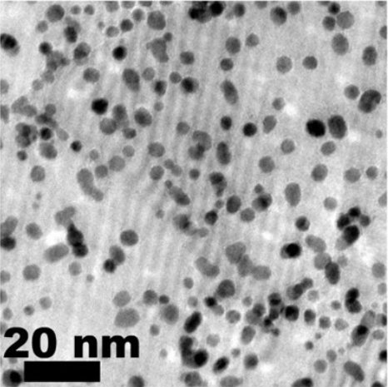  a | 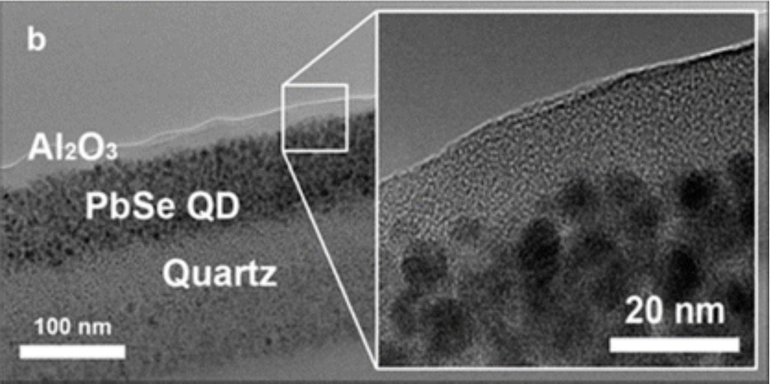
Figure 1. (a) TEM image of platinum nanoclusters deposited on graphene using ALD [2]; (b) Cross-sectional TEM image of a quantum film, in which a protecting alumina overcoating made by ALD is visible [4].

A third sector where materials scarcity plays an important role is the production of Li-ion batteries. The most pressing need for the Li-ion industry to move forward is a strong reduction of the amount of cobalt that is required [5]. Using atomic layer deposition, we can make more stable cathode materials, reducing the amount of cobalt required. However, this will need large amounts of powders to be coated. Most likely the batch-wise operation of fluidized beds is less suitable to achieve this: our continuous pneumatic transport reactor [6] will be a more attractive option for such a large-scale process.
4. Conclusions
Atomic layer deposition (ALD) can be used to provide powdered substrates with a thin film or with nanoclusters of the required materials. The high degree of control makes ALD perfectly suited to produced nanostructured materials that can be applied to strongly reduce the use of critical materials; the scalability of the method makes a smooth translation to industrial practice feasible.
References
[1] Van Bui, H., Grillo, F., & Van Ommen, J. R. 2017, Chemical Communications, 53(1), 45-71.
[2] Grillo, F., Van Bui, H., Moulijn, J. A., Kreutzer, M. T., & Van Ommen, J. R. 2017, The journal of physical chemistry letters, 8(5), 975-983.
[3] Sinha, S., Nandi, D. K., Kim, S. H., & Heo, J. 2018, Solar Energy Materials and Solar Cells, 176, 49-68.
[4] Valdesueiro, D., Prabhu, M. K., Guerra-Nunez, C., Sandeep, C. S., Kinge, S., Siebbeles, L. D., de Smet, L.C., Meesters, G.M., Kreutzer, M.T., Houtepen, A.J. & van Ommen, J. R. 2016, The Journal of Physical Chemistry C, 120(8), 4266-4275.
[5] Jaffe, S. 2017, Joule, 1(2), 225-228.
[6] van Ommen, J. R., Kooijman, D., Niet, M. D., Talebi, M., & Goulas, A. 2015, Journal of Vacuum Science & Technology A: Vacuum, Surfaces, and Films, 33(2), 021513.

Van Bui, H., Grillo, F., & Van Ommen, J. R. (2017). Atomic and molecular layer deposition: off the beaten track. Chemical Communications, 53(1), 45-71.

Grillo, F., Van Bui, H., Moulijn, J. A., Kreutzer, M. T., & Van Ommen, J. R. (2017). Understanding and controlling the aggregative growth of platinum nanoparticles in atomic layer deposition: An avenue to size selection. The journal of physical chemistry letters, 8(5), 975-983.

Sinha, S., Nandi, D. K., Kim, S. H., & Heo, J. (2018). Atomic-layer-deposited buffer layers for thin film solar cells using earth-abundant absorber materials: A review. Solar Energy Materials and Solar Cells, 176, 49-68.

Valdesueiro, D., Prabhu, M. K., Guerra-Nunez, C., Sandeep, C. S., Kinge, S., Siebbeles, L. D., ... & van Ommen, J. R. (2016). Deposition mechanism of aluminum oxide on quantum dot films at atmospheric pressure and room temperature. The Journal of Physical Chemistry C, 120(8), 4266-4275.

Jaffe, S. (2017). Vulnerable links in the lithium-ion battery supply chain. Joule, 1(2), 225-228.

van Ommen, J. R., Kooijman, D., Niet, M. D., Talebi, M., & Goulas, A. (2015). Continuous production of nanostructured particles using spatial atomic layer deposition. Journal of Vacuum Science & Technology A: Vacuum, Surfaces, and Films, 33(2), 021513.

