Inline microscopy for multidimensional particle characterization in bioprocess monitoring
Jörn Emmerich¹, Sebastian Maaß², Peter Neubauer¹, Stefan Junne¹
1 Technische Universität Berlin, Ackerstr. 76 ACK 24, 13355 Berlin; 2 SOPAT GmbH, Boyenstr. 41, 10115 Berlin
*Corresponding author: joern.emmerich@sopat.de
Highlights
- High resolution inline microscopy
- Monitoring fatty acid production by microalgae
- Correlation of Budding Index with growth dynamics in yeast fermentations
- Multidimensional and real-time image analysis

1. Introduction
The present work describes the development and methodology to apply a microscopy probe for the measurement of the sizes, shapes, colors and concentrations of particles in biological processes. To date, the direct measurement of these parameters inside the process is a challenge, since the monitoring instrumentation has to be applicable under various process conditions and in different process phases. High particle concentrations, different particles in multiphase systems or changing particle features and velocities are challenging for an inline measurement method. For microscopy in particular, overlapping signals and background can disturb object identification. Nevertheless, recent advances in photo-optics and image processing allow to generate images with a high level of details even under demanding process conditions. This makes it easier to extract individual features from the images. Coupled with image analysis, it allows precise and automated real-time measurements of particle size, shape and concentration.
In this study, an inline microscopy probe was particularly developed for the application in microbial bioprocesses, in which the microbe changes its morphology during the process phases. In a first study, morphological changes in fed-batch cultivations of the heterotrophic algae Crypthecodinium cohnii were monitored. It is shown that both size and shape changes relate to the intracellular accumulation of the polyunsaturated fatty acid docosahexaenoic acid (DHA).
In a second study the morphological heterogeneity in yeast fermentations of Saccharomyces cerevisiae is investigated by inline microscopy. By means of automatic image analysis, various budding states of the yeasts can be investigated. It is possible to classify budding yeasts with a daughter cell and non-budding yeasts into two different classes. The relation of the two different size and shape distributions resulting from the two classes can be correlated with the growth activity at any point during the process, and thus conclusions on the growth dynamics can be derived.
2. Methods
The general working principle of inline microscopy is bringing the focal plane of the microscopic objective into the sample, which is usually the flow regime inside a process. Therefore, inline microscopes need to be more compact and robust to be integrated into a process. The acquired images are analyzed with an artificial neural network. The employed U-Net is a deep convolutional network for a more advanced segmentation of images. The network learns to segment images in an end to end setting.
3. Results and discussion
In this study, changes in the cell size distribution of the heterotrophic microalgae C. cohnii were tracked with an offline holographic microscopy and an inline photo-optical microscopy probe (Figure 37 – a). The accumulation DHA, which is a product of major interest as a dietary supplement for fish production leads to a larger cell diameter (Hillig et al., 2014). On the basis of the cell size and broadness of the size distribution, the applied inline photo-optical measurements enabled to distinguish between cells in the growth phase with little or no intracellular lipid droplet accumulation and production phase with lipid droplet accumulation (Figure 37 – b).
Under conditions of low growth and high fatty acid accumulation, the cell sizes and its distributions were changing accordingly. The correlation between the predicted inline measurements based on the Sauter mean diameter and the measured intracellular DHA content with GC-FID was confirmed and showed a maximum coefficient of determination (R) of 0.983 by regression analysis (Figure 37 – c).
The results obtained by digital holographic and the side scatter values from flow cytometry, which was performed as golden standard method for single cell measurement, were in good agreement with the inline microscopy, which enables this method to photo-optically measure DHA content in real-time (Marbà-Ardébol et al., 2017).
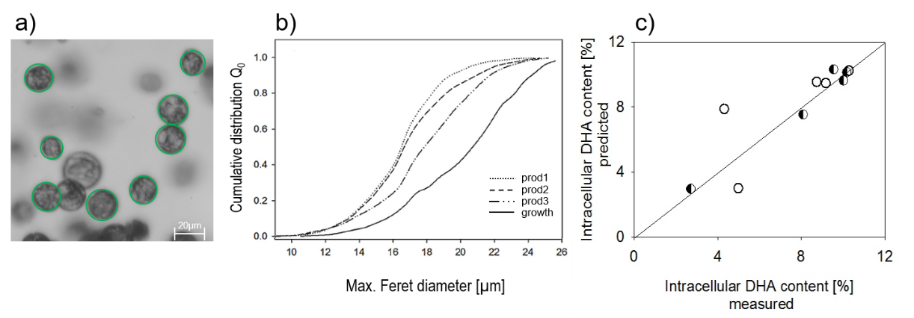
Figure 37: a) Segmented cells, b) Cumulative size distributions in different growth states, c) Second order correlation between DHA content measured offline (GC-FID) and predicted DHA content based on the measured Sauter mean diameter with inline microscopy. Values used for calibration ( ) and for prediction ().

Yeast is one of the most important species in biotechnology. In this study Baker’s yeast S. cerevisiae and its morphological changes during fermentation is monitored inline. The morphology of yeast cells is altering during maturation, depending on the growth rate and cultivation conditions. Inline microscopy was used to monitor such morphological changes of individual cells directly in the cell suspension. With automated image analysis it was possible to analyze budding and non-budding cells in parallel based on a trained artificial neural network. Deviations between automated and manual counting were considerably low (Figure 38 – a and b).
The homogeneity among the population during the growth phase increased and at growth retardation, the portion of smaller cells increased due to a reduced bud formation. The maturation state of the yeast cells was determined by the budding index, which Is defined as the ratio between the number of budding cells and the total number of cells. Inline monitoring showed a linear correlation between the budding index (BI) and the growth rate during the batch cultivation (Figure 38 – c and d). An real-time differentiation of growth activity across all process stages of several batch cultivations in complex media became feasible (Marbà-Ardébol et al., 2018b).
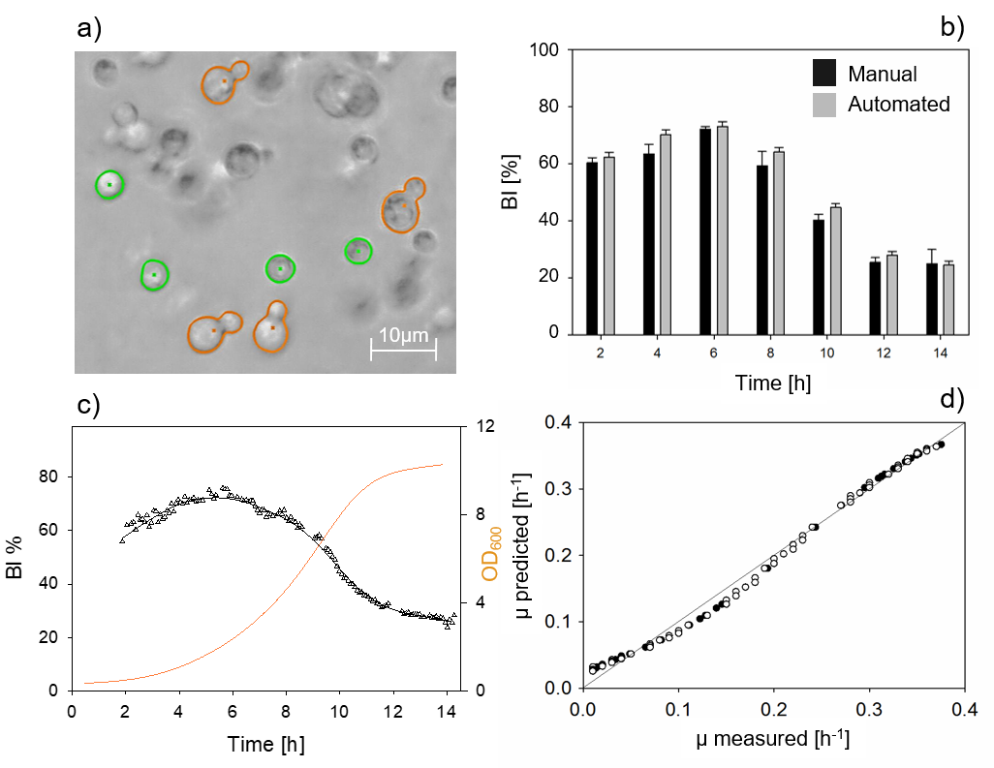
Figure 38: a) segmented and classified cells into budding and non-budding cells, b) Comparison between the budding indices obtained automatically (black bars) and with manual counting (gray bars) resulting in a confidence interval R²=0,99, c) monitored BI as determined with inline microscopy and OD₆₀₀ of cultures, d) the correlation of predicted and measured growth rates.

4. Conclusions
The presented inline microscope provides accurate automatic particle recognition in highly concentrated disperse systems and provides statistically robust parameters within short calculation times (<5min). The consideration of population heterogeneity based on morphologic features becomes feasible. The method allows both, a deeper understanding of functional relationships in bioprocesses as well as process control - by faster response on process changes.
References
[1] Hillig, F., Porscha, N., Junne, S. and Neubauer, P., Engineering in Life Sciences, 2014, 14(3): 254-263.
[2] Marbà-Ardébol, A.-M., Emmerich, J., Muthig, M., Neubauer, P. and Junne, S., Microbial Cell Factories, 2018, 17(1): 73.
[3] Marbà-Ardébol, A.-M., Emmerich, J., Neubauer, P. and Junne, S., Process Biochemistry, 2017, pp. 223-232.
[4] Ronneberger, O., Fischer, P. and Brox, T., Springer International Publishing, 2015, Cham, pp. 234-241.

