Structuring and functionalization of magnetic nanoparticles for biotechnological applications
Lennart Kleinfeldt^{1,2}, Johannes Gädke^{2,3}, Rebekka Biedendieck^{4,5}, Rainer Krull^{2,3},
Georg Garnweitner^{1,2,}*
1 Institute for Particle Technology, Technische Universität Braunschweig, Germany; 2 Center of Pharmaceutical Engineering (PVZ), Technische Universität Braunschweig, Germany; 3 Institute of Biochemical Engineering, Technische Universität Braunschweig, Germany; 4 Institute of Microbiology, Technische Universität Braunschweig, Germany; 5 Braunschweig Integrated Centre of Systems Biology (BRICS), Technische Universität Braunschweig, Germany
*Corresponding author: l.kleinfeldt@tu-braunschweig.de
Highlights
- Synthesis and hierarchical structuring of superparamagnetic iron oxide nanoparticles
- Functionalization with ligand that interacts specifially with recombinant model proteins
- Highly efficient purification and regeneration over multiple cycles
- Modification of nanoparticle structures in terms of magnetization and morphology

1. Introduction
Magnetic nano- and microparticles have become highly promising for diverse areas of biomedicine, including in vitro applications in diagnostics and downstream processing due to their highly selective manipulation possible by applying external magnetic fields.^{[1]} For these applications, homogeneous particle properties, e.g. the magnetization, are of crucial importance, allowing a uniform response and defined chemical and physical characteristics. In addition, the surface chemistry must be tailored for the intended application to ensure stability of the particles against agglomeration in the desired medium as well as the targeted interaction with the biological system.
2. Methods
A multi-step synthesis process for biofunctionalized superparamagnetic iron oxide nanoparticles has been established and their application for the purification of recombinant model proteins has been investigated in detail. As-synthesized nanoparticles were structured to hierarchical micron-sized aggregates in a spray drying process to improve the magnetic separation efficiency. The aggregate surface was then modified with a previously established ligand system capable of forming metal complexes with histidine tags that allows for the use in multiple separation cycles.^{[2]} In situ purification experiments were performed, separating recombinant proteins with His₆-tags produced by genetically engineered Bacillus megaterium in a lab-scale stirred tank bioreactor with an external separation loop using handheld magnets.^{[3]} Additionally, the modification of the aggregates was studied by varying the magnetization after the partial substitution of the magnetic iron oxide nanoparticles with silica nanoparticles.
3. Results and discussion
Structuring of iron oxide nanoparticles via spray drying of aqueous suspensions leads to micrometer-sized aggregates with a specific magnetization comparable to that of the individual nanoparticles. Modification of the aggregates via addition of silica nanoparticles to the suspension allows for control of the resulting magnetization by adjusting the iron oxide content. Moreover, the morphology of the produced aggregates is gradually shifted from irregular inflated-like shapes in case of pure iron oxide aggregates to spherical structures when bringing the silica-content to only 20 % (see Figure 1).
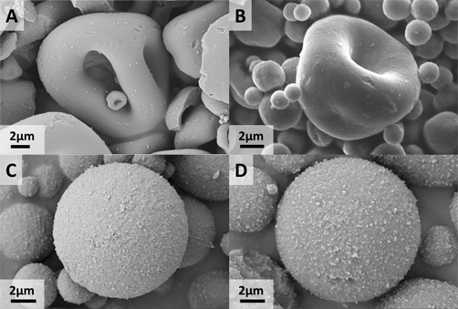
Figure 1. Scanning electron micrographs of spray-dried aggregates with an iron oxide content of (A) 100 %, (B) 90 %, (C) 80 %, and (D) 40 %, respectively.
High efficiency magnetic separation of aggregates with different magnetization is shown. Functionalization of pure iron oxide aggregates with a previously coupled ligand holding an NTA moiety and subsequent loading with Ni²⁺-ions leads to the ability to bind His₆-tagged target proteins via a chelation complex. The functional recyclability of the particles and the successful application of protein purification in an automated set-up over multiple cycles with a protein purity above 97.5 % will be presented.
4. Conclusions
The successful synthesis of superparamagnetic iron oxide nanoparticles and their structuring in a spray-drying process with subsequent functionalizaton for bioseparation processes will be shown. The highly efficient selective purification of recombinant proteins over mutliple cycles will be demonstrated.
References
- J. Gädke, J.-W. Thies, L. Kleinfeldt, T. Schulze, R. Biedendieck, I. Rustenbeck, G. Garnweitner, R. Krull, A. Dietzel, Eur. J. Pharm. Biopharm. 126, (2018), 67-74
- J. Gädke, L. Kleinfeldt, C. Schubert, M. Rohde, R. Biedendieck, G. Garnweitner, R. Krull, J. Biotechnol. 242 (2017) 55-63
- J. Gädke, J.-W. Thies, L. Kleinfeldt, A. Kalinin, G. Starke, A. Lakowitz, R. Biedendieck, G. Garnweitner, A. Dietzel, R. Krull, Biochem. Eng. J. 126 (2017) 58-67

