Use of a filamentous fungus for phosphorus solubilization in iron ore tailings.
José Daniel Gonçalves Vieira*¹, Glalber Luiz da Rocha Ferreira¹, Geraldo Sadoyama², Nelson Roberto Antoniosi Filho ³
¹ Environmental and Biotechnology Laboratory. Instituto de Patologia Tropical e Saúde Pública. Universidade Federal de Goiás. 74605-050, Goiânia, GO, Brazil
²Departamento de Biologia, Universidade Federal de Goiás, Campus Catalão
³Laboratório de Métodos de Extração e Separação. Instituto de Química. Universidade Federal de Goiás
*Corresponding author: jdgvieira62@gmail.com, +55 6232096527
Highlights
- Efficiency solubilization of phosphate present in iron ore.
- Iron ores wastes may be used as source of phosphorus when properly treated.
- Biolixiviation using fungus proved to be efficient for reduction of phosphorus in iron ore tailings reducing its environmental pollution.
1. Introduction
In iron and steel production chain, phosphorus element is present in almost all stages, tending to concentrate during the extractive process, due to its ability to pass from the oxidized form to elemental form, being present in metallic iron after reduction mineral (Delvasto et al., 2009). Steel produced at high phosphorus levels will be brittle and can easily break, hence the need for dephosphorization (Chime et al., 2011). As a result, different iron dephosphorization techniques have been developed. These methodologies tend to have high production costs with low productivity (Mendes et al., 2013, Xiao et al., 2015). In view of this problem, it is necessary to develop sustainable and cost-effective processes for the exploitation of minerals containing different levels of phosphorus (Liu et al., 2015). One of the most promising solutions is the use of microorganisms in a process called microbial bioleaching, when compared to other physical-chemical processes (Chime et al., 2011). Its advantage is the use of mild conditions, usually without addition of toxic chemicals. The objective of this work was to test a filamentous fungus isolated from the iron ore tail itself in the solubilization of the phosphorus present in this ore.
2. Methods
Fungus was isolated by enrichment cultivation in NBRIP medium (Nautiyal, 1999), whose phosphate was withdrawn and added 5g of iron ore tailings for the fungus isolation and also as N₂ source. Erlenmeyers containing 50mL of medium were incubated under agitation (130 rpm) at a temperature of 30 ± 2 °C. Every 7 days 1.0 ml aliquot was withdrawn and inoculated into fresh culture medium and incubated for another 7 days. This process was repeated two more times. After last repeat, aliquots were taken, diluted conveniently and inoculated into Petri dishes containing NBRIP medium plus Ca₅(OH)(PO₄)₃ as source of phosphorus. Plates were incubated in a BOD oven at 30 ± 2 °C for a period of 7 days. Colonies that had a characteristic halo of phosphorus solubilization were isolated. Following parameters were determined: growth curve, pH evolution, acid phosphatase activity, phosphorus solubilization. Parameters were performed for 168 hours with collection of 24/24 hours. For growth curve, samples were taken at described time, filtered in previously weighed Millipore® type filter (0.22μm). The material was dried in a desiccator with silica gel in an oven at 30 °C for 24 hrs until constant weight and the fungus mass was deteminated. pH was determined in aliquot of the aliquots after centrifugation using a pHmeter. Phosphatase acid activity was performed using the Labtest® Trade Kit according to the manufacturer's guidelines. Phosphorus solubilization was performed by dosage of the solubilised phosphate using the Spectro Kit of the Alfakit® brand, according to the manufacturer's guidelines.
3. Results and discussion
Results obtained for determination of fungic mass, pH, acid phosphatase activity and phosphate solubilization can be observed in Figure 1.

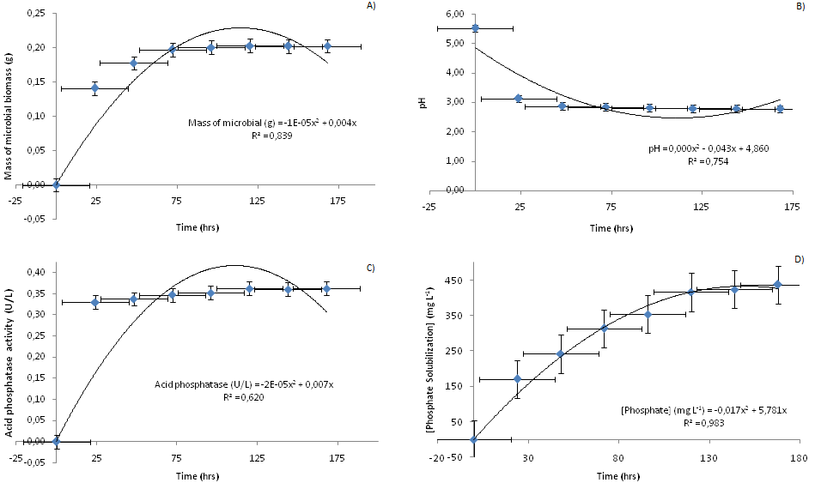
Figure 1. Results obtained for determination of fungal mass (A), pH (B), acid phosphatase activity (C) and phosphate solubilization (D).

According to analyzed parameters, it was observed that, between 144 and 168 hours, its stabilization occurred (Fig. 1). Xiao et al. (2015) testing dephosphorization of iron ore with high concentration of phosphorus by different strains of Aspergillus niger, observed similar results of pH reduction, phosphorus solubilization and fungal growth. Phosphate biosolubilization has been shown to be a very efficient process for conversion of insoluble phosphate into phosphorus, corresponding to a solubilization of 43% in 7 days of incubation, ie, equivalent to a mass of 0.1539 g of phosphate in the counterpart of 0.3576 g of iron ore.
4. Conclusions
Using of filamentus fungus for phosphorus solubilization, present in iron ore tailings, proved to be efficient in this study. Researches are underway to make this process feasible on a large scale
References
- T.O. Chime, M.C. Menkiti, O.D. Onukwuli, New York Science Journal (2011): 1-6.
- Z. Liu, Y.C. Li, S. Zhang, Y. Fu, X. Fan, Appl. Soil Ecol., (2015): 217-224.
- G.O. Mendes,. C.S. Dias, I.R. Silva, J.I.R., Júnior, O.L. Pereira, M.D. Costa, World J. Microbiology Biotech. (2013): 29-43.
- C.S. Nautiyal, FEMS Microbiol. Lett. (1999): 265-270.
- C. Xiao, X. Wu, R. Chi, Appl. Bioch. Biotech. (2015): 518-528.

