Development of a high pressure bioreactor system for the production of biomethane from CO2 using an axenic methanogenic culture as biocatalyst
Sébastien Bernacchi^{1,*}, Arne H. Seifert¹
Krajete GmbH, Josef Perger-Straße 2, 3031 Pressbaum, Austria
*Corresponding author: sebastien@krajete.com
Highlights
- Gas to gas (GtoG) converting bioprocess
- CO₂-BMP, an axenic unsterile methanogenic archaea-based process using a fully defined mineral medium for growth
- Gas limitation and liquid limitation in gas converting bioprocesses
- Continuous and intermittent bioprocessing of industrially sampled H₂/CO₂ gas mixtures

1. Introduction
Over recent years the interest in new biofuel generations, based on converting gaseous substrate(s) such as carbon dioxide (CO₂), carbon monoxide (CO) or hydrogen (H₂) to gaseous product(s), arose. An example for such a gas converting bioprocess is the biological methane production process using CO₂ as sole carbon source (CO₂-BMP) [1]. Axenic cultures of Methanothermobacter marburgensis grown in a defined mineral medium already proved that high conversion rates of CO₂ and H₂ to methane (CH₄) can be reached [2]. However, this bioprocess was often described in literature as a gas transfer limited bioprocess [3]. Therefore, the kinetic limitation towards an increased methane productivity cannot be overcome solely by the growth of more biomass during continuous operation. More important is the development of a suitable bioreactor system that allows reaching a high mass transfer of the limiting gaseous substrate (H₂) in the liquid phase once an appropriate feeding strategy is applied to maintain sufficient biocatalyst in suspension for converting all the dissolved reactive gases. This work will present development steps [4], [5], methods [6], [7] as well as the applied bioprocess control approach [8] that enabled to construct and operate a custom designed and manufactured high pressure 20 L bioreactor system to overcome the so far existing performance limitations. In this setup, a methane evolution rate (MER) higher than 1.4 mol_{CH4} L_{broth}⁻¹ h⁻¹ was reached using an axenic chemostat culture of Methanothermobacter marburgensis grown on a defined mineral medium at pressures up to 16 bar while using solely CO₂ as carbon source. The application of this feed forward control strategy enabled to predict and control biomass growth during operation which in return allowed to convert more than 99% of the applied 2.9 vvm [NL_{gas} L_{broth}⁻¹ min⁻¹] of H₂-CO₂ into a high purity bio-CH₄ (>95 Vol.% CH₄ in the raw wet gas).
2. Methods
The integrated modular development workflow that will be presented consists of studying the biomethanation process from different angles and using different “levels” of pressurized H₂ and CO₂ gas mixtures to unscramble both, the potential physiologic limitation that could arise on one side, and the benefits of high pressure on the reaction kinetic on the other side. The following aspects have been investigated: pressure tolerance, media demands, feed strategy development for fermentation and validation runs in continuous culture to reach performances above 20 kg_{CH4} m⁻³ h⁻¹ (MER > 1250 mmol_{CH4} L_{broth}⁻¹ h⁻¹) in steady state production in order to support process simulation and tecno-economic assessment.
3. Results and discussion
A reference culture of Methanothermobacter marburgensis was used to validate the application of the feed forward strategy concept and demonstrate the possibility to control gas transfer limited bioprocesses. This allowed reaching the desired stability for operations as well as predicting media demand when elaborating specific feed strategies for the different operational profiles. An example of a dynamic intermittent operation is shown in Figure 1.

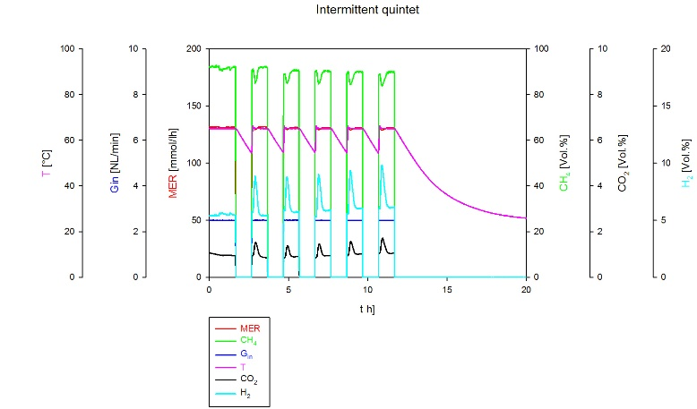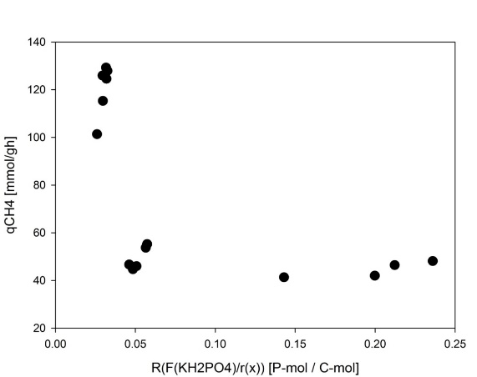

Figure 1. Feed forward strategy application to a CO2-BMP intermittent operation allowed uncoupling biomass growth control from methane production by varying the biocatalyst performances.
The feed strategy used to predict and control operations has been validated in pressure less conditions and further used for designing the cultivation medium for high pressure experiments where pseudo-steady state conditions had to be applied. After that, the know-how on the bioprocess was used for engineering, designing and building a custom-made pressure resistant CSTR that allowed to transfer axenic cultures to an elevated pressure environment (up to 16 barg). The latter allowed reaching unprecedent productivities using solely CO₂ as carbon source.
4. Conclusions
The application of an interdisciplinary modular development approach [9] to the CO2-BMP process allowed on one side assisting the prediction works for tecno-economic analysis [10] and process scale up while on the other hand elaborating a control strategy for the bioprocess suited for a vast range of operational regimes. This resulted in reaching high performances (methane evolution rate (MER) higher than 1.4 mol_{CH4} L_{broth}⁻¹ h⁻¹) with sufficient methane (CH₄ > 95 Vol.% for the raw wet gas) that allow to reach most of EU countries gas grid specifications after a final purification step. Greatly acknowledge is the funding from the European Union's Horizon 2020 research and innovation program under grant agreement number 679050 (project: CELBICON).
References
[1] Sébastien Bernacchi and Christoph Herwig, “Challenges and solutions for development of gas limited bioprocesses illustrated by the biological methane production (BMP) process development” Current Biochemical Engineering, Volume 3, Number 3, 2016, pp. 165-176(12).
[2] A. H. Seifert, S. Rittmann, and C. Herwig, “Analysis of process related factors to increase volumetric productivity and quality of biomethane with Methanothermobacter marburgensis,” Appl. Energy, Vol. 132, pp. 155–162, 2014.
[3] N. Schill, W. M. van Gulik, D. Voisard, and U. von Stockar, “Continuous cultures limited by a gaseous substrate: Development of a simple, unstructured mathematical model and experimental verification with Methanobacterium thermoautotrophicum,” Biotechnol. Bioeng., vol. 51, no. 6, pp. 645–658, 1996.
[4] R.-S. Taubner et al., “Biological methane production under putative Enceladus-like conditions,” Nat. Commun., Vol. 9, No. 1, 2018.
[5] S. Bernacchi, S. Rittmann, A. H. Seifert, A. Krajete, C. Herwig, “Experimental methods for screening parameters influencing the growth to product yield (Y(x/CH4)) of a biological methane production (BMP) process performed with Methanothermobacter marburgensis,” AIMS Bioeng., Vol. 1, No. 2, pp. 72–86, 2014.
[6] A. H. Seifert, S. Rittmann, S. Bernacchi, and C. Herwig, “Method for assessing the impact of emission gasses on physiology and productivity in biological methanogenesis,” Bioresour. Technol., Vol. 136, pp. 747–751, 2013.
[7] W. Nischkauer, F. Vanhaecke, S. Bernacchi, C. Herwig, and A. Limbeck, “Radial line-scans as representative sampling strategy in dried-droplet laser ablation of liquid samples deposited on pre-cut filter paper disks,” Spectrochim. Acta Part B At. Spectrosc., Vol. 101, pp. 123–129, 2014.
[8] S. Bernacchi, A. Krajete, C. Herwig “Experimental workflow for developing a feed forward strategy to control biomass growth and exploit maximum specific methane productivity of Methanothermobacter marburgensis in a biological methane production process (BMPP),” AIMS Microbiol., Vol. 2, No. 3, pp. 262–277, 2016.
[9] Christoph Herwig Sebastien Bernacchi, “Application of a modular and interdisciplinary approach to the development of a biological methane production (BMP) process,” 2015.
[10] S. Bernacchi, M. Weissgram, W. Wukovits, C. Herwig; “Process efficiency simulation for key process parameters in biological methanogenesis,” AIMS Bioeng., Vol. 1, No. 1, pp. 53–71, 2014.

