Granular vertical bladed mixer: flow patterns and homogenization
Martin Kozakovic^{1*}, David Kramolis¹ , Tereza Travnickova², Petr Stanovsky², Martin Kohout³, Jaromir Havlica^{1,2}
1 University of Jan Evangelista Purkyne in Usti nad Labem, Ceske mladeze 8, 400 96 Usti nad Labem, Czech Republic, 2 Institute of Chemical Process Fundamentals Czech Academy of Sciences, Rozvojova 2/135, 165 02 Prague, Czech Republic; 3 University of Chemistry and Technology Prague, Technicka 5, 166 28 Prague, Czech Republic
*Corresponding author: martin.kozakovic@gmail.com
Highlights
- Formation of primary and secondary flow patterns was analyzed
- Description of the primary and secondary flows influence on the homogenization process
- Determination of the best working conditions for homogenization process

1. Introduction
This contribution is focused on mixing dynamics and homogenization process during mixing of the dry granular material. Inasmuch as a granular flow is a very complex problem, it is still intensively researched. Our motivation is to interpret the complex behavior of the granular flow and to describe the connection between dynamics of primary and secondary granular flows and the homogenization process during the convection mixing mechanism. The results presented here are the continuation of our previous publishing activities^{[1-3]}, which were particularly focused on the description of the secondary flow formation during the mixing process.
2. Methods
This contribution deals with numerical simulations and experimental measurements of the granular mixing process in a vertical cylindrical mixer with two opposed flat blades with a 45° rake angle. The mixing process was performed for 42212 monodisperse colored spherical glass particles with 2 mm diameter and three limit initial packing configurations: tangential (side-by-side), axial (bottom-up) and radial (inside-outside). The blade rotational speed was changed from 0.1 rpm to 960 rpm. Each of simulated processes was performed for 80 stirrer revolutions. The simulation was conducted using open-source code LIGGGHTS with implemented Discrete Element Method (DEM). The experiments consisted of a borosilicate cylindrical glass vessel and bottom part was made from polyamide. The whole mixing process was recorded by color high-speed camera Redlake MotionPro X-3 with 50mm (Nikon f/1.2) lens to obtain sharp images even for higher rotational speed (with resolution 1280x1024 in speed range 30-1040 fps and exposure 722ns) ^{[3]}.
3. Results and discussion
In order to better understand the behavior of the mixing process and what aspects affect the resulting process of homogenization, individual particles were tracked, force chains were visualized and also discrete quantities, such as velocity or concentrations, were transformed into Eulerian 1D, 2D and 3D fields. An important part was also the evaluation of mixing indexes, displacement characteristics and variation of the interface surface between particles of different colors during mixing process.
Especially in the first stage of the mixing process, the dominant mechanism is convection. The homogenization process takes place, when the phase interface between different types of particles significantly increases. In order to increase the interface, it is necessary for particles to move in the normal direction with respect to the interface and at the same time their mutual normal velocity has to be of different magnitude. Using different initial configurations and different blades rotational speeds, the relationship between the orientation of the phase interface and velocities of individual particles was determined. It was also described the influence of primary and secondary flows on the homogenization process. Fig. 1 presents an evolution of concentration fields for blades rotational speed 150 rpm and two different initial packing configurations (tangential and radial). For a tangential initial configuration (Fig 1a), it is possible to monitor the effect of primary flows (tangential velocity) on the homogenization process. On the other hand, Fig 1b illustrates the importance of secondary flows for mixing process especially for initial packing configuration with phase interface oriented in the tangential direction to the primary flow.
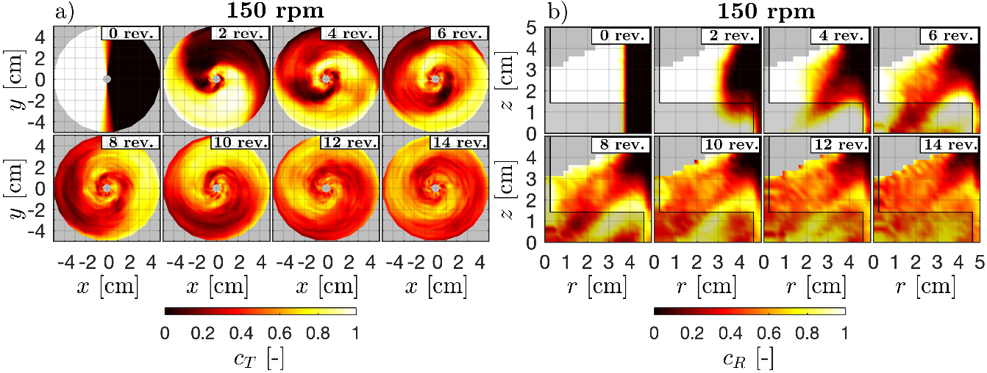
Figure 1. 2D concentration patterns for a) side-by-side and b) inside-outside initial packing. The stirrer is semi-transparent. The blades rotational speed is 150 rpm.
4. Conclusions
The mixing process of granular material in a vertical mixer with two opposed flat blades for different blades rotational speeds and initial configurations was studied by numerical simulations and experimentally. Results from simulations and experiments describe the mixing process in the same way with significant agreement in observations. This study shows the influence of both primary and secondary flows on the homogenization process. Based on these results, ideal working conditions were determined for investigated mixing process.
References
- J. Havlica, K. Jirounkova, T. Travnickova, M. Kohout, Powder Technol. 280 (2015), 180–190.
- T. Barczi, T. Travnickova, J. Havlica, M. Kohout, Chem. Eng. Technol. 38 (2015), 1195–1202
- J. Havlica, K. Jirounkova, T. Travnickova, P. Stanovsky, P. Petrus, M. Kohout, Powder Technol. 334 (2019), 79–88.
Acknowledgements: This research was supported by the grant UJEP-SGS-2018-53-002-2.

