CFD studies on the hydrodynamics in systems with open-cell foam internals
José D. Araújo*¹, João Barbosa¹, Manuel A. Alves¹ and João M. Campos¹
¹ CEFT, Department of Chemical Engineering, Faculty of Engineering of the University of Porto
Rua Dr. Roberto Frias, 4200-465 Porto, Portugal
*Corresponding author: daraujo@fe.up.pt
Highlights
- Open-cell foams based on cubic cells with different tilt angles were investigated
- Residence time distribution was computed by CFD techniques
- Mass dispersion coefficients and pressure drop per unit length were estimated
1. Introduction
Fixed bed reactors are among the most relevant operation units in chemical industries, and the design of the internals is a subject that gathers particular attention. In the past, random or unstructured packings were mostly used which largely limited the freedom of design. Nowadays, this freedom is continuously increasing due to the application of more ordered structures, which can be even more potentiated by the implementation of 3D printing in the reactors intensification [1]. Following this trend, open-cell foams place themselves as a very attractive option suitable to enhance a wide range of industrial applications [2]. However, there is still a lack of detailed investigations about the hydrodynamics in fixed beds based on open-cell foams. Regarding chemical engineering, computational fluid dynamics (CFD) is widely used to simulate specific phenomena and also the combination of features that occurs on entire production units like chemical reactors. Overall, CFD tools can provide great flexibility for parametric studies and sufficient detail to describe different phenomena with distinct spatial and temporal characteristic scales.
The present work consists on a parametric and systematic study of the hydrodynamics of single phase flows through open-cell foams with cubic cell topology. CFD techniques are used to numerically replicate tracer experiments for the prediction of several characteristic parameters, such as mass dispersion and pressure drop.
2. Methods
The present numerical study was based on a CFD approach entirely open-source: OpenFOAM® CFD package to perform the numerical simulations; Blender® to generate the geometry/domain in the form of STL files; and SnappyHexMesh tool of OpenFOAM® to create the computational mesh. The domain under consideration (total length of 4.5 cm and diameter of 2.0 cm) is a portion of a cylindrical tube filled with ordered open-cell foam structure with different configurations derived from the repetition of unitary cubic cells. The space between struts (pore size) varied from 0.2 to 0.3 cm corresponding to porosities in the range of 0.60-0.95.
The simulated systems replicate tracer tests in order to produce residence time distribution data, i.e., it consists on liquid phase flow (water properties) through the foam with a feed of solute in the core of the inlet cross-section (step input). The model includes the Navier-Stokes equations and the mass balance equation for the tracer. A large set of simulations was performed with different superficial velocities and cubic cells orientations.
3. Results and discussion
The main raw data to extract from the CFD simulations are the velocity, pressure and concentration fields. Based on this data for each simulation, it is possible to determine the pressure drop per unit length, produce the cumulative residence time distribution (Figure 1a) and estimate axial and radial mass dispersion coefficients (Figure 1b). These coefficients are obtained from fitting the numerical data to Danckwerts [3] and Hiby and Schummer [4] equations. The first step was to perform mesh independency tests to define a proper density (around 1300000 mesh elements) to apply throughout the work. It was verified that the mesh density affects mainly the dispersion coefficients results and the estimation of stagnant regions.
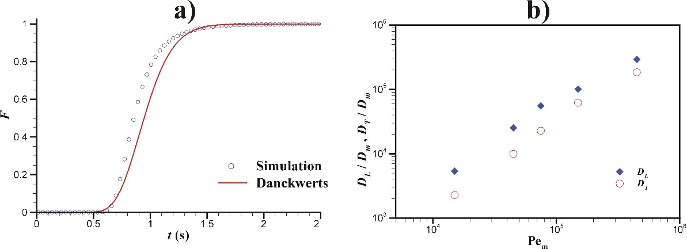
Figure 1. Cumulative residence time distribution for a system with a superficial velocity of 0.03 m/s (a) and dimensionless axial and radial dispersion coefficients as a function of molecular Peclet number (b).
The results in Figure 1 are illustrative of what will be obtained in this study, since the work is still under active development. More detailed and extensive results will be presented and comparisons will be made with available experimental and/or correlation data. Furthermore, there is the possibility of including a last set of simulations addressing illustrative homogeneous and surface reactions in some selected foam structures.
4. Conclusions
The implementation of open-source computational tools to simulate the flow inside tubes filled with open-cell foams was carried out. Single phase flow simulations were performed to replicate tracer experiments and produce important hydrodynamic information such as mass dispersion coefficients and pressure drop. A parametric study will be presented about the influence of the superficial velocity and tilt angles of the foam unitary cubic cells on the referred hydrodynamic parameters.
References
- https://www.sintef.no/projectweb/printcr3dit/.
- E. Bianchi, W. Schwieger, H. Freund, Adv. Eng. Mater. 18 (2016) 608-614.
- P.V. Danckwerts, Chem. Eng. Sci. 2 (1953) 1-13.
- J. Hiby, P. Schümmer, Chem. Eng. Sci. 13 (1960) 69-74.

