Mass transfer at rising single nitric oxide bubbles in reacting iron ligand systems
David Merker*, Lutz Böhm and Matthias Kraume
Technische Universität Berlin, Chair of Chemical and Process Engineering, Sekr. FH 6-1, Fraunhoferstraße 33-36, 10587 Berlin, Germany
*Corresponding author: david.merker@tu-berlin.de
Highlights
- Liquid phase reaction
- Mass transfer enhancement
- Bubble fluid dynamic

1. Introduction
The design of gas liquid reaction is still a challenging task. In addition to the reaction itself, the fluid dynamics of the phases and thus the changed mass transfer conditions must also be taken into account. Occurring processes are not completely understood yet. To be able to describe a complex gas liquid, the DFG Priority Program 1740 "Reactive Bubbly Flows" SPP1740 focuses on different substance systems and scales. In this project the complexity is reduced by first analyzing single bubbles with a high spatial and temporal resolution.
2. Methods
The experimental setup built in this project can be seen in Figure 1. The main part is a 2 m long glass tube, in which a single bubble can rise freely through a stagnant fluid. [1]
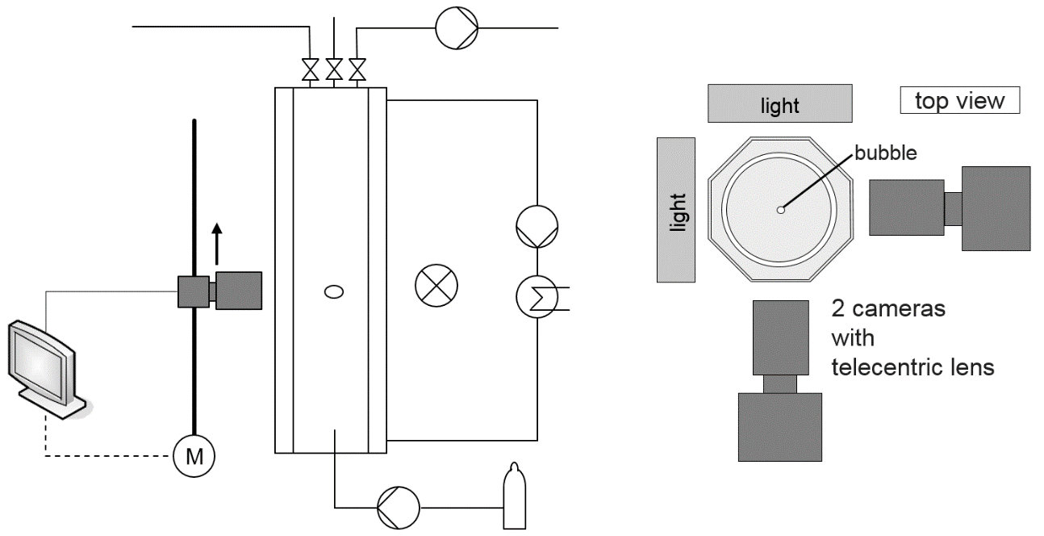
Figure 1. Experimental setup: schematic sketch (left), single bubble rises in a temperature-controlled glass tube (h = 2m) observed with high-speed cameras; Cross section of the system (right)

The temperature is controlled with an acrylic glass jacket that also provides a better optical access. The bubble is tracked with two high-speed cameras, which are moved along with the rising bubble. It is possible to perform experiments under a protective atmosphere. Apart from the solution of carbon dioxide (CO₂) in water/NaOH_{aq}, experiments with different iron complexes reacting with nitric oxide (NO) as the gas phase were carried out. The choice of ligand influences the reaction rate of the system.
3. Results and discussion
Figure 2 shows a nitric oxide bubble in an iron sulfate edta solution (FeII(edta)_{aq}). The product is colored and can be detected in the wake of the bubble. The two images were taken at the same time by the two cameras with an offset of 90°. The size, shape and 3D rising path can be resolved with a high temporal and spatial resolution.
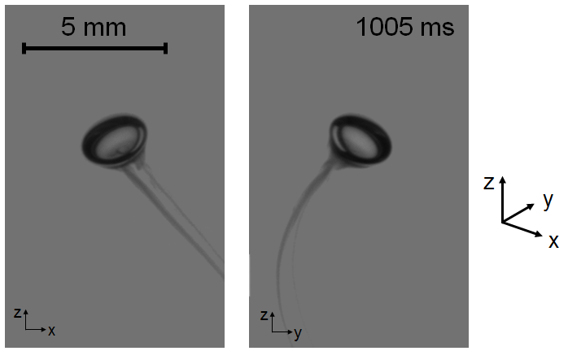
Figure 2. nitric oxide (NO) bubble in FeII(edta)_{aq} with a concentration of 75 mmol/l, view from the two cameras simultaneous
The changing fluid dynamics of the dissolving bubble can be tracked. Different initial diameters were investigated. Various ligands have an influence on the reaction rate, as well as on the shape and fluid dynamics.
4. Conclusions
It is possible to measure the volume change and thus evaluate the mass transfer of a bubble depending on the contact time. Due to the detailed measurements, enhancement factors can be measured depending on the ligand and educt concentration.
Acknowledgements
The authors gratefully acknowledge the financial support provided by the German Research Foundation within the Priority Program ‘‘Reactive Bubbly Flows’’, SPP 1740.
References
- D. Merker, L. Böhm, M. Oßberger, P. Klüfers, M. Kraume, Chem. Eng. Technol. 40 (8) (2017) 1391-1399.

