BIOCOMPATIBLE EXTRACTION OF β-CAROTENE FROM DUNALIELLA SALINA – NEW CONTRIBUTION
Guillaume Tanguy*^{1,2}, Olivier Goncalves¹, Benoît Schoefs², Luc Marchal¹
1 Process engineering, environment and food processing, GEPEA
UMR – FR 6144 CNRS, Nantes University, Saint-Nazaire, France
2 Metabolism, bioengIneering of Molecules from Microalgae and Applications, Mer Molécules Santé,
IUML - FR 3473 CNRS, Le Mans University, Le Mans, France
*Corresponding author: Guillaume.tanguy1@univ-nantes.fr
Highlights
- The extraction is biocompatible at the culture level but not at the cell level
- The biocompatibility of the extraction follows a granulo-selective phenomenon
- The extraction kinetics were obtained using Centrifugal Partition Chromatography

1. Introduction
Biotechnological production of carotenoids from the green microalga Dunaliella salina involves two steps: (i) biomass growth followed by β-carotene accumulation inside the cell and (ii) carotenoid extraction. Microalgae milking was introduced for the recovery of biomolecules directly from culture broth using long-chain alkanes as solvent [1]. In this condition, photosynthesis was not highly impacted [2] and the fraction of extracted β-carotene from biomass exceeded the fraction of disrupted cells [3]. In a biocompatible extraction or in situ extraction concept, cells remain alive during extraction and the extracted molecules can be re-accumulate [1].
The aim of this study was to determine how the extraction of β-carotene from the green microalga Dunaliella salina was biocompatible. The solvent used was n-decane and two extraction parameters were investigated: (i) time of contact and (ii) interfacial area between the solvent and the microalgal culture.
2. Methods
Dunaliella salina was grown in a 1L Air-Lift flat panel Photobioreactor (PBR) [4]. To trigger β-carotene accumulation, the green biomass was stressed through a combination of nitrogen limitations and light stress (400 µE/m²/s) or, nitrogen depletion and high light stress (800 µE/m²/s). After carotenoid accumulation, the extraction was run on a Centrifugal Partition Chromatography (CPC), which allowed to control the two liquids phases hydrodynamics with centrifugal acceleration [5]. After extraction the biomass was re-inoculated within the same medium or in the growth medium. The biomass was analyzed before and after extraction and during the re-growth to access the biocompatibility and kinetics of relaxation. Analysis were focused on cell granulometry (density and size), metabolites (pigments and lipids) and dry biomass regarding the extraction parameters.

3. Results and discussion
As a first result, total cell volume decreased as a function of time of contact of the culture media and the solvent (Figure 1). Concerning the cell volume distribution before and after extraction, the biocompatibility is lower for big than for small cells (“granulo-selective” phenomenon) and the median value µ of the distribution decrease (p < 0.05). As a consequence, difference between population biocompatibility and individual biocompatibility appeared a key point and a new contribution. These results suggest that carotenoid and lipid extraction yields were correlated with cell destruction.
Finally, a comparison has been made between the two stress applied to the biomass and the scenarii of re-growth to determine the most productive process scheme.
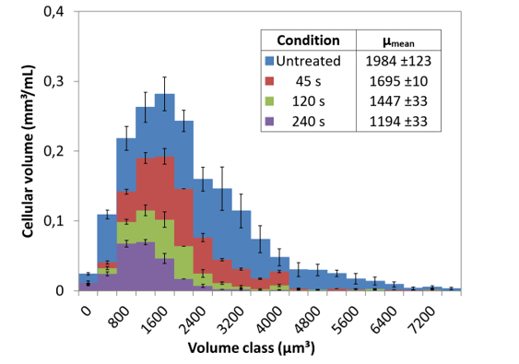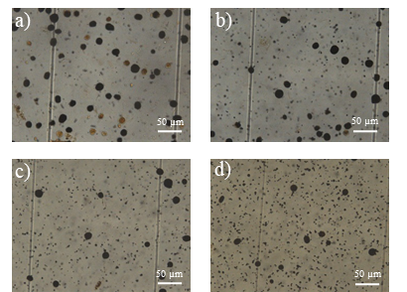
Figure 1. Cell volume distribution (Left) and light microscopy pictures for different extraction time (Right). The larger the extraction time the shorter the mean median value and the fewer cells survive. a) Untreated, b) 45 s, c) 120 s and d) 240 s of contact between the solvent and the microalgal culture. Cells were fixed with 1% lugol.
4. Conclusions
Centrifugal Partition Chromatography allowed the decoupling of biomass/metabolites production and the extraction steps giving a better understanding of the mechanism. The granulo-selective effect of the solvent extraction is an original contribution that opens the reflexion for new carotenoid production schemes. The scenarii investigated allowed to choose suitable conditions for the open-loop process with high metabolite productivity and low solvent consumption.
References
- Vinayak et al., "Diatom milking: a review and new approaches.", Marine Drugs, 13(5): 2629-2665. (2015)
- León et al. ,“Microalgae-mediated photoproduction of β-carotene in aqueous organic two phase systems.”, Biomolecular engineering, 20. 177-82, (2003).
- Mojaat et al., “Optimal selection of organic solvents for biocompatible extraction of β-carotene from Dunaliella salina.”, J. Biotechnol, 133 433-441, (2008).
- Taleb et al., “Investigation of lipid production by nitrogen-starved Parachlorella kessleri under continuous illumination and day/night cycles for biodiesel application.”, Journal of Applied Phycology, 30. 1-12, (2017).
- Marchal et al., “Centrifugal partition extraction of β-carotene from Dunaliella salina for efficient and biocompatible recovery of metabolites.”, Bioresource technology, 134. 10.1016, (2013).

