Use of fungi in a Membrane-aerated Biofilm Reactor
Ester Rosa¹, Marcello Pagliero², Grazia Cecchi¹, Simone di Piazza¹, Renzo Di Felice³, Antonio Comite², Mirca Zotti¹
1 Laboratory of mycology, Department of Earth, Environment and Life Sciences, University of Genoa, C.so Europa 26, 16136 Genoa, Italy;
2 Department of Chemistry and Industrial Chemistry, University of Genoa, Via Dodecaneso 31, 16146 Genoa, Italy
3 Department of Civil, Chemical and Environmental Engineering, University of Genoa, Via all’Opera Pia 15, 16145 Genoa, Italy
*Corresponding author: ester.rosa@edu.unige.it
Highlights
- Membrane aerate biofilm reactor (MABR) is a promising, ecological and economic new technology for biological wastewater treatment.
- The potential role of microfungi in biological wastewater treatment has not received the attention merited, despite their metabolic ability to degrade many organic environmental pollutants.
- Hollow fiber as Accurel PP S6/02 are good for supplying air to fungal biofilm.

1. Introduction
A innovating wastewater treatment is the Membrane Biofilm Reactor (MBfR) based on the transfer of a gas through a membrane to a biofilm. The outer surface of biofilm is in contact with a liquid phase containing the substrates to be metabolized [1].
In a common wastewater treatment using MBfR the biofilm is formed by activated sludge organisms, but in this work it was studied the possibility to develop a biofilm using different fungal strains. [2]
The use of fungi to remove pollutant from environment components is called mycoremediation and is a new eco-friendly technology. Fungi can survive and grow at high concentration of many pollutants and some strains are used in wastewater treatment [3].
In this work a laboratory-scale reactor study was carried out by using commercial hydrophobic hollow fiber membranes, in polypropylene. The aim of work is to verify the capability of different fungi to grow and degrade synthetic or real wastewaters using air through a membrane.
2. Methods
Two common fungal strains usually used for mycoremediation were selected for the biofilm formation on the membrane surface: Trichoderma harzianum Rifai group and Penicillium expansum Link. The membrane bioreactors were realized starting from commercial fibers Accurel PP S6/2 (3M, Germany).
A small batch MABR consisted of 3 L glass flasks containing a model wastewater and hollow fiber membranes (about 20 cm² of the membrane surface area) immersed in the liquid phase and connected to an air feeding line at atmospheric pressure.
Another MABR was built using a hollow fiber membrane module of about 600 cm², where the feed was recirculated from a wastewater tank (Fig.1).
Various experiments aimed at evaluating the oxygen transfer rate were carried out at different air and liquid velocities. The biofilm growth was monitored and various operating parameters, as well as temperature, air velocity, and oxygen consumption and demand were studied using model and real wastewaters.

3. Results and discussion
In batch conditions the Penicillium expansum showed a better ability than Trichoderma harzianum to form a biofilm on the hollow fiber outer surface. In recirculation mode, the oxygen transfer performance of the membrane without biofilm was better by increasing the air and liquid velocity. Adhesion and growth of different fungal strain were tested using the same hollow hydrophobic fibers. The MABR performance where oxygen was supplied directly to the biofilm through the membrane was compared with the one of a suspended aerated biomass reactor based on a conventional sparger.
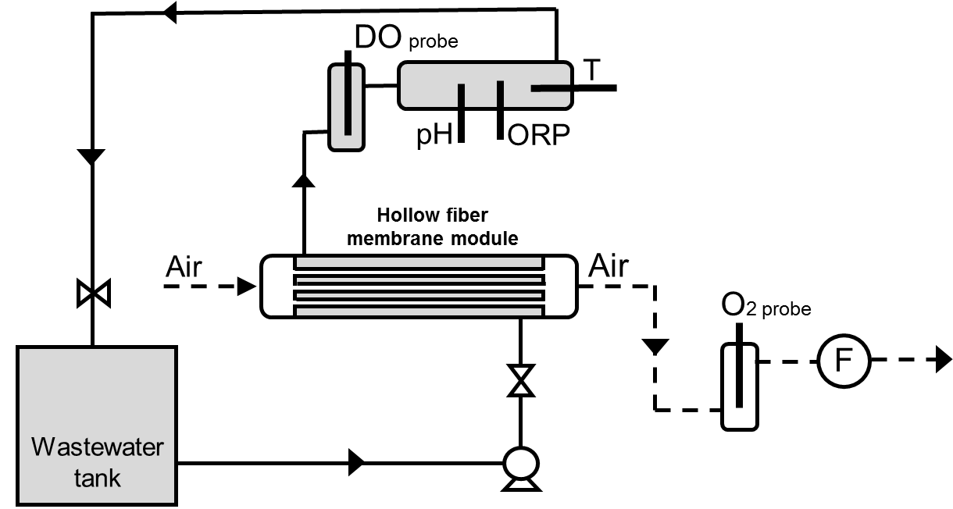
Figure 1. Membrane Areated Biofilm Reactor Plant scheme used for oxygen transfer and fungal growth experiment.
4. Conclusions
Some fungal strains are able to form a stable biofilm on the membranes Accurel PP S6/02. A preliminary screening revealed which strains are able to metabolize simple and more complex organic pollutants. Supplying oxygen directly thought the hollow fiber is an efficient approach to improve the kinetics of the pollutant degradation process. The fungi that have been tested show a different adherence on Accurel PP S6/02 and different capability to degrade the substrate, but it is still research is needed to explore new type of fungi and the substrates tested.
References
- A. Basile, Handbook of membrane reactors, first ed., Woodhead Publishing 2, 2013, pp. 763-807.
- K.J. Martin, R. Nerenberg, The membrane biofilm reactor (MBfR) for water and wastewater treatment: Principles, applications, and recent developments, Bioresource Technology 122, 2012, pp. 83–94.
- G. M. Gadd, Fungi in bioremediation, Cambridge University Press, 2001.

