A two-components model for glucose uptake dynamics of E. coli cells
Vincent QUEDEVILLE¹, Jérôme MORCHAIN*¹, Rodney O. FOX², Philippe VILLEDIEU³
1 LISBP, Université de Toulouse, CNRS, INRA, INSA, Toulouse, France; 2 IMFT Université de Toulouse, CNRS, INPT, Toulouse, France ; 2 Department of Chemical and Biological Engineering, Iowa State University, Ames, USA; 3 ONERA/DMPE, Université de Toulouse, F-31055 Toulouse, France
*Corresponding author: jerome.morchain@insa-toulouse.fr
Highlights
- A dynamic model for glucose uptake is proposed
- Two subsystems : PTS and permeases work in parallel
- Batch and continuous culture subject to dilution shifts are simulated
- The overshoots reported in the literature are predicted

1. Introduction
The very specificity of biological systems compared to chemical ones is the ability of cells to modulate the magnitude of the mass transfer between the liquid and biotic phases. A thermodynamic law of equilibrium can be set at the interface between two phases in chemical multiphase systems. However, the situation is much more complex for living systems because cells adapt their uptake capacity dynamically to match their needs. On the top of that, a long series of works from Ferenci proved that multiple transport systems are present [1]. On the long term, a cell regulates its uptake capacity so that the maximum possible growth rate is achieved, but the dynamics toward this steady state situation is far from simple. Little has been made in the modelling community to account for these facts. Our former proposition suffered from many constitutive defaults [2]. In this version, the difference between the actual uptake and the cell needs is used to trigger the regulatory mechanisms that control the cell uptake.
2. Methods
A structured model at the single cell level is formulated and used to write overall mass balance for nutrients and cell number at the reactor scale, resulting in a set of differential equations. Two internal properties are attached to a cell: its maximum potential uptake rate and its maximum elongation rate. The former is expressed as the sum of two contributions by PTS and permeases.
$$q_{S}=q_{PTS}(S)+q_{perm}(N,A,S)$$
The uptake by permeases implies the product of a number of permeases, N, by a permease activity A. These two quantities evolve in time, increasing when the uptake due to the sole PTS is insufficient to satisfy the cell need for growth (known from the second cell property, its elongation rate) and decreases when sugar uptake overtakes the cell needs. A basic flux metabolic model is used to orient the carbon fluxes toward growth or overflow. Beside the biological properties defining the biological upper limit, the overall uptake rate is obviously upper-bounded by the maximum flux of substrate reaching the cell –liquid interface considering possible external limitation.
3. Results and discussion
Batch and continuous cultures of E.coli were simulated. Figure 1 show that PTS dominates at high concentrations at the beginning of the culture. The cell needs are high for the elongation rate is also high. As the sugar concentration decreases, the PTS contribution becomes insufficient and that triggers the activation of the permease system. Interestingly and as reported by Ferenci [3], the induction of permeases occurs well before the sugar concentration has reached the affinity constant of the PTS system (here set to 10 mg/L). This apparent ability of cells to anticipate glucose exhaustion remained unexplained until now, but emerges as a natural consequence of the flux formulation adopted in our model. At the end of the batch, the time lapse before glucose exhaustion is so short that the number of permeases cannot significantly increase.
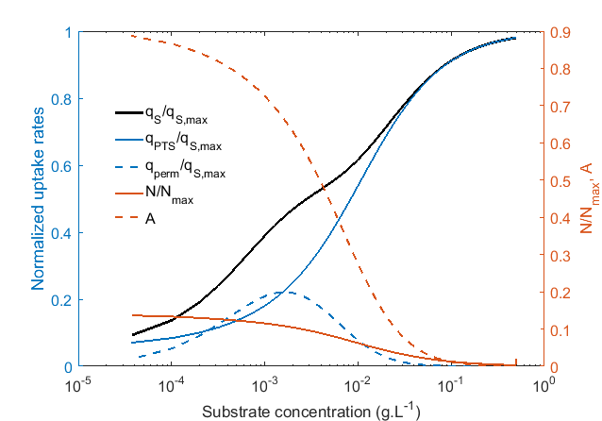
Figure 1. Evolution of PTS and permease contribution to the total uptake rate during the course of a batch culture. Number of permeases and permease activity. Read from right to left to follow the time course of the batch culture
4. Conclusions
A model for the regulation of sugar uptake under transient conditions was formulated and tested under various conditions (setp-up/step-down of the dilution rate, pulse addition). The most striking result is its ability to predict glucose uptake overshoots (far above the maximum value observed in batch) in the following of a pulse addition of substrate, as reported years ago by Neubauer and co-workers [4].
References
[1] T. Ferenci, FEMS Microbiol. Rev. 18 (1996) 301–317. doi:10.1111/j.1574-6976.1996.tb00246.xJ.
[2] V. Quedeville, H. Ouazaite, B. Polizzi, R.O. Fox, P. Villedieu, P. Fede, F. Létisse, J. Morchain, Chem. Eng. Res. Des. 132 (2018) 966–981. doi:10.1016/j.cherd.2018.02.025.
[3] T. Ferenci, Hungry bacteria – definition and properties of a nutritional state, Environ. Microbiol. 3 (2001) 605–611. doi:10.1046/j.1462-2920.2001.00238.x
[4] P. Neubauer, L. Häggström, S.O. Enfors, Biotechnol. Bioeng. 47 (1995) 139–146.

