**Stability of nanobubble dispersions in liquids of various composition and physicochemical properties**

Karol Ulatowski, Paweł Sobieszuk*\**, Tomasz Ciach

*Warsaw University of Technology, Faculty of Chemical and Process Engineering, Warynskiego 1, Warsaw, Poland*

*\*Corresponding author: Pawel.Sobieszuk@pw.edu.pl*

**Highlights**

* Gas nanobubbles are stable even in deionized water.
* The stability of nanobubbles varies in liquids of different polarity.
* Nanobubbles are stable for low absolute values of zeta potential (under 30 mV).
* Diameter of bubbles is different for each gas phase used.

**1. Introduction**

Bulk nanobubbles are spherical gas domains in liquid which are characterized by diameter under 1 μm. In consequence, the rising velocity of nanobubbles is extremely low (according to Stokes law) and their internal pressure is high as for Laplace equation [1]. What is more, nanobubbles are reported to be stable for a long time (weeks to months) in aqueous dispersions [2-4]. However, the investigation of generation in non-polar liquids and systematic research of stability of bubbles in aqueous solutions with salt or surfactant additions is still to be done. This study aims to show the results of research of stability of bubbles generated in mentioned liquid phases.

**2. Methods**

Nanobubbles were generated in the system presented schematically in Figure 1. Gas from the cylinder squeezes through the pores of the ceramic membrane and forms hemispherical domains which are cut off by the flowing liquid. Several gases were used, including nitrogen, oxygen and air among others. The two-phase flow was returned to the storage tank. Liquid stored in tank was sucked by the rotary pump which induced the flow of the liquid inside the cylindrical membrane. Liquids ranged from pure (deionized) water, through water with salt and surfactant additions up to nonpolar organic liquids.

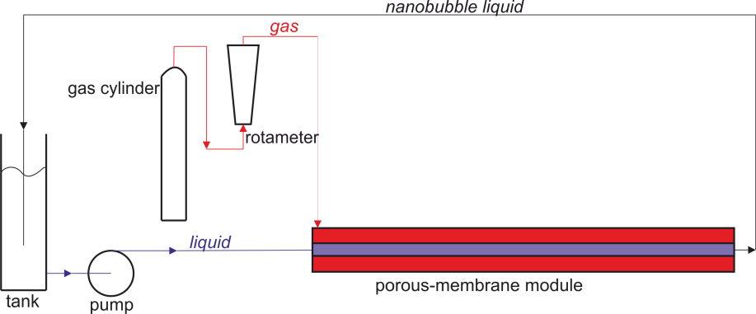

**Figure 1.** Scheme of the experimental setup

The distribution density of bubbles and zeta potential was measured using Malvern Zetasizer Nano ZS using DLS technique. For each measurement the Sauter diameter ($d_{32}$) was calculated.

**3. Results and discussion**

In Figure 2 one can see the exemplary results of Sauter diameter obtained for nitrogen and oxygen nanobubbles with deionized water as a liquid phase. It is clear that the diameter of bubbles over time is nearly constant. Another interesting fact is that oxygen nanobubbles are about two times smaller than the nitrogen nanobubbles. The reasons for such extraordinary stability of nanobubbles are not clear. Ulatowski et al. [2] proposed the possible explanation of this phenomenon, linking it with the reduction of surface tension due to accumulation of charge on nanobubble surface (analogously to reduction of surface tension on charged drop proposed by Lord Rayleigh theory). Another theory proposed by Ohgaki et al. [4] states that water molecules form hard shells around bubbles, due to their hydrophobicity. That leads to a reduction in diffusivity of gas through the gas-water interface and increase of surface tension. The stability of nanoobjects is linked to zeta potential value. For solid nanoparticles, the absolute value of zeta potential which indicates high stability of dispersion is assumed as 30 mV. In this work, the stable nanobubbles were obtained for low value of zeta potential of about –15 mV.



**Figure 2.** Sauter diameter of bubbles as a function of time for nitrogen and oxygen nanobubbles in pure water

**4. Conclusions**

Investigation of reasons of nanobubble stability is not a closed case. There is much to discuss and investigate in future. This works aims to investigate the stability of nanobubbles in various liquids of different polarity, ions presence and other physicochemical properties.

**Acknowledgements**

This work was supported by the National Science Centre, Poland (grant number 2018/29/B/ST8/00365).

**References**

1. H. Tsuge, Micro- and Nanobubbles. Fundamentals and Applications, Pan Stanford Publishing, Boca Raton, 2015.
2. K. Ulatowski, P. Sobieszuk, A. Mróz, T. Ciach, Chem. Eng. Process. Process Intensif. 136 (2019) 62-71.
3. K. Ulatowski, P. Sobieszuk, Chem. Process Eng. 39(2018), 335-345
4. K. Ohgaki, N. Q. Khanh, Y. Joden, A. Tsuji, T. Nakagawa, Chem. Eng. Sci. 65 (2010) 1296-1300