Comparison between a Rocking and a Stirred Bioreactor Concerning Particle Stress in a Liquid-Liquid Model System
Robert Panckow¹*, Chrysoula Bliatsiou¹, Lutz Böhm¹, Michael Muthig², Sebastian Maaß², Matthias Kraume¹
1 Chair of Chemical and Process Engineering, Technische Universität Berlin, Fraunhoferstr. 33-36, 10587 Berlin, Germany; 2 SOPAT GmbH, Boyenstraße 41, 10115 Berlin
*Corresponding author: panckow@tu-berlin.de
Highlights
- Mixing concept determines hydro-mechanical stress on particles in bioreactors.
- Liquid-liquid model system substitutes biological system.
- New image analysis by neural networks provides faster and more accurate results.
- Particle analysis tool provides distinction between different disperse phases.

1. Introduction
High mechanical power input to achieve fast heat and mass transfer can damage a present disperse phase, with cells and cell agglomerates being of interest in biotechnology. An eﬃcient mixing system which gives even suspension with gentle stirring and does not generate high shear forces results in a homogeneous culture environment. In this study, fluid-mechanical particle stress is characterized by application of a two-phase model system with liquid disperse phase.
2. Methods
Comparatively, the investigations were carried out in a rocking single-use bioreactor (CELL-tainer® 20L, Celltainer Biotech BV) and in a DN160 stirred tank with torispherical bottom, see Fig. 1.
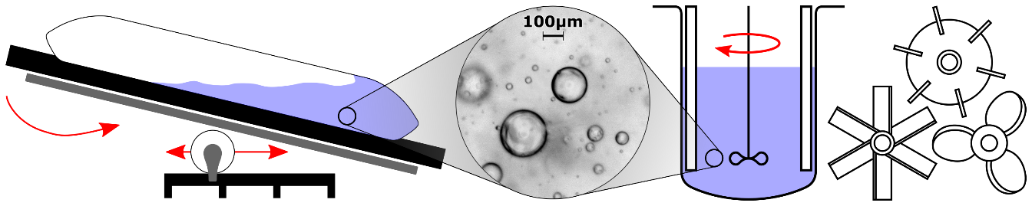
Figure 1. Motion concept of CELL-tainer® 20L (left), recording of drop sizes (middle), DN160 stirred tank with torispherical bottom (right).
The disperse droplet phase consisted of Mobil EAL Arctic 22 refrigerator oil having a density similar to the continuous phase [1]. By variation of working volume V, rotational frequency k and rocking angle φ (CELL-tainer) as well as stirrer geometry and stirrer frequency n (stirred tank), the droplet sizes of the disperse phase were recorded in situ by means of photo-optical particle analysis technology from SOPAT GmbH [2, 3], see Fig. 1 (middle). Measurement of the two-dimensional raw image data by automated image analysis provided the droplet size distribution. New implementations of image analysis algorithms based on neural networks yielded faster and more precise size measurements with classification of the detected particles.
The fluid dynamic investigations by particle image velocimetry (PIV) in the stirred vessel and by computational fluid dynamics (CFD) for both reactors support the understanding of the experimentally determined droplet breakage. In the stirred vessel, only the liquid phase was modeled, whereas in the CELL-tainer simulations the volume of fluid (VOF) method was applied to describe the two-phase flow. For both reactors, the RANS-based k-ε turbulence model was used. The velocity vector fields provide the basis for a coordinate transformation towards the flow direction along the streamlines to calculate shear and elongation gradients.
3. Results and discussion
The droplet breakage caused by different wave motion due to various operating points in the CELL-tainer and by the investigated stirrers in the stirred tank was monitored for the model system. The dynamic destruction kinetics were recorded, with the steady-state droplet diameter characterizing the particle stress. Noticeable, the measured drop sizes in the CELL-tainer show higher values as compared to the stirred tank for the investigated range of operating conditions and thus, indicate less particle stress. For the comparison of different stirrer geometries, axial stirrers show higher droplet breakage than radial pumping ones.
4. Conclusions
Due to the high sensitivity of the photo-optical measurement system, a precise differentiation of operating points was possible. The new algorithms could not only detect the desired droplets, but also were able to distinguish between different dispersed phases, for example disturbing bubbles. The dynamic destruction kinetics for different operating points of both reactor types in combination with the particular flow fields give new insights into the transferability of cell cultivation between the two reactor types.
References
- S. Wollny, R. Sperling, Partikelbeanspruchung in gerührten Behältern. Chem. Ing. Tech. 79 (3), 2007, pp. 199–208.
- Maaß et al., Automated Drop Detection Using Image Analysis for Online Particle Size Monitoring in Multiphase Systems. Comput. Chem. Eng. 45, 2012, pp. 27–37.
- Panckow et al., Determination of Particle Size Distributions in Multiphase Systems Containing Nonspherical Fluid Particles, Chem. Eng. Technol. 38 (11), 2015, pp. 2011–2016.

