Removal of p-coumaric acid and 4-ethylphenol from wine by yeast cell walls.
Elena Bakhos ^{1,2,4}, Alexandre Monnier ¹, Nathalie Sieczkowski ², Roger Lteif ¹, Dominique Salameh ³, Cedric Brandam ⁴
¹Unité de Technologie et Valorisation Alimentaire, ³Unité de recherche Environnement, Génomique et Protéomique, Centre d’Analyses et de Recherche, Université Saint-Joseph de Beyrouth, Faculté des sciences, Campus des Sciences et Technologies, Mar Roukos, Dekwaneh, B.P. 17-5208, Mar Mikhaël, Beirut, 1104 2020, Lebanon
² Lallemand SAS, 19 rue des Briquetiers, BP 59, 31 702 Blagnac, France
⁴ Laboratoire de Génie Chimique, Université de Toulouse, CNRS, INPT, UPS, 4 Allée Emile Monso-31029, Toulouse, France
elena.bakhos@net.usj.edu.lb
Highlights
- The sorption capacity of yeast cell walls changes depending on the type of adsorbate used
- The sorption profile differs between strains issued from the same species of Saccharomyces cerevisiae
- The sorption capacity of yeast cell walls changes according to the adsorbate/adsorbent ratio initially added

1. Introduction
During the winemaking process, Brettanomyces bruxellensis contaminates the wine by producing volatile phenols such as 4-ethylphenol (4-EP) that is the origin of the unpleasant aroma described as “horse sweat” [1,2]. Several methods were used to prevent wine contamination by these microorganisms such as filtration of wine, the addition of antimicrobial agents, applying high pressures to reduce populations of certain yeasts or the use of PVPP and charcoal to remove the volatile phenols. The latter resulted in the decrease of aromatic compounds concentration and color in red wines [3]. The benefit of using yeast cell walls as biosorbent is mostly driven by the presence of macromolecules such as mannoproteins which are located on the surface of the cell wall and able to retain volatile compounds [4]. The objective was to study the sorption profiles of p-coumaric acid and 4-EP with different specific yeast cell walls of Saccharomyces cerevisiae.
2. Methods
Yeast cell walls were produced from biomass that has undergone thermal autolysis and were dried either by lyophilization or spray-drying. The five specific yeast cell walls were provided by Lallemand, Blagnac (France) and were produced from different strains of Saccharomyces cerevisiae. Each experiment was conducted in 11 Erlenmeyer flasks containing synthetic wine medium composed of fructose, glucose, yeast extract, (NH₄)₂SO₄, citric acid, malic acid, tartaric acid, MgSO₄ and KH₂PO₄. The pH of the medium was adjusted at 3.5. Experiments were performed at 30ºC in the presence of 3 g/L of yeast cell walls with 10 mg/L of p-coumaric acid or 20, 30, 40 or 50 mg/L of 4-EP and stirred at 250 rpm. Control sample was prepared in the same conditions but without yeast walls. The amount of adsorbate unbound to cell wall was measured by UV spectrophotometry and sorption kinetics for both adsorbates were plotted in order to determine the time required to reach the equilibrium.
3. Results and discussion
Thermodynamic equilibrium time are considered relatively long. This is explained by the microporous structure of the adsorbent, which slows down the diffusion of the liquid since its dimensions are close to the diameter of the molecule. Sorption capacities are really greater with 4-EP than with p-coumaric acid. The maximum percentage of adsorption reached with
p-coumaric acid was 20% with the strain named CW1 (Figure 1) while the maximum percentage of 4-EP adsorbed by yeast cell walls was between 70 and 80% with the CW5 and CW2 specific cell-walls (Figure 2). A differential mannoprotein content might explain the variation of adsorption capacity by cell wall strains. It is known that the sorption capacity depends on the composition of the cell wall which varies depending on the yeast strain and the culture conditions. Furthermore, Saccharomyces cerevisiae adsorb preferentially 4-EP while the Brettanomyces adsorb preferentially p-coumaric acid [5]. It is due to the differential cell wall chemical composition between these two genera. In addition, for all specific cell-walls tested, the optimal adsorption concentration of 4-EP is 20 mg/L. The percentage adsorbed decreases inversely proportional with the increased concentration of 4-EP added. This may be explained by the saturation of the yeast wall sorption sites that are specific to 4-EP.
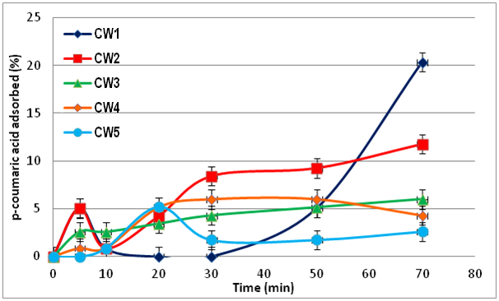 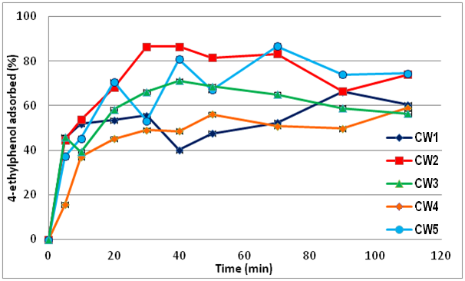
Figure 1. Sorption kinetics of p-coumaric acid Figure 2. Sorption kinetics of 20 mg/L 4-ethylphenol solution
4. Conclusions
The sorption varies according to the type of adsorbate and the yeast cell wall’s type (strain effect). The chemical composition of the yeast cell walls greatly influences the sorption profiles. In the end, this latter is a promising technique for the treatment of wine contaminated by volatile phenols.
References
- P. Chatonnet, D. Dubourdieu, J.N. Boidron, Am. J. Enology Vitic. 46 (1995) 463-468
- D. Salameh, C. Brandam, W. Medawar, R. Lteif, P. Strehaiano, Food Chem. 107 (2008) 1661-1667
- R. Pradelles, H. Alexandre, A. Ortiz-Julien, D. Chassagne, J. Agric. Food. Chem. 56 (2008) 11854-11861
- D. Chassagne, M. Guilloux-Benatier, M. Alexandre, A. Voilley, Food Chem. 91 (2005), 39-44
- J. Kheir, D. Salameh, P. Strehaiano, C. Brandam, R. Lteif, Eur. Food Res. Technol. 237 (2013) 655-671

